Activity 2.7.4 Construction of a Perpendicular to a Line
from a Point not on the Line

Construction

Given: $\overset{⃡}{AB }$with C a point not on $\overset{⃡}{AB }$

To construct: a line passing through C and perpendicular to $\overset{⃡}{AB }$
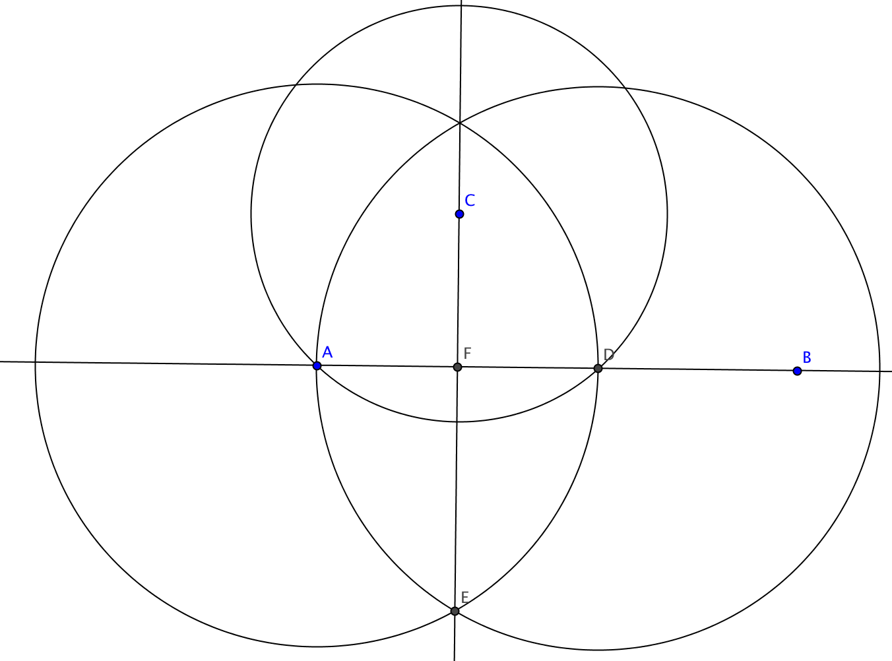
Steps in the construction:

- Construct the circle with center C passing through A.
- Label the other point where the circle intersects $\overset{⃡}{AB }$ as point D.
- Construct an equilateral triangle ∆ADF with side $\overline{AD}$.
- Draw the line through C and E.
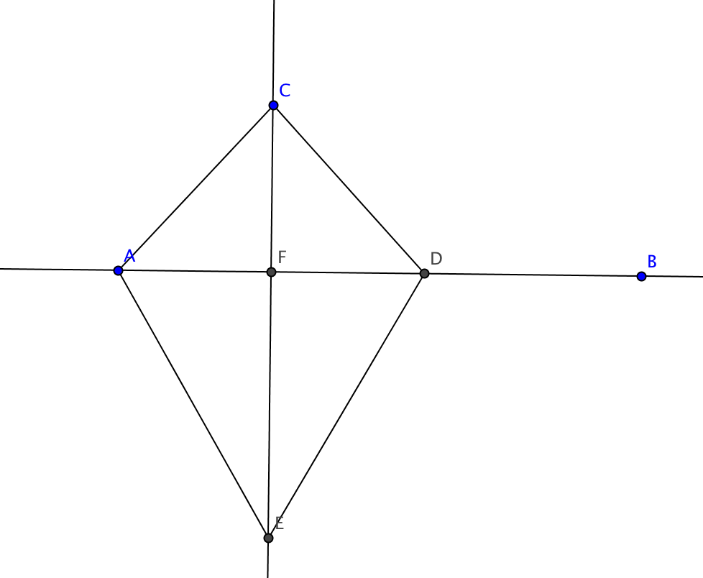
- Label point F, the intersection of $\overset{⃡}{AB }$ and $\overset{⃡}{CE}$.

Claim: $\overset{⃡}{CE}$ $⊥$ $\overset{⃡}{AB}$.

Proof

- Construct segments $\overline{AC}$, $\overline{DC}$, $\overline{AE}$, and $\overline{DE}$.
- Show that ∆CAE $≅$∆CDE. (Write out the steps)

3. Explain why $∠ACE$ $≅$ $∠DCE$.

- Show that ∆CAF $≅$∆CDF. (Write out the steps)

- $∠AFC$ $≅$ $∠DFC$ because ___________________________________________

- Explain why $\overset{⃡}{CE}$ $⊥$ $\overset{⃡}{AB}$.

