Activity 2.7.2 Construction of an Angle Bisector
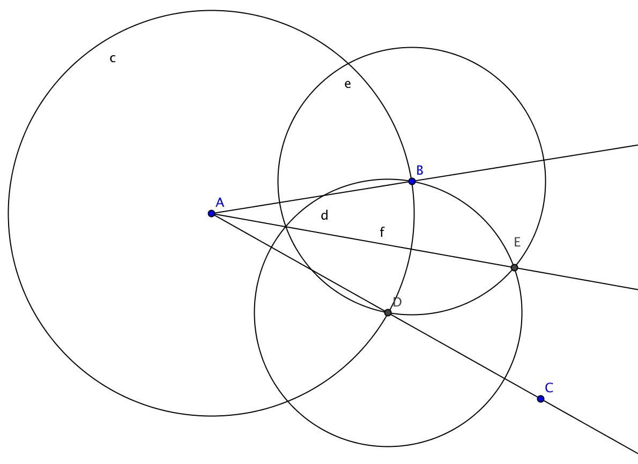
Construction

Given: $∠CAB$

To construct: the ray from A that bisects $∠CAB$

Steps in the construction:

- Construct the circle with center A passing through B.
- Label the point where the circle and ray $\overline{AC}$ intersect at point D.
- Construct the circle with center D passing through B.
- Construct the circle with center B passing through C.
- Label point E as one of the points where these last two circles intersect.

Claim: Ray $\overset{⃑}{AE}$ bisects $∠CAB$
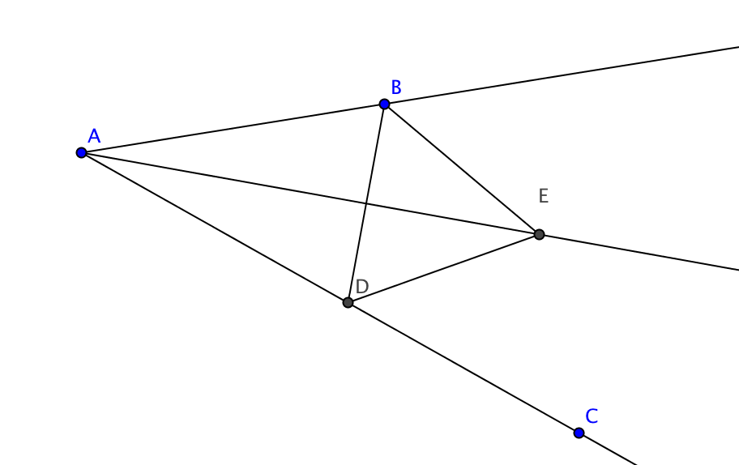
Proof

- Construct segments $\overline{BD}$, $\overline{BE}$ and $\overline{DE}$.
- As in the proof for the equilateral triangle construction, BE = DE. Explain why.

- AB = AD because ________________________________________________
- AE = AE because ________________________________________________
- Now we can show that ∆ ______ $≅$∆ ______ by the ______ Congruence Theorem.
- $∠BAE$ $≅∠DAE$ because corresponding ____________ of congruent triangles are _____________
- $By definition of bisect, Ray \overset{⃑}{AE} bisects ∠CAB$ because it divides $∠CAB$ into _________________________________.

