Activity 2.7.1 Construction of an Equilateral Triangle

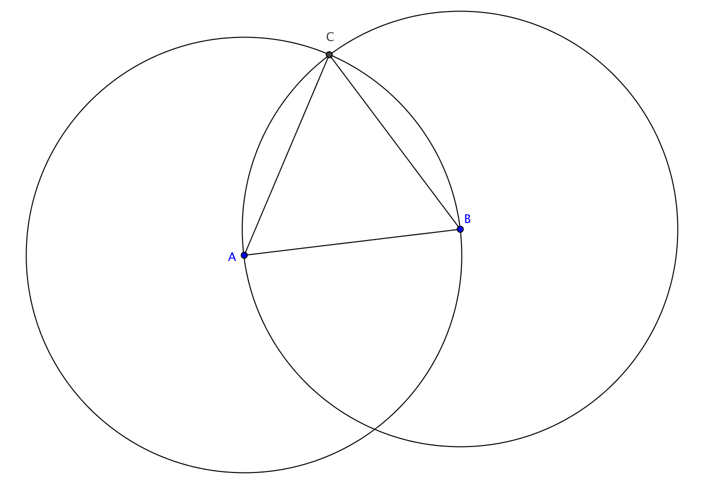
Construction

Given: Line segment $\overline{AB}$

To construct: An equilateral triangle with $\overline{AB}$ as a side.

Steps in the construction:

- Construct the circle with center A passing through B.
- Construct the circle with center B passing through A.
- Label one of the points where the two circles intersect at C.
- Construct segments $\overline{AC}$ and $\overline{BC}$.

Claim: ∆ABC is equilateral.

Proof

- AB = AC because radii of the same circle are congruent.
- AB = BC because _______________________________________________
- AC = BC because _______________________________________________
- ∆ABC because _________________________________________________

