Activity 2.6.2 Constructing an Equilateral Triangle
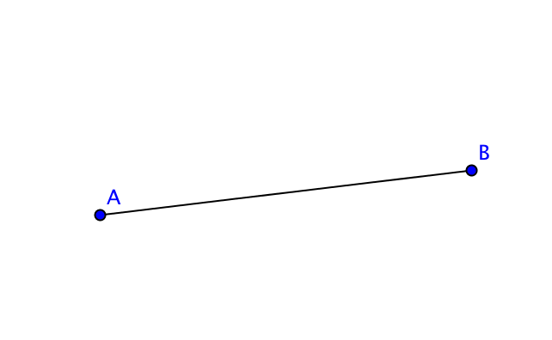
Follow these steps to construct an equilateral triangle using Geogebra.
(Start by setting Options Labeling New Points Only

- Create a segment $\overline{AB}$
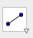
(Use the segment tool
from the Line menu)

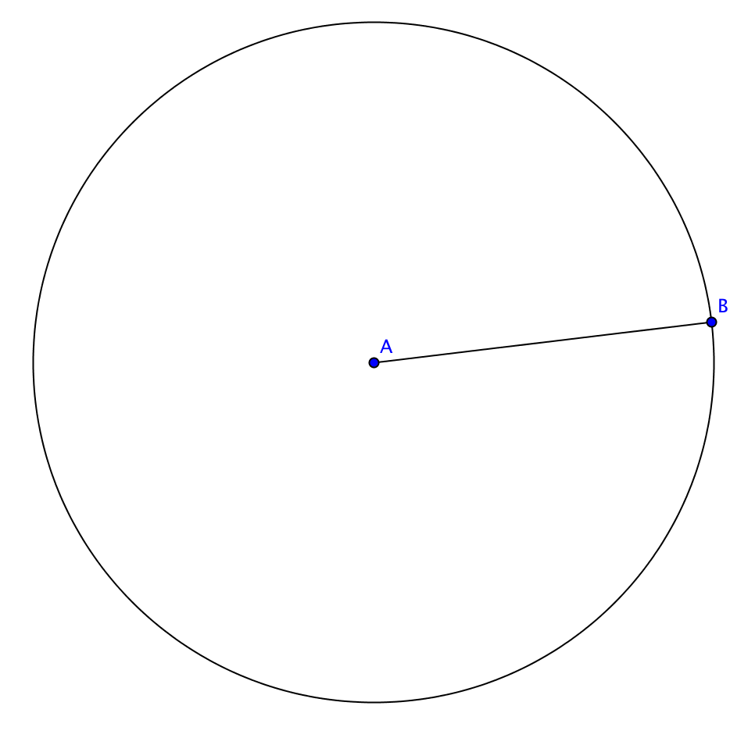

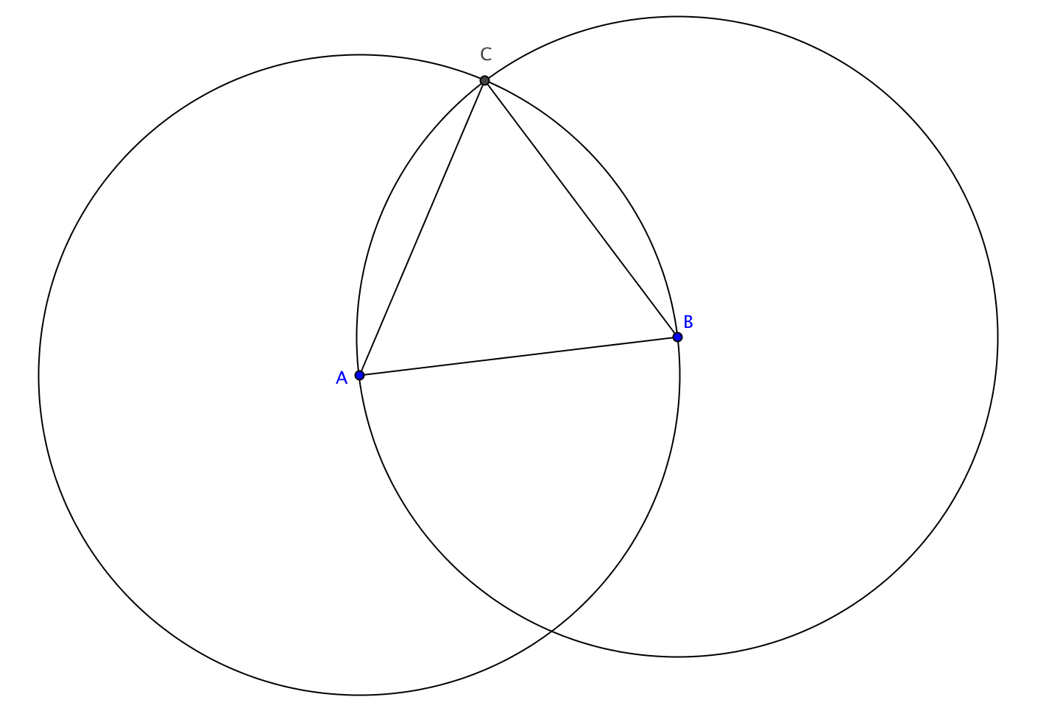
- Draw a circle with center A through point B.
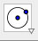
(Use the circle-center-through-point tool
from the Circle menu)
- Draw a circle with center B through point A. Label one of the points of intersection C. Then connect segments $\overline{AC}$ and $\overline{BC}$.
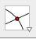
(Use the intersect tool
from the Point menu)

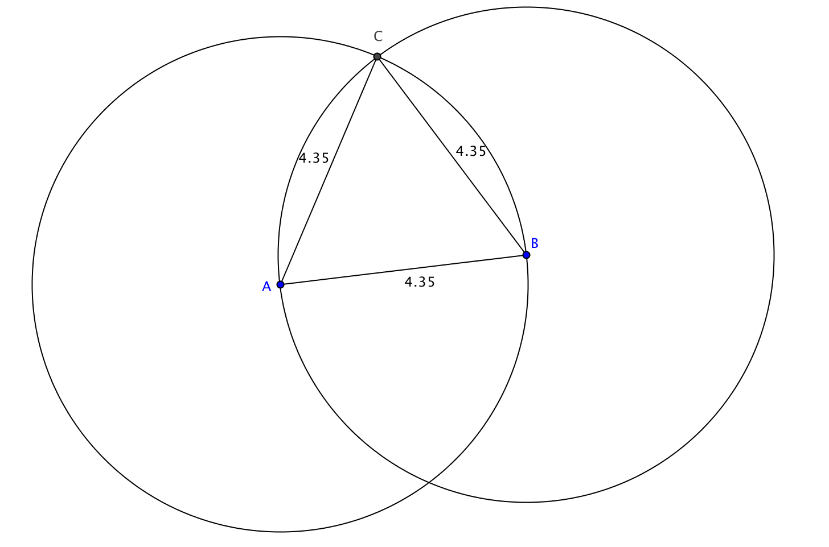
- With the arrow tool, select one side of the triangle. Click on
in the upper right corner.
Under PreferencesObjects, show Label but Value only.

Repeat for the other two sides.

You should now see the lengths of the sides on your sketch.

- Based on the measurements shown for the lengths of the sides, classify ∆ABC.

- Try moving point A or point B. Describe what happens.

- Try moving point C. Describe what happens.

- Measure each of the interior angles of ∆ABC.
a. What do you notice?
b. Why should this not be a surprise?

- Again move one of the vertices of ∆ABC. What happens to the measures of the angles?

