Activity 2.5.6 More Proofs with Parallel Lines

In the figure below, $\overset{⃡}{AH}∥\overset{⃡}{EF}$. $\overset{⃡}{DE }$is a transversal.

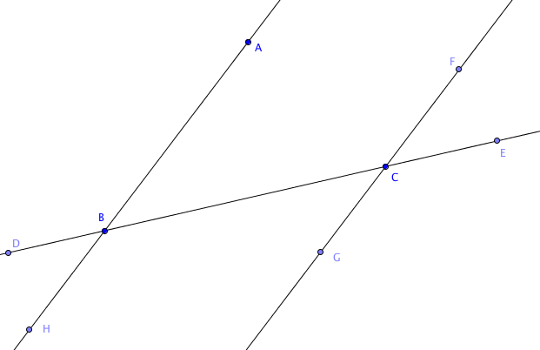

1- 6. Fill in the blanks:

- $∠CBH≅∠FCB$ because they are ____________________________________ angles.
- $∠DBH≅∠BCG$ because they are ____________________________________ angles.
- $∠FCE≅∠BCG$ because they are ____________________________________ angles.
- $∠DBA≅∠GCE$ because they are ____________________________________ angles.
- $∠HBC$ and $∠GCB$ are supplementary because they are _____________________ angles.
- $∠ABC$ and $∠BCF$ are supplementary because they are _____________________ angles.
Suppose m$∠ABC$ = 51°. Find the measures of each of these angles and explain why your answer is correct.
- m$∠BCG$ = ________. Explanation:
- m$∠FCE$ = ________. Explanation:
- m$∠BCF$ = ________. Explanation:
- m$∠GCE$ = ________. Explanation:

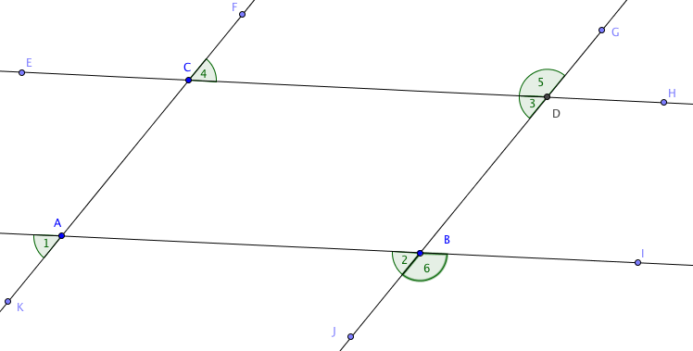

Use the figure above for the proofs on this page.
11. Given $\overset{⃡}{AB}∥\overset{⃡}{CD}$ and $\overset{⃡}{AC}∥\overset{⃡}{BD}$.
Prove that m $∠$1 = m $∠$3.
(Hint: first show that both are equal to m $∠$2)

12. Given $\overset{⃡}{AB}∥\overset{⃡}{CD}$ and $\overset{⃡}{AC}∥\overset{⃡}{BD}$.
Prove that m $∠$2 = m $∠$4.

13. Given $\overset{⃡}{AB}∥\overset{⃡}{CD}$ and $\overset{⃡}{AC}∥\overset{⃡}{BD}$.
Prove that m $∠$1 + m $∠$5 = 180°.

14. Given $\overset{⃡}{AB}∥\overset{⃡}{CD}$ and $\overset{⃡}{AC}∥\overset{⃡}{BD}$.
Prove that m $∠$4 + m $∠$6 = 180°.

