Activity 2.5.5 Proving Angle Relationships

In these proofs you may use these postulates and theorems:

Parallel Lines Corresponding Angles Theorem
(Parallel lines Corresponding Angles Congruent)
Vertical Angles Theorem
Linear Pair Postulate
Transitive property
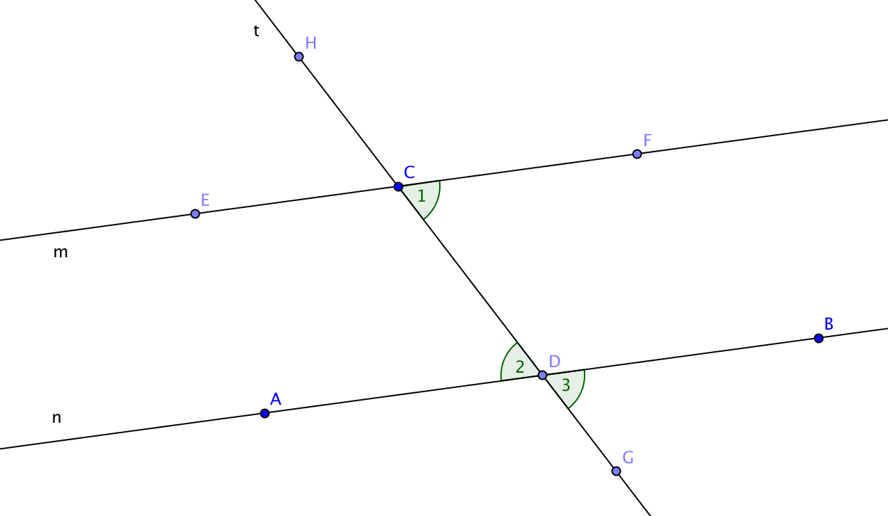
Substitution property

- In the figure at the right:

- $∠2$ and $∠3$ are a pair of _____________ angles

- $∠1$ and $∠3$ are a pair of _____________ angles

- Given: m || n
Prove: m$∠1$ = m$∠2$

d. State the results of this proof as a theorem: If two parallel lines are intersected by a transversal, then pairs of ________________________ angles are _________________.

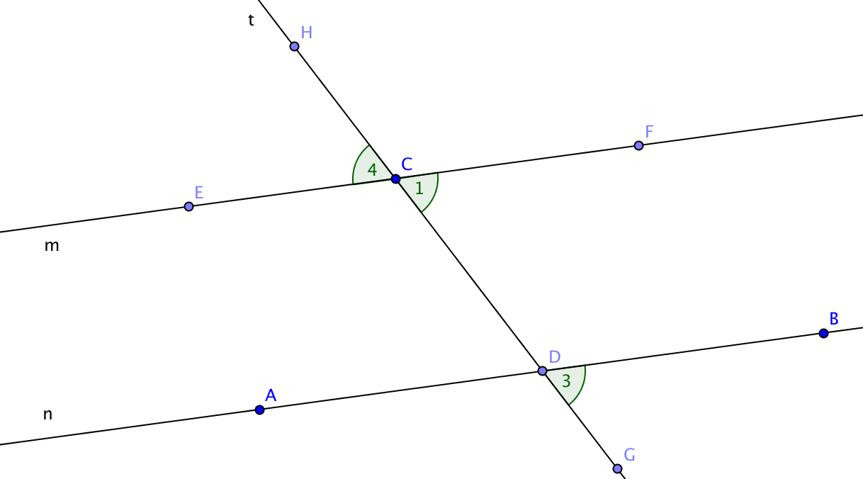
- In the figure at the right:

- $∠1$ and $∠4$ are a pair of ___________ angles

- $∠1$ and $∠3$ are a pair of ___________ angles

- Given: m || n
Prove: m$∠3$ = m$∠4$

d. State the results of this proof as a theorem: If two parallel lines are intersected by a transversal, then pairs of ________________________ angles are _________________.
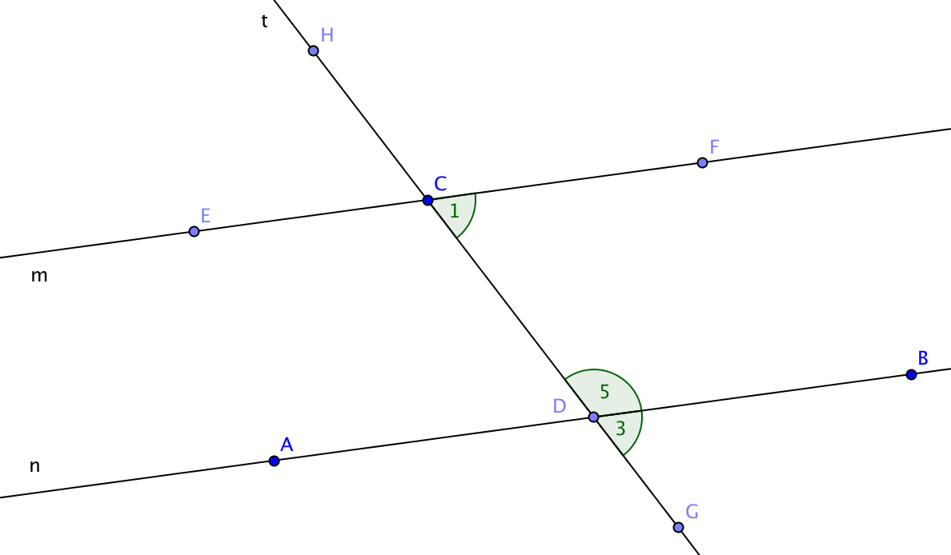
3. In the figure at the right
a. $∠5$ and $∠3$ are a ___________ pair of angles.
b. $∠1$ and $∠3$ are a pair of __________ angles.

c. Given: m || n
Prove: m$∠1$ + m$∠5$ = 180°

- State the results of this proof as a theorem: If two parallel lines are intersected by a transversal, then pairs of ________________________ angles are _________________.

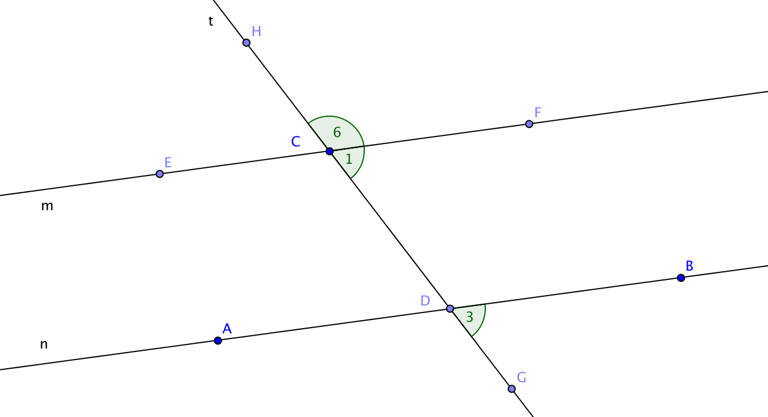
4. In the figure at the right
a. $∠6$ and $∠1$ are a ___________ pair of angles.
b. $∠1$ and $∠3$ are a pair of __________ angles.

c. Given: m || n
Prove: m$∠6$ + m$∠3$ = 180°

d. State the results of this proof as a theorem: If two parallel lines are intersected by a transversal, then pairs of ________________________ angles are _________________.

