Activity 2.5.2 – Areas of Equilateral Triangles

What is the relationship between the length of a side and area of an equilateral triangle? We will investigate this question by collecting data on many equilateral triangles using Geogebra. To form equilateral triangles, we will use a construction that involves the radii and intersection point of two circles.

Geogebra Instructions:

- Open up a blank document in Geogebra. Make sure that the Algebra and Graphics windows appear.
- Click on Circle with Center through Point tool. Insert a circle (Center is at Point A; Point B is on circle).
- Insert a second circle centered at Point B that has Point A on the circle.
- Click on the Point tool. Insert a point at one of the points where the two circles intersect (Point C).
- Click on the Polygon tool. Create a triangle by clicking on Point A, Point B, Point C, and Point A again.
- Click on the Angle tool to see the submenu. When the submenu appears, click on Area. Then click on a point in the triangle; this will cause the Area label to appear.
- Click on the Move tool. Your image should look similar to the image below.

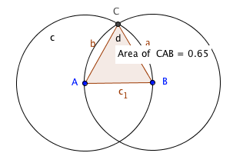

When you move Point A (or Point B) the sizes of the circles and triangle change. This allows you to record the area of the equilateral triangle for various side lengths. The lengths of the sides of the equilateral triangles are shown in the Algebra window. The area of the equilateral triangle is shown in the Graphics window.

- Choose five side lengths that vary between 2 and 8. Find the corresponding areas and enter the ordered pairs in the table below.

x (side length)
y (area)
- What type of relationship exists between side length and area?

- Using the points in the table, develop a quadratic regression function for area of the triangle in terms of side length.

- Given an equilateral triangle with side length x, algebraically create an equation for the area of the triangle y. Draw a diagram to represent the equilateral triangle.

- Plot the equations from Questions 3 and 4 on the same coordinate plane. How do the graphs compare?

