Activity 2.4.3 The SSS Congruence Theorem

Experiment

Use sticks or straws of different lengths to create a triangle. Or you may use paper strips with holes and fasteners.) Have your partner use sticks or straws of the same lengths you used to create another triangle. Compare the two triangles you have created.

Based on your observation, write a conjecture. Fill in the blanks:

1. If three sides of one triangle are congruent to three sides of another triangle, then _________
_______________________________________________________.

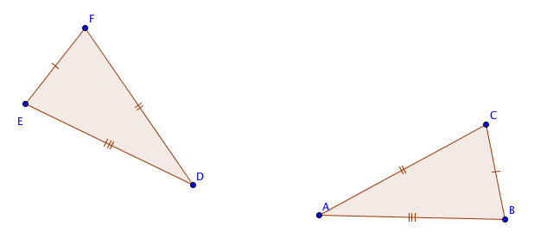
Proving the SSS Conjecture

Given ∆ABC and ∆DEF with
AB = DE
BC = EF and
CA = FD

Prove: ∆ABC $≅$ ∆DEF

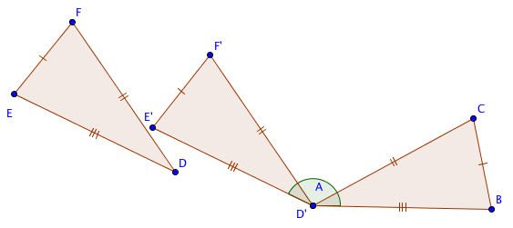
2. Translate ∆DEF by the vector from D to ___

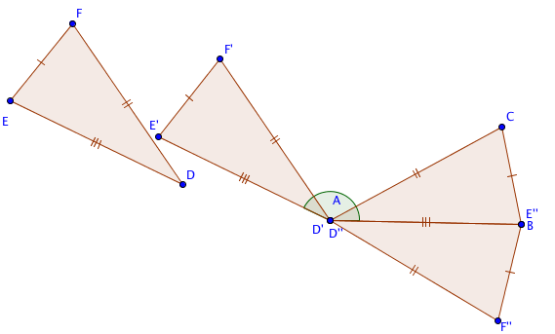
Rotate ∆D’E’F’ about point D so that ray $\vec{DE’}$’ coincides with ray $\overset{⃑}{AB}$.
3. Explain why E’’ will coincide with B.

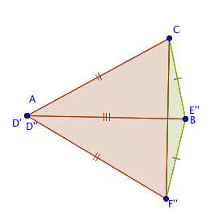
4. What kind of figure is quadrilateral AF’‘E’‘C?

Draw segment $\overline{CF’‘}$
5. Explain why ∆CBF’’ is an isosceles triangle.

6. Therefore m $∠$F’‘CE’‘ = m $∠$________
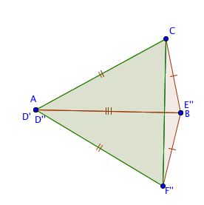
7. Explain why ∆CAF’’ is an isosceles triangle.

8. Therefore m $∠$F’‘CA = m $∠$________

9. m $∠$ACE’’ = m $∠_________$ + m $∠$________

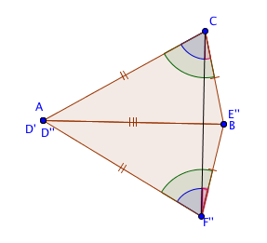
10. m $∠$AF’’E’’= m $∠_________$ + m $∠$________

11. Explain why m $∠$ACE’’ = m $∠$AF’’E’’.

12. Which theorem may now be used to prove that ∆ABC $≅$ ∆D’’E’’F’’?

