Activity 2.4.1 Bungie Jumping: Is It Safe?

Six Flags is going to introduce a new attraction to the park: bungee jumping. They know that the height of the jumper t seconds after jumping from a height of c feet is given by the equation h(t) = 15t² – 90t + c. How high does the platform from which the jumpers drop have to be to ensure their safety?  1. In order for the jumpers to be safe, they should get as close to the ground as possible without hitting it. What does that mean in the context of the problem? | 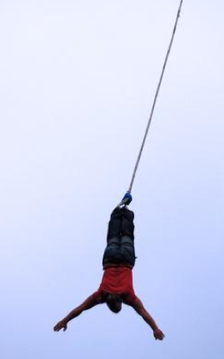

2. Investigate what value of c would keep the jumpers safe by initiating the TRANSFORM application on your graphing calculator. Enter the equation Y1=15x² – 90x + C into the equation editor. Begin with a WINDOW that has an x-min of 0 and a x-max of 6, and then set the y-min and y-max to be –10 and 100 respectively. Then vary the value of C until you find a value that would keep the jumper safe but also give them a thrilling ride. Use the table below to enter the values of C that you chose and the results for the safety of the jumper.

Value of C | Safety of the Jumper | Thrill of the Ride
a.
b.
c.
d.
e.

3. What value of C seemed to work the best for keeping the safety of the jumper while making the ride the most thrilling?

4. What feature of the graph of the height function will ensure the safety of the jumpers?

5. Find the value of C algebraically that will guarantee the safety of the jumper, but still give the jumper the biggest thrill from the jump?

6. How long would the bungie jumper be falling before he/she reached the lowest point on the jump and began to come back up?

7. If the equation were presented in the general form h(t) = at² + bt + c, what calculation, in general, can you make that would assure that the jumper doesn’t hit the ground?

