Activity 2.3.4b Proving the Isosceles Triangle Converse
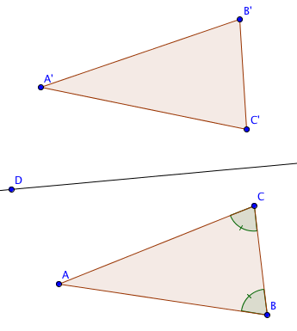
Fill in the blanks in this proof.
Given ∆ABC with m$∠$ABC= m$∠$ACB

Prove AB = AC

Step 1. Draw any line $\overset{⃡}{DE}$ in the plane of the triangle and reflect ∆ABC over $\overset{⃡}{DE}$.

Step 2a. In ∆ABC and ∆A’C’B’
m$∠$ABC= m$∠$ACB Why? _______________
m$∠$ABC= m$∠$A’B’C’ Why? _________________
Therefore m$∠$ACB= m$∠$A’B’C’ Why? _________________
Step 2b. In ∆ABC and ∆A’C’B’
m$∠$ACB= m$∠$ABC Why? _________________
m$∠$ACB= m$∠$A’C’B’ Why? _________________
Therefore m$∠$ABC= m$∠$A’C’B’ Why? _________________
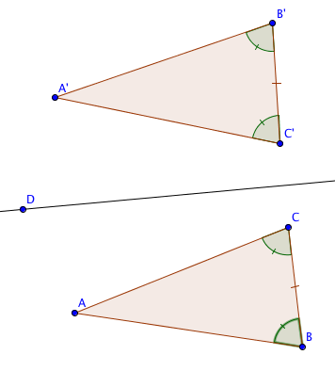
Step 2c. BC = B’C’ Why? _________________

Step 3. From steps 2a, 2b, and 2c we can prove that ∆ABC and ∆A’C’B’ are congruent, by the _______ Congruence Theorem.

Step 4. AB = A’C’ since corresponding parts of congruent triangles are _______________.

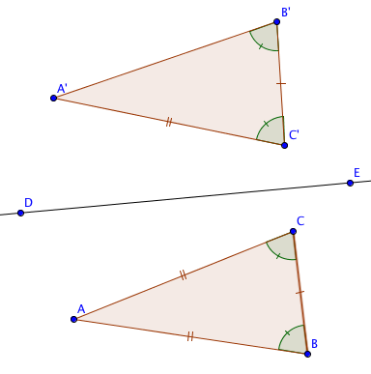
Step 5. AC = A’C’. Why? _____________________

Step 6. Therefore AB = AC. Why? _____________________

