Activity 2.3.3b Proving the Isosceles Triangle Theorem

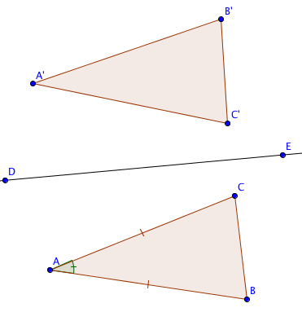
Fill in the blanks in this proof.
Given ∆ABC with AB = BC

Prove m$∠$ABC= m$∠$ACB

Step 1. Draw any line DE in the plane of the triangle and reflect ∆ABC over DE.

Step 2a. In ∆ABC and ∆A’C’B’

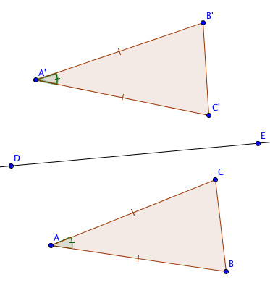
AB = AC Why? _________________
AB = A’B’ Why? _________________
Therefore AC = A’B’ Why? _________________
Step 2b. In ∆ABC and ∆A’C’B’

AC = AB Why? _________________
AC = A’C’ Why? _________________
Therefore AB = A’C’ Why? _________________
Step 2c. m$∠$BAC= m$∠$CAB’ Why? _________________

Step 3. From Steps 2a, 2b, and 2c, we can prove that ∆ABC and ∆A’C’B’ are congruent, by the _______ Congruence Theorem.

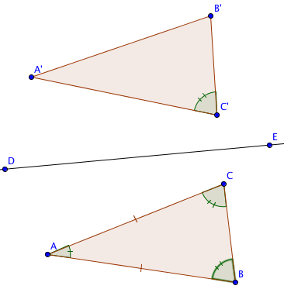
Step 4. m$∠$ABC = m$∠$A’C’B’ since corresponding parts of congruent triangles are _______________.

Step 5. m$∠$A’CB’ = m$∠$ACB since reflections preserve _____________measure.

Step 6. m$∠$ABC = m$∠$ACB by the ___________ property of equality.

