Activity 2.2.6 Which Triangles can be Proved Congruent?

Warmup I: Which of the following acronyms correspond to theorems we have shown can be used to prove that triangles are congruent.
Circle the valid theorems and write out their names in full words.

ASA SAA SSA SAS AAA SSS

Warmup II: Three triangles are shown. Select two triangles that can be proved congruent and state the theorem that could be used to prove congruence.
1. | Triangle 1 | Triangle 2 | Triangle 3 | Congruent Triangles
 | 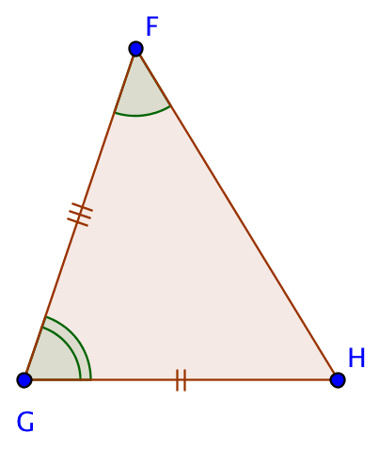 | 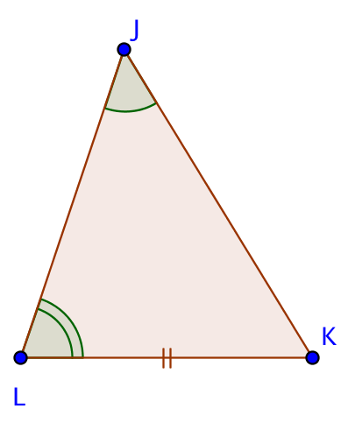 | 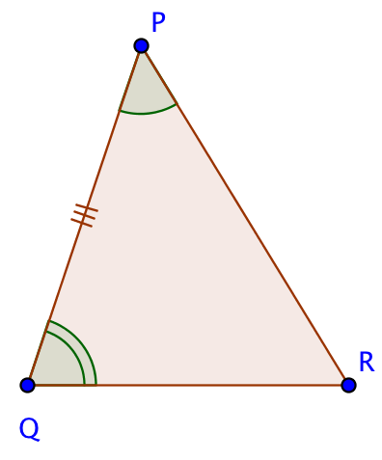
 |  |  |  | Theorem
2. | Triangle 1 | Triangle 2 | Triangle 3 | Congruent Triangles
 | 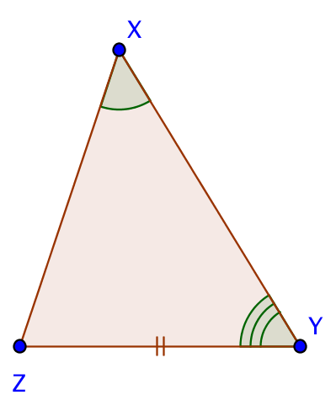 | 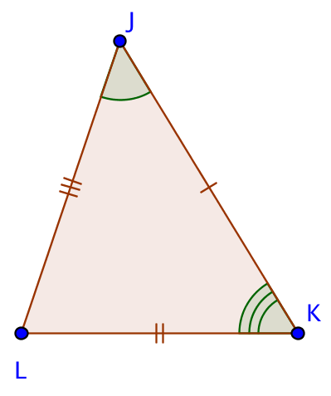 | 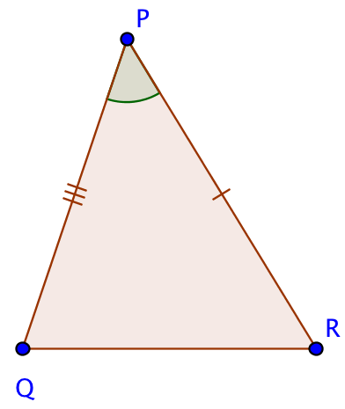
 |  |  |  | Theorem
3. | 3 Triangles are shown in the image below. |  |  | Congruent Triangles
 | 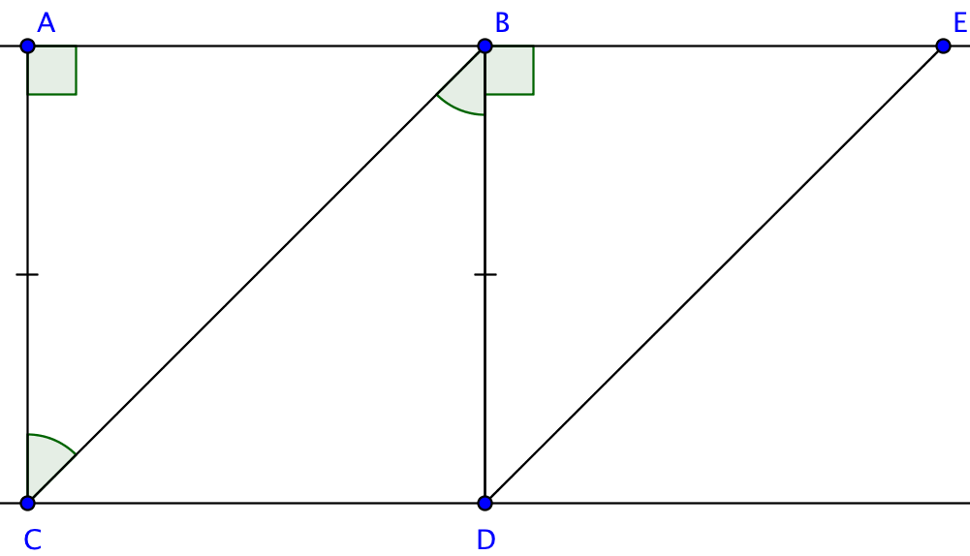
 |  |  |  | Theorem

Which triangles can be proved congruent?
Five triangles are shown, the first of which has all measurements shown. Select the other triangles that can be proved congruent to the first and state the theorem that could be used.

4. | 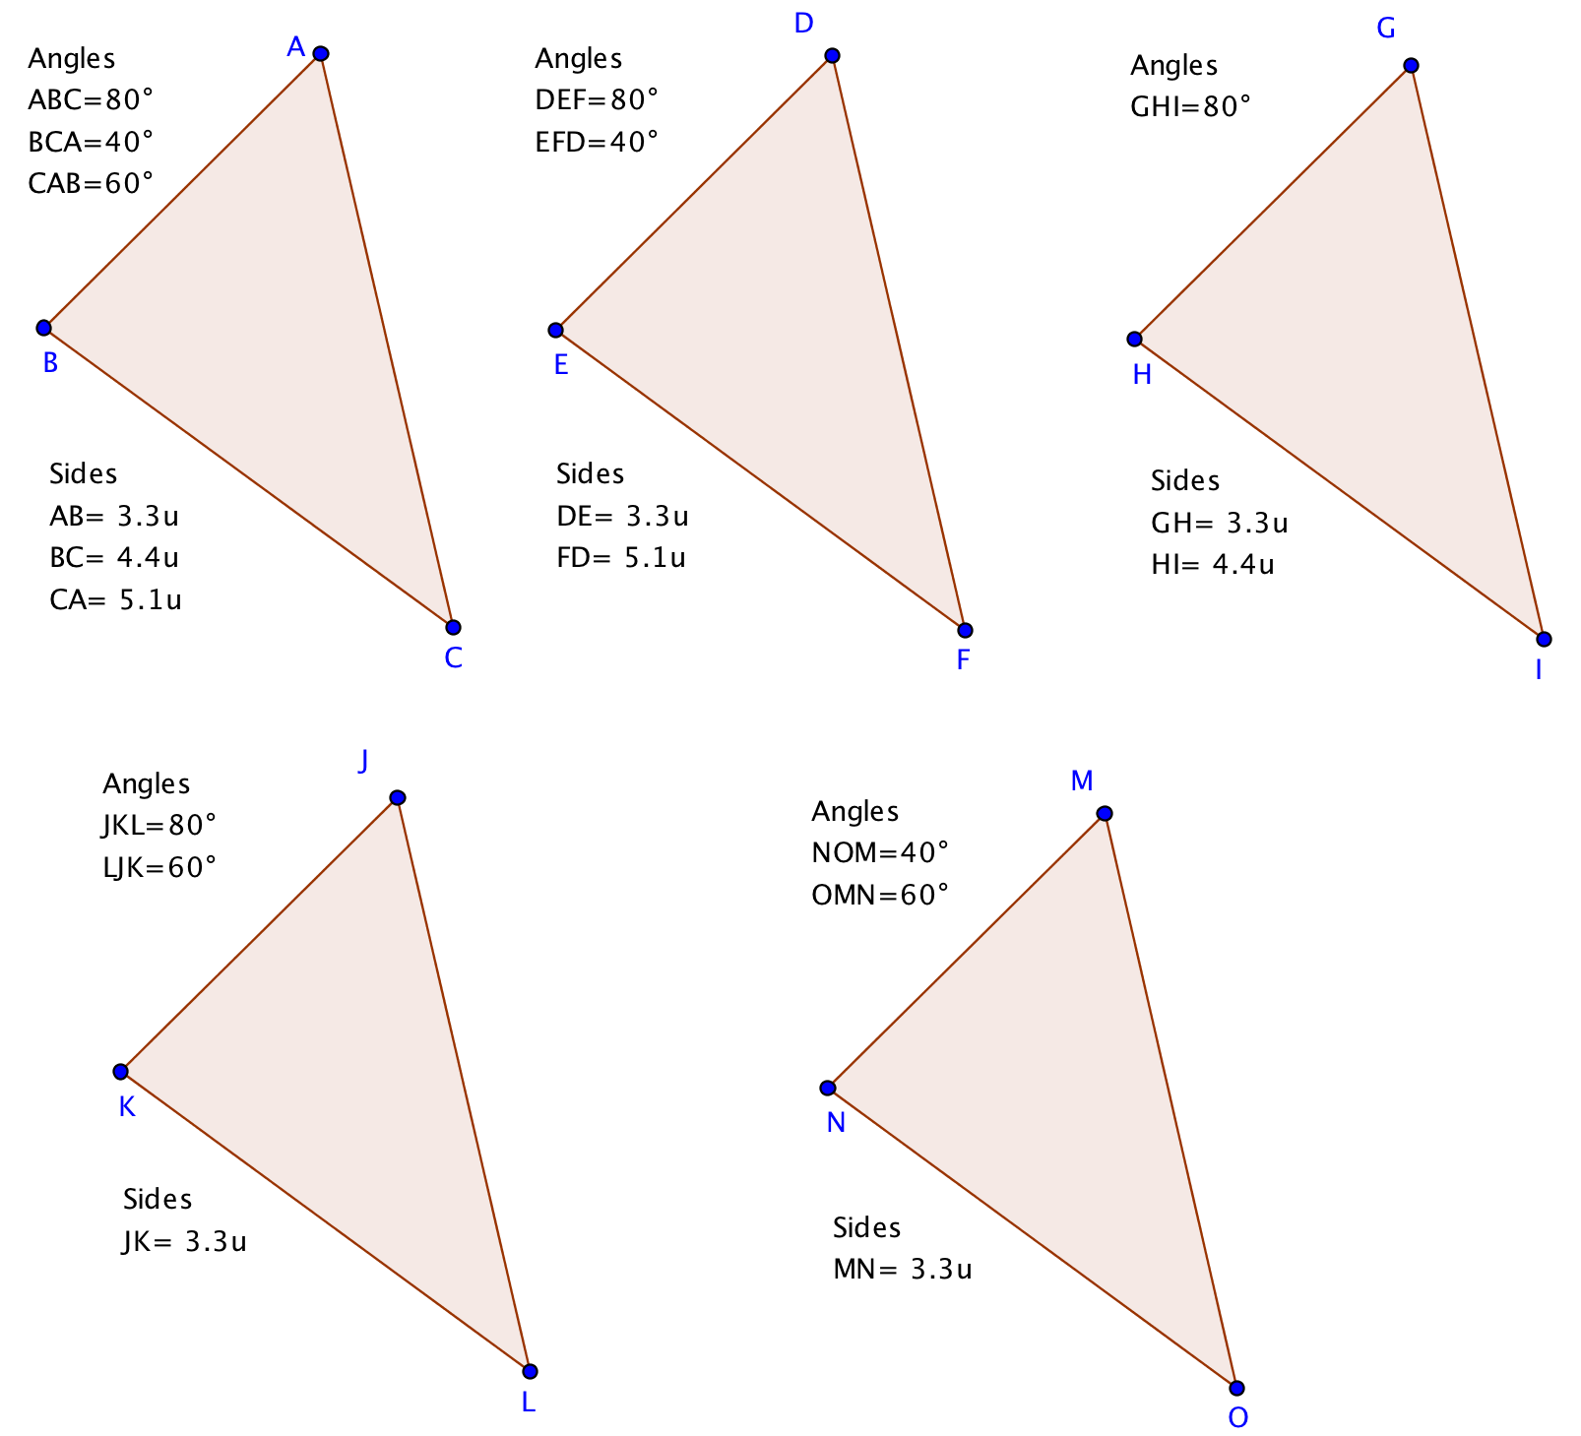
 | Congruent Triangles and Theorem:
5. | 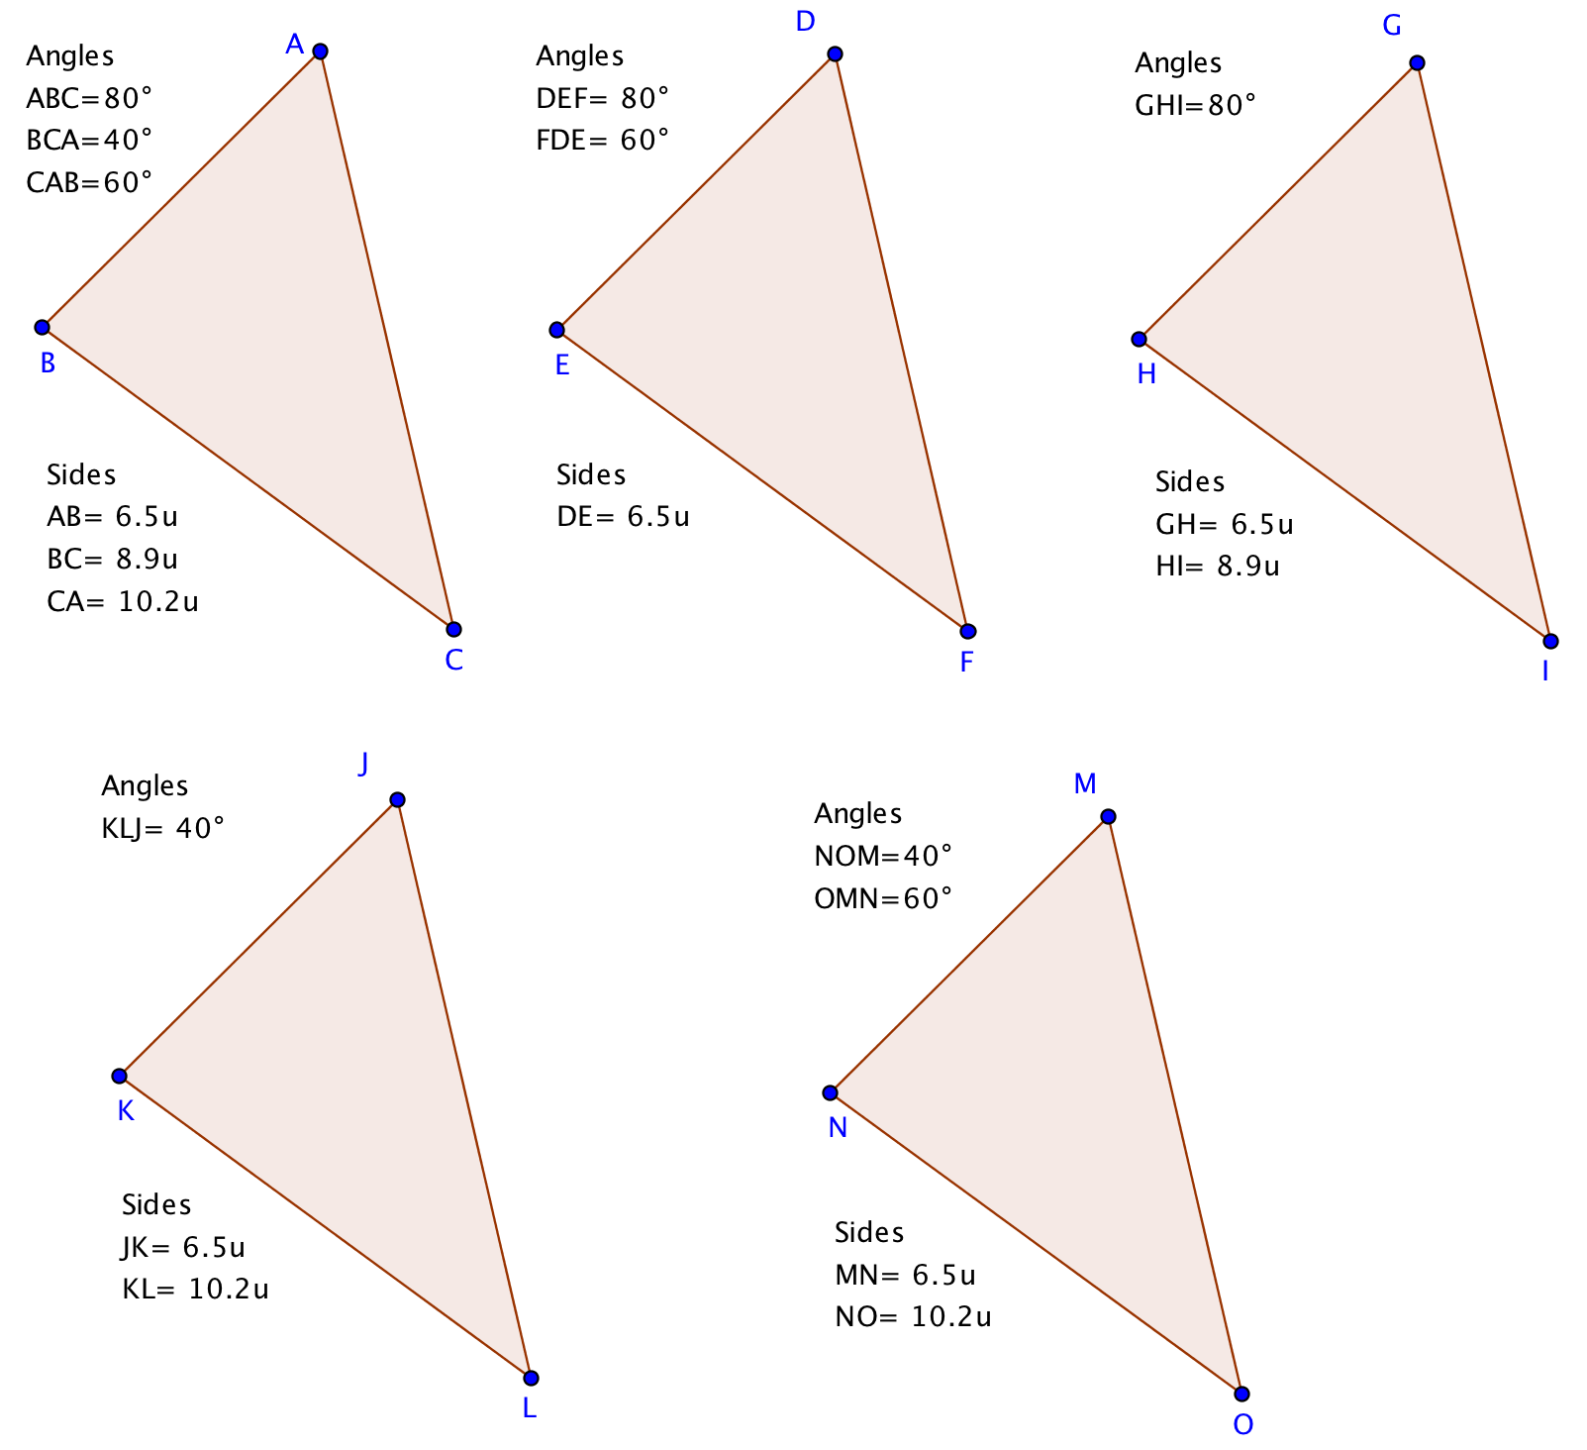
 | Congruent Triangles and Theorem:
6. | 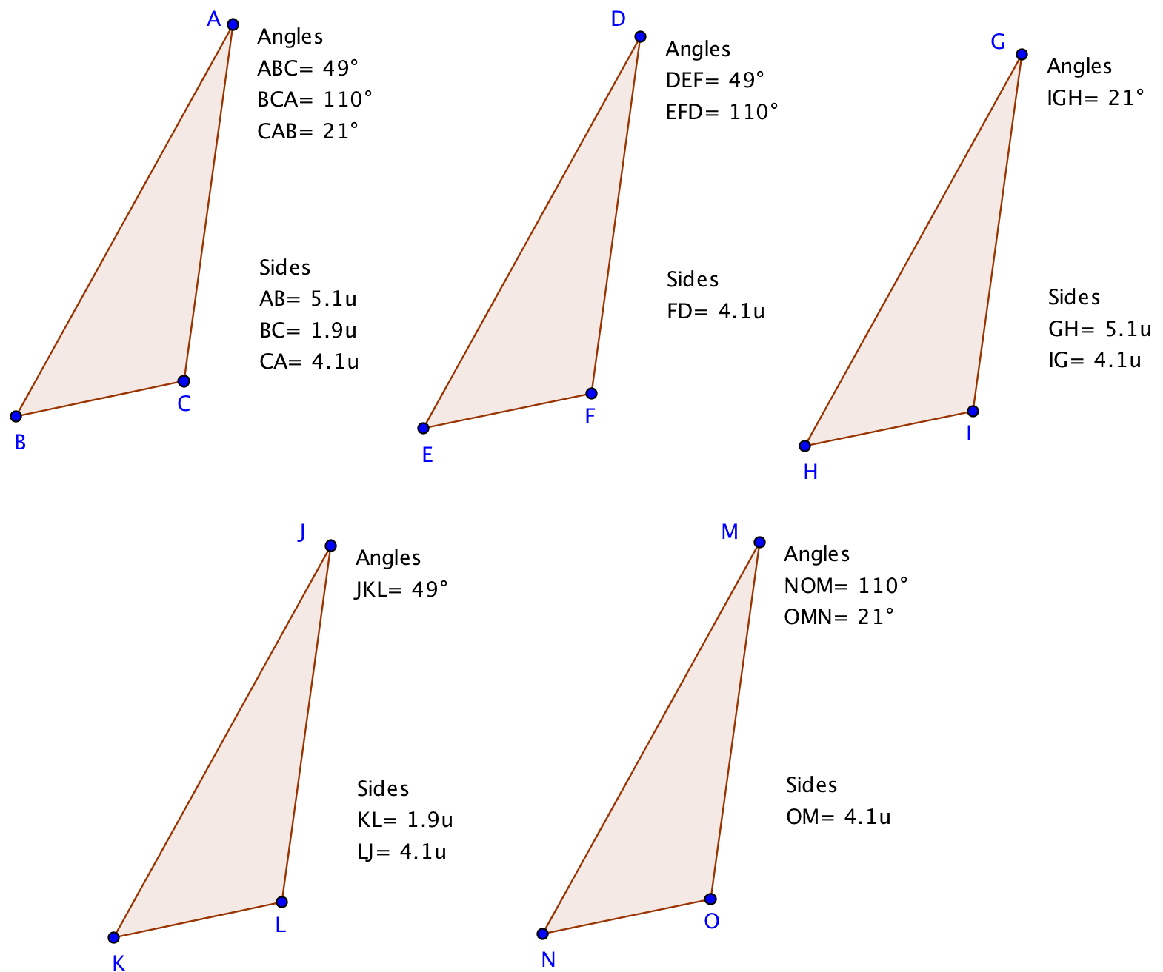
 | Congruent Triangles and Theorem:
7. | 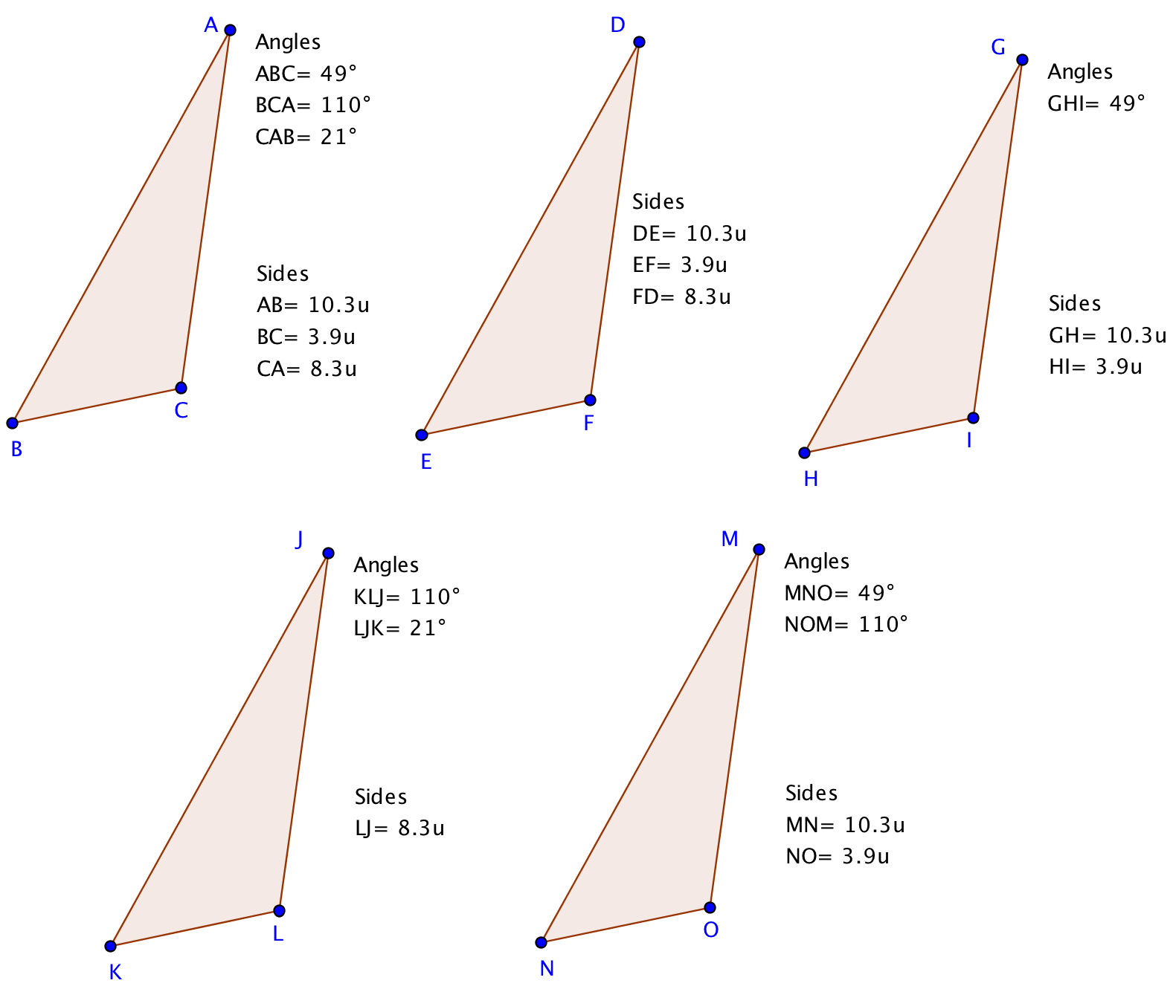
 | Congruent Triangles and Theorem:

