Activity 2.2.5 Posing Problems with Congruent Triangles
For this activity, you will be working in groups of 4. For groups of 3, one person should complete both steps 1 and 2. You will be working together, passing your papers after each step. At the end of the activity, each student in your group will have completed a step on each student's paper. You will be presenting one proof to the class at the end of the activity.

Activity Directions
First: Select either the ASA Congruence Theorem or the SAS Congruence Theorem.
Pass your paper to the next student in your group.

Second: Draw two triangles. The triangles should look the same.
Pick a pair on angles on the triangles and mark them congruent.
Pick a pair of sides on the triangles and mark them congruent.
Pick one more pair of either angles or sides to mark congruent, based on the theorem selected in step 1. You may mark more than is needed for the theorem, but not less.
Pass the paper to the next student in your group.

Third: Write a proof showing that the triangles drawn in step 2 are congruent.
Your proof should use the theorem selected in step 1
Your proof should start with the information given in step 2.
Pass the paper to the next student in your group.

Four: Check the proof.
Does the proof use the theorem selected in step 1?
Was the information given in step 2 sufficient for the theorem used?
Did the proof correctly use the information given in step 3?
Pass the paper to the next student in your group.

Final: Everyone should have their original paper back now.
Review the proofs created in your group.
You should have 1 completed proof for each person in your group.
Does everyone agree that the proofs are correct?
Could any of the proofs be completed using the other congruence theorem?
Choose 1 of the proofs to present to the rest of the class.

Examples of work, both correct and incorrect, are shown on the reverse side of this handout.

Example 1 - Correctly completed
Step 1: Theorem | ASA Congruence Theorem
Step 2: Triangles | 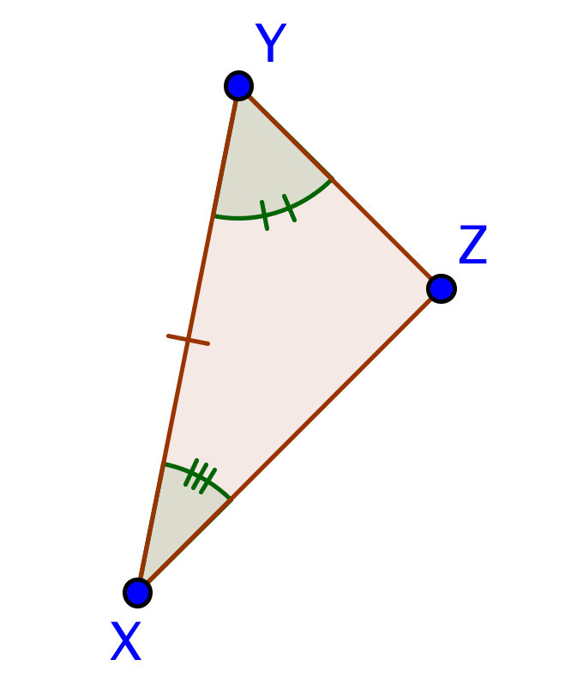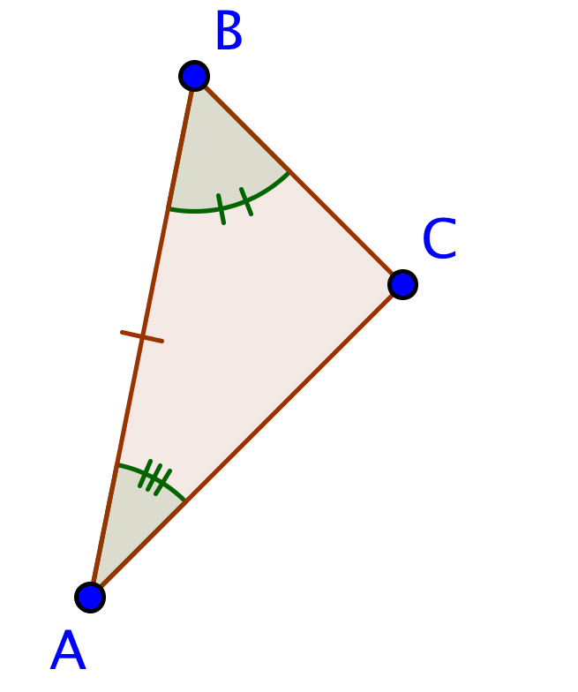
Step 3: Proof | $\overline{XY}≅\overline{AB}$ Given  $∡XYZ≅∡ABC$ Given  $∡YXZ≅∡BAC$ Given  $△ABC≅△XYZ$ ASA
Step 4: Check | Proof is correct and does use two angles and the included side.

Example 2 - Incorrect theorem
Step 1: Theorem | SAA Congruence Theorem | SAA is not one of the theorems we have proved.
Step 2: Triangles
Step 3: Proof
Step 4: Check

Example 3 - Incorrect triangles
Step 1: Theorem | ASA Congruence Theorem
Step 2: Triangles | 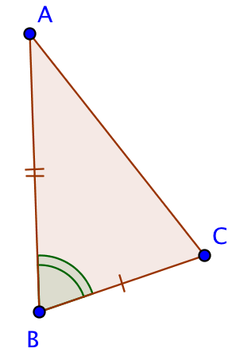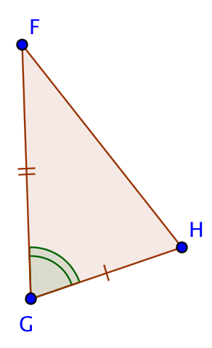 | The triangles do not have the information required to use the ASA Congruence theorem
Step 3: Proof
Step 4: Check

Example 4 - Incorrect Proof
Step 1: Theorem | SAS Congruence Theorem
Step 2: Triangles | 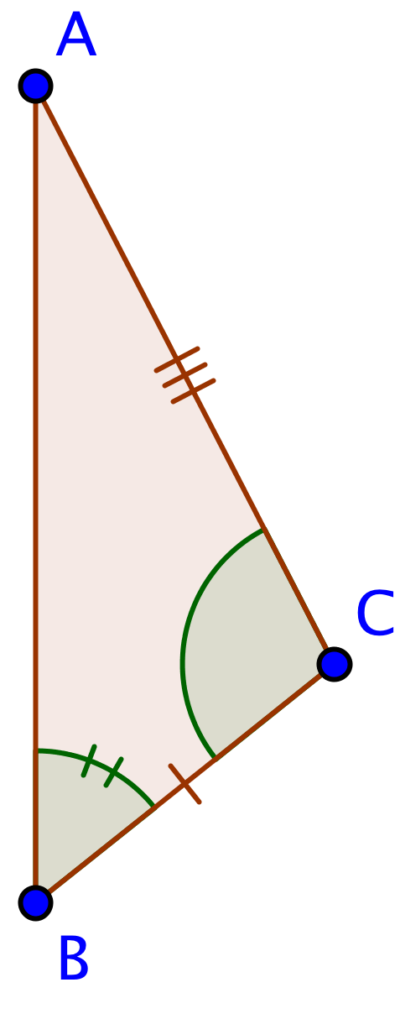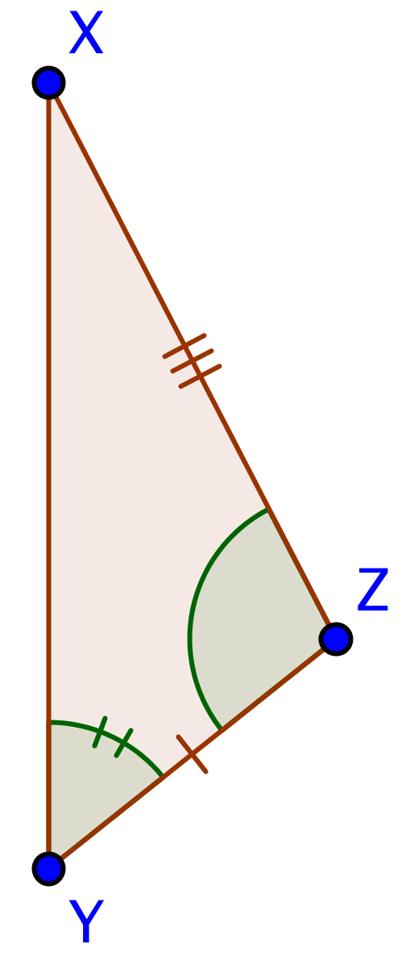
Step 3: Proof | $\overline{BC}≅\overline{YZ}$ Given  $∡ABC≅∡XYZ$ Given  $∡BCA≅∡YZX$ Given  $△ABC≅△XYZ$ ASA | This proof uses the ASA congruence theorem, not the SAS congruence theorem.
Step 4: Check

