**Activity 2.2.3 ASA Congruence**

In this activity you will discover and prove our second theorem about congruent triangles.



1. Included sides. For each pair of angles in ∆XYZ, name the included side.

Angles: $∠$*XYZ* and $∠$*YZX* Included Side: $___________$

Angles: $∠$*XYZ* and $∠$*ZXY* Included Side: $___________$

Angles: $∠$*ZXY* and $∠$*YZX* Included Side:

2. Experiment. Work with one other student. You will each draw two triangles using a ruler and protractor.

a. Agree upon the measure of two angles of the triangle and the included side.

Our two angles measure ______________ and ______________.

Our included side measures _______________.

b. Now draw your triangles. Cut one triangle out and place it on the other. What do you notice?

c. Formulate a conjecture: If two angles and the included side of one triangle are congruent to two angles and the included side of another triangle then ____________________________________________.

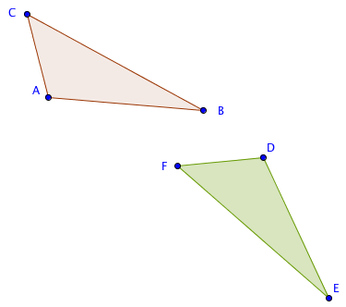

3. Proving the ASA Congruence Theorem. Study this proof and fill in the blanks.

Given ∆*ABC* and ∆*DEF* with

m $∠$*BAC* = m $∠$*EDF*,

$m∠$*ABC* = m $∠$*DEF*, and

*AB* = *DE*

Prove ∆*ABC $≅$*∆*DEF*.

*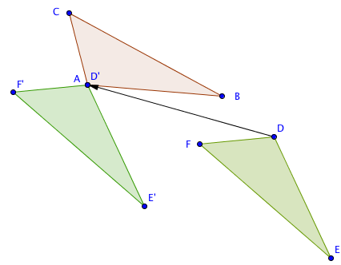Step 1*. If *A* and *D* do not coincide then translate ∆*DEF* by the vector from *D* to *A*.

Now *D’* is the same point as _______.

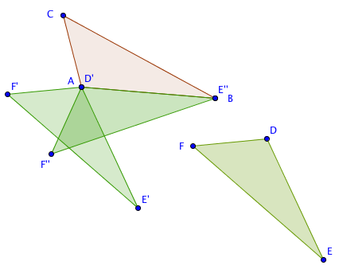

*Step 2*. If $\overline{AB}$ and $\overline{D'E'}$ do not coincide then rotate ∆ $D’E’F’$ about point *A* through $∠$*E’AB.*

*Step 3. $\overline{D’’E’’}$* will now coincide with $\overline{AB}$ since we were given that *AB* = _______.

*Step 4.* If *F’’* is on the opposite side of $\overset{⃡}{AB}$ from *C*, reflect ∆*D’’E’’F’’* over $\overset{⃡}{AB}$.

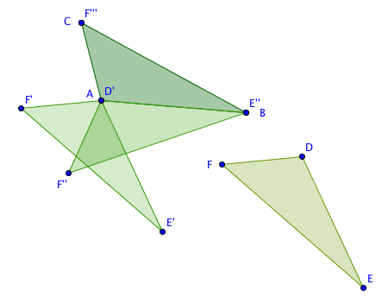

*D’’* is the same as which point? _____

*Step 5*. $∠$*E’’’D’’’F’’’* will now coincide with $∠$*BAC* since we were given m $∠$*BAC* = m $∠$______, and $∠$*D’’’E’’’F’’’* will now coincide with $∠$*ABC* since we were given m*ABC* = m______.

6. Therefore ray $\vec{D’’’F’’’}$ coincides with ray $\vec{AC}$ and ray $\vec{E’’’F’’’}$ coincides with ray $\vec{BC}$. These two rays intersect at point *C*. Is it possible for them to intersect at another point? Explain. ________________________________________________________________

If we agree that two lines can only intersect at one point, we can conclude that point *F’’’* coincides with point *C.*

*Step 7*. Since ∆*ABC* is the image of ∆*DEF* under an isometry, ∆*ABC*∆*DEF*.

4. Now state the theorem you have just proved. We will call this the ASA Congruence Theorem.

If ___________________________________________________________________________,

then ________________________________________________________________.

5. What properties of transformations were used in the proof?

6. How was this proof similar to the proof of the SAS Congruence Theorem? How was it different?