Activity 2.2.1:What’s the Product of Two Linear Functions?

This activity will examine what function we obtain when we multiply two linear functions together. To do this, we will create two linear functions in GeoGebra and examine what the resulting product of the two lines is.

Start the activity by opening the GeoGebra file called Linear Products. The graph shows two lines, one red and one blue. The red line has the equation y = m1•x + b1, where the values of m1 and b1 are determined by the corresponding sliders. The blue line has the equation y = m2•x + b2, where the values of m2 and b2 are determined by the corresponding sliders. The product of the two lines graphed is calculated as the function P(x), but the graph is not shown. The point A(input, f(input)•g(input)) is the point whose x-coordinate is determined by the value on the input slider and whose y-coordinate is the product of the y-coordinates on the two lines. (See the image below.)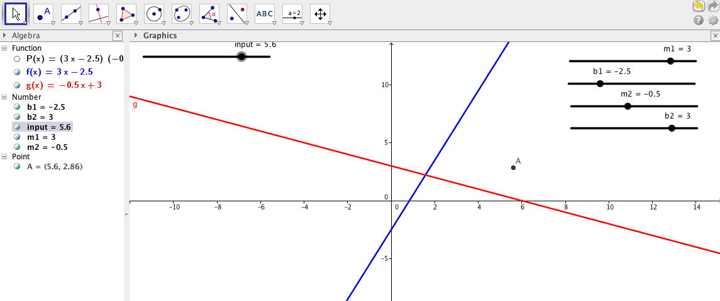
Answer the following questions based on the graphs of the two lines.
1. Highlight the key in order to move the points on the sliders. Move the sliders for m and b of the two lines so that the lines are parallel.

2. Without moving the “input” slider, estimate what path the point P would follow as you change its x-coordinate.

3. Now move the “input” slider to see if the path that point P followed is close to what you predicted.

4. Move the lines so that the lines are now intersecting, each with a positive slope, and estimate what path point P will follow now.

5. Move the “input” slider to see if the path of point P follows the path you predicted.

6. Now move the sliders so that one line has a negative slope and the other line has a positive slope and predict again the path of point P when you move the input slider. Were you able to better predict the path?

7. Vary the values of m1, b1, m2, and b2 and follow the corresponding paths of point P. Based on your observations, answer the following questions.
a. When does the path of the point cross the x-axis?

b. When does the path of the point turn upwards?

c. When does the path of the point turn downwards?

d. Make a conjecture about what is the graph of the function P(x) = f(x)•g(x). Explain your answer.

8. Double click (or right click) on the point P and choose object properties. Check the box marked Trace. You can now see the path that point P follows as you move the “input” slider. What curve does the path follow? Explain why this makes sense.

Now click on the P(x) icon in the algebra menu to the left. This will produce the graph of the function P(x). Answer the following questions.
9. What is the connection between the x-intercepts of the linear functions f(x) and g(x) and the product function P(x)?

10. How can you create a graph of P(x) that is tangent to the x-axis?

11. How can you create a graph of P(x) that turns upward? Downward?

12. Describe what happens to the graph as the values of m1 and m2 become less than 1? Greater than 1?

13. Predict what the graph of P(x) will be if f(x) = 2x + 3 and g(x) = -x + 1. Explain your answer.

