Activity 2.1.5 Using Congruence to Find Unknown Parts
Group Activity:
Name the members of your group:
Group member 1: _______________________
Group member 2: _______________________
Group member 3: _______________________
Given that ∆MAP is congruent to ∆FUR and to ∆HOT
Share information with others in your group to find the measures of all three angles and sides in your triangle.
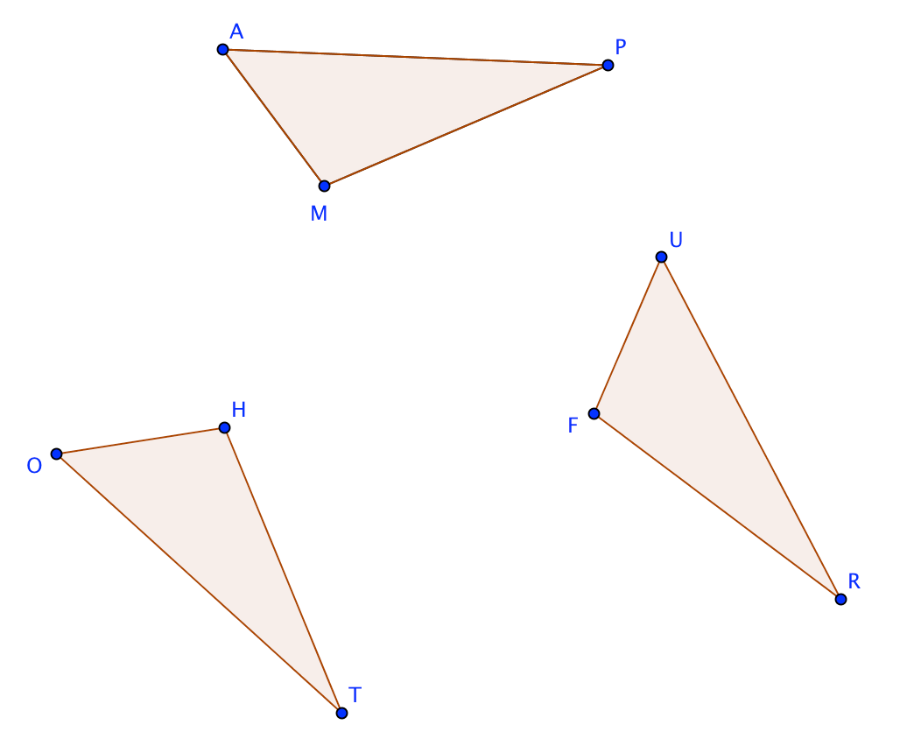

Group member 1: In ∆MAP, MA = 2 and m $∠$ M = 104°
Group member 2: In ∆FUR, FR = 3.7 and m $∠$ U = 51°
Group member 3: In ∆HOT, OT = 4.6 and m $∠$ T = 25°

