Activity 1.7.2a Understanding Isometries
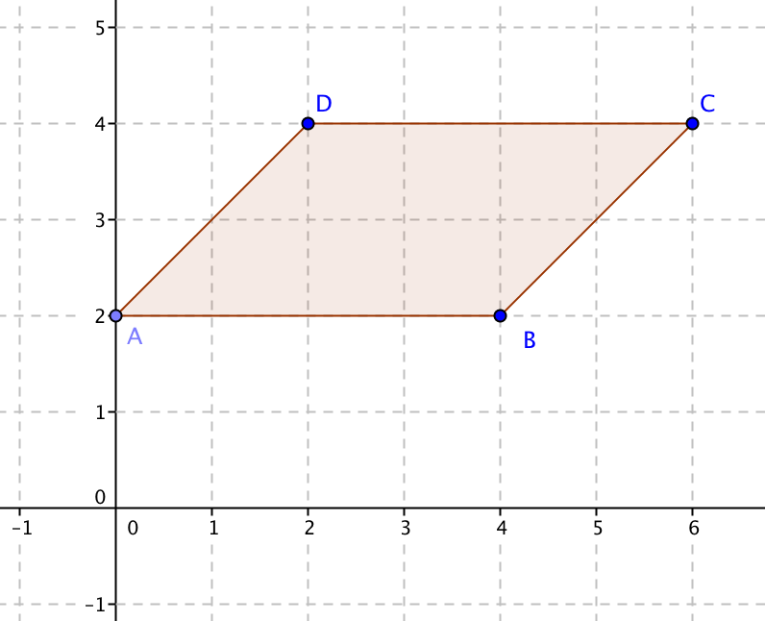
- On a sheet of graph paper draw a set of axes and parallelogram ABCD with these vertices: A = (0,2), B = (4,2), C = (6,4) and D = (2,4).

- Use the distance formula or a centimeter ruler to find the lengths of the sides.
AB = _______ BC = ________
CD = _______ DA = ________
- Use a protractor to measure the angles.
m$∠DAB$ = ________ m$∠ABC$ = ________ m$∠BCD$ = ________ m$∠CDA$ = ________
- On the same sheet of graph paper plot the image of parallelogram ABCD under reflection over the y-axis. Recall that the mapping rule is (x, y) (–x, y).
a. Use the distance formula or a centimeter ruler to find the lengths of the sides.
A’B’ = _______ B’C’ = ________ C’D’ = _______ D’A’ = ________
b. Use a protractor to measure the angles.
m$∠D'A'B'$ = _____ m$∠A'B'C'$ = _____ m$∠B'C'D'$ = _____ m$∠C'D'A'$ = _____
- On the same sheet of graph paper plot the image of parallelogram ABCD under the translation with mapping rule (x, y) (x – 6, y –5).
a. Use the distance formula or a centimeter ruler to find the lengths of the sides.
A’B’ = _______ B’C’ = ________ C’D’ = _______ D’A’ = ________
b. Use a protractor to measure the angles.
m$∠D'A'B'$ = _____ m$∠A'B'C'$ = _____ m$∠B'C'D'$ = _____ m$∠C'D'A'$ = _____

- On the same sheet of graph paper plot the image of parallelogram ABCD under a 270° counter-clockwise rotation about the origin. Recall that the mapping rule (x, y) (y, –x).
a. Use the distance formula or a centimeter ruler to find the lengths of the sides.
A’B’ = _______ B’C’ = ________ C’D’ = _______ D’A’ = ________
b. Use a protractor to measure the angles.
m$∠D'A'B'$ = _____ m$∠A'B'C'$ = _____ m$∠B'C'D'$ = _____ m$∠C'D'A'$ = _____
- On the same sheet of graph paper plot the image of parallelogram ABCD under the glide reflection with mapping rule (x, y) (x + 3, –y).
a. Use the distance formula or a centimeter ruler to find the lengths of the sides.
A’B’ = _______ B’C’ = ________ C’D’ = _______ D’A’ = ________
b. Use a protractor to measure the angles.
m$∠D'A'B'$ = _____ m$∠A'B'C'$ = _____ m$∠B'C'D'$ = _____ m$∠C'D'A'$ = _____
- Summarize you results: translations, rotations, reflections and glide reflections are all examples of isometries.
a. How does the length of a segment and the length of its image compare under an isometry?
b. How does the measure of an angle and the measure of its image compare under an isometry?

- Now let’s look at some other transformations.
a. On a fresh sheet of graph paper, draw a set of axes and the parallelogram ABCD with these vertices: A = (0,2), B = (4,2), C = (6,4) and D = (2,4), the same as before.
b. Assign each member of your group one of these transformations:
Dilation: (x, y) (1.5x, 1.5y)
Vertical stretch: (x, y) (x, 3y)
Horizontal stretch: (x, y) (2x, y)
Shear: (x, y) (x + y, y)
c. Plot the image of parallelogram ABCD under the transformation you were assigned.

- Record the results for your transformation:
a. Use the distance formula or a centimeter ruler to find the lengths of the sides.
A’B’ = _______ B’C’ = ________ C’D’ = _______ D’A’ = ________
b. Use a protractor to measure the angles.
m$∠D'A'B'$ = _____ m$∠A'B'C'$ = _____ m$∠B'C'D'$ = _____ m$∠C'D'A'$ = _____

- Compare your results with those of other members of your group. Summarize your findings here:
- How do the last four transformations (dilation, vertical shift, horizontal shift, and shear) differ from the four transformations we call “isometries” (translation, rotation, reflection, and glide reflection)?
- An additional question: Find the area of the original parallelogram ABCD and the areas of each of the image parallelograms, A’B’C’D’. For which transformations is the area unchanged?

