Activity 1.4.3 Exploring Reflections
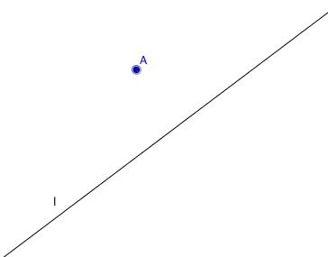
For this activity you will need, paper, pencil, ruler, and protractor.
- Take a sheet of paper. Draw a line l and a point A on one side of l.

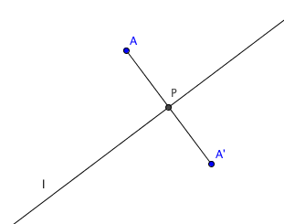
- Fold the paper over line l. Mark the point on the other side of l from A where A touches. Call this point A’.
A’ is the image under reflection of point A over line l.
3. Unfold the paper. Draw segment $\overline{AA’}$. Label the intersection of $\overline{AA’}$ and l as point P.
4. Measure PA and PA’. What do you notice?

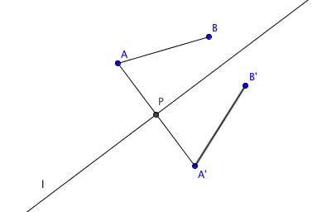
5. Measure the angle formed by $\overline{AA’}$ and l. What do you notice?

6. Locate another point on the same side of l as A. Call this point B. Fold the paper again and locate B’ the image of B under reflection over l.
7. Draw segments $\overline{AB}$ and $\overline{A’B’}$. Measure AB and A’B’.
What do you notice?

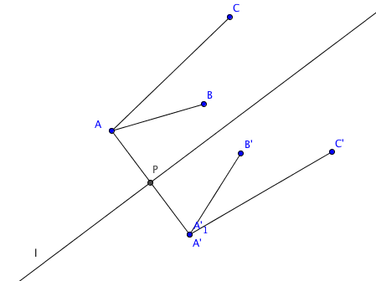
8. Locate another point on the same side of l as A and B, but not on line $\overset{⃡}{AB}$. Call this point C. Fold the paper again and locate C’ the image of C under reflection over l.
9. Draw segments $\overline{AC}$ and $\overline{A’C’}$. Measure angles $∠$CAB and $∠$C’A’B’. What do you notice?

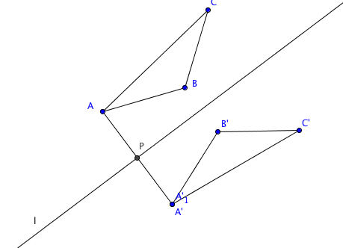
10. Draw segments $\overline{BA}$ and $\overline{B’C’}$. You know have two triangles ∆ABC and ∆A’B’C’. Describe the orientation
of A-B-C as clockwise or counterclockwise. Describe the orientation of A’-B’-C’ as clockwise or counterclockwise. What do you notice?

11. In the space below, summarize the properties of reflections you have observed in this activity.

