Activity 1.3.1a Examining Angles in Runways

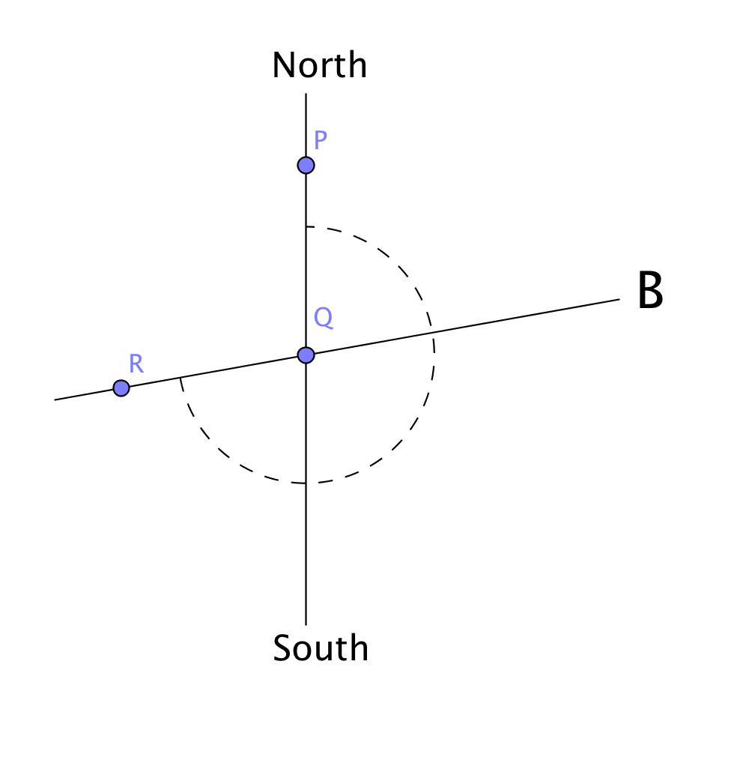
On the next sheet of paper is a map of the Danbury airport runway. The number of each runway has been replaced by a letter.

Look at Runway B. Use your ruler (or the gridlines) to draw a line segment that is parallel to the North-South line and intersects the runway. Try to be as precise as possible. Now place a point on this segment that is on the North side of the runway and label this point P. Now place a point where the North-South segment and the runway intersect and label this point Q. Finally, place a point, R, on the runway on the opposite side of $\overline{PQ}$ from B. Rays $\overset{⃑}{QP}$ and $\vec{QR}$ now form the angle we call $∠$PQR. See the figure at the right.

You should notice that two angles are formed. There is an obtuse angle (greater than 90° and less than 180°) and a reflex angle (greater than 180° and less than 360°).

We want the angle formed by going clockwise from point P to point R. So, in this case it is the reflex angle we want. How can you use a protractor to measure this?

Now find the runway number. (Do you remember, from class discussion, how that is related to the angle measured clockwise from North?)

1. Find the runway numbers for the rest of the runways:

A ________ B__26____

C ________ D________

Danbury Airport Runway Map

