Activity 1.2.7 Midpoints
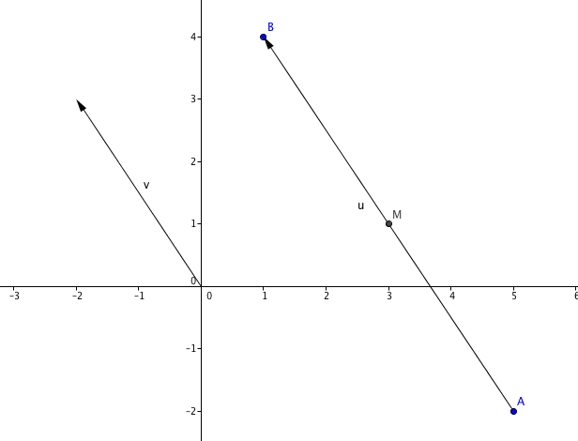
In the figure at the right$\overline{ AB}$ is a line segment with endpoints A(5, –2) and B(1, 4).

1. Describe the vector from A to B terms of
run and rise:

run = ________ rise = __________

2. Name the vector from A to B as u. Find a mapping rule for the translation by the vector u.

(x, y) (__________, _________)

3. Find the coordinates of the image of A under this translation (______, ______). What is the name of this point?________.

4. Now consider the vector v that is half the size of u. Describe its run and rise:

run = _________ rise = _________

5.Find a mapping rule to the translation by vector v.

(x, y) (__________, _________)

6. Find the coordinates of the image of A under this translation (______, ______).
Name this point M.

7. M is called the midpoint of segment $\overline{AB.}$ Why is this an appropriate name for this point?

8. Use the distance formula to find AM and MB. What do you notice?

9. Approximate to the nearest 0.001 the two distances you found in question 8.

AM ≈ __________________ MB ≈ _____________

10. Now find a decimal approximation for the length of segment $\overline{AB}$, that is the distance
AB ≈ __________. What do you notice?
11. Summarize what you have learned so far about midpoints.

12. Here is another way to think about midpoints: the coordinates of the midpoint are the averages of the x- and y-coordinates of the endpoints. For the segment $\overline{AB}$, the endpoints are A(5, –2) and B(1, 4).

What is the average of the x-coordinates? _______
What is the average of the y-coordinates? _______
How are these averages related to the coordinates of M?

13. Find the average of the coordinates of these two points ($x_{1}, y_{1}$) and ($x_{2}, y_{2}$):

( ________, ________).

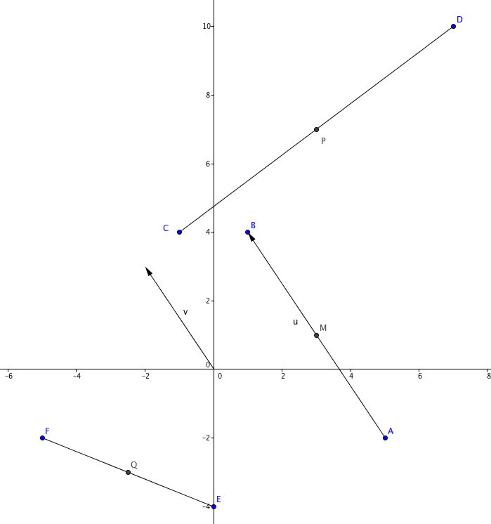
This result is called the Midpoint Formula.

14. Find the midpoint of segment $\overline{CD}$ where the coordinates of the endpoints are C(–1, 4) and D(7, 10). Call this midpoint P.

P(______, ______)

15. Find the distances CP, PD and CD from question 14.

CP = _________ PD = _________ CD = _________

What do you notice?

16. Find Q, the midpoint of segment$\overline{EF}$ where the coordinates of the endpoints are E(0, –4) and F(–5, –2).

Q(______, ______)

17. In answering questions 9 and 10 Tanya says: It looks like the distance AB is 4 times the distance AM because $\sqrt{52}$ is four times as large as $\sqrt{13}$. How would you respond to her statement?

