Activity 1.1.5 Finding Perimeters

1) In your own words, define the word perimeter.

2) Explain how you calculate the perimeter of any figure

3) Find the perimeter of the figure below. Person 1: Find the lengths of the top and left side. Person 2: find the length of the bottom and right side. Together find the perimeter of the figure.
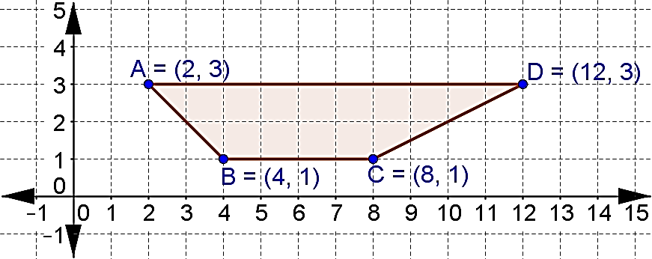

4) Each person will calculate the approximate perimeter of a triangle, rounded to the nearest hundredth of a unit. You will know that your answer is correct if you end with the same perimeter as your partner. Only draw your triangle on the coordinate plane below!
Person 1: Plot the points A(-4, -3), B(-1, 1) and C(2, 0) on the plane below. Draw the triangle and calculate the perimeter. | Person 2: Plot the points X(1, 0), Y(-2, -4) and Z(-5, -3) on the plane below. Draw the triangle and calculate the perimeter.

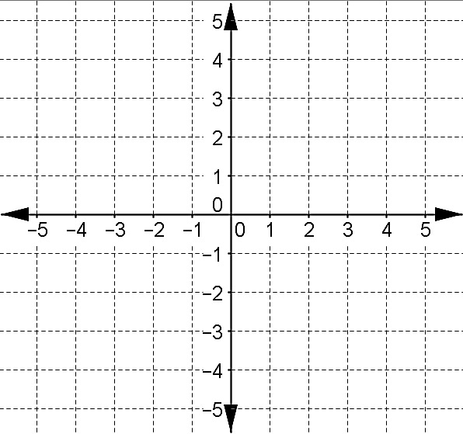

5) In your own words, define the word area.

Formulas you should be familiar with are:
- Area of a rectangle = (length)(width) A=lw
- Area of a square = (side)² A = s²
- Area of a triangle = $\frac{1}{2}(base)(height)$ A = $\frac{1}{2}bh$
- Area of a parallelogram = $(base)(height)$ A = $bh$
- Area of a circle = pi times square of radius $A=πr^{2}$

Directions for numbers 6, 7 and 8. Use the picture below to answer the following questions. Work together to get the answers. Suggestion: One partner might find the perimeter, the other partner the area. Be sure to check each others’ work.

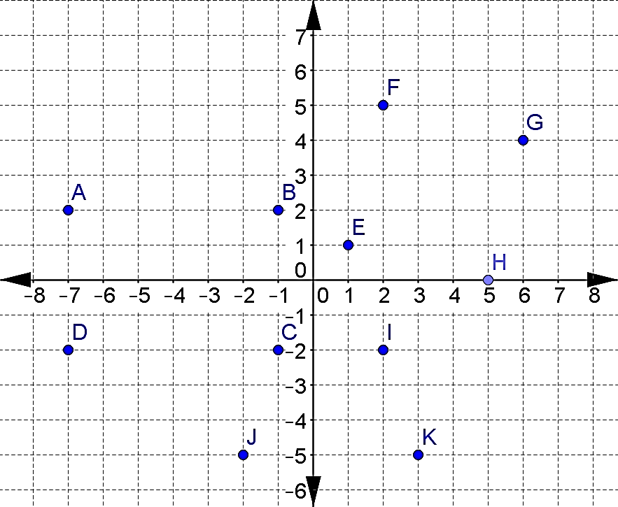 | 6) Connect the points A, B, C, and D. Find the perimeter and area of this rectangle.

7) Connect the points E, F, G, and H. Find the perimeter and area of this square. Leave the length of each side in radical form.

8) Connect the points I, J, and K. Find the perimeter and area of this triangle. Round any distances to the nearest thousandth of a unit.

Using GeoGebra to calculate perimeter and area:

Steps to calculate the perimeter for Question #3 on page 1
1. Open GeoGebra and select the Algebra & Graphics view from the Perspectives menu.

2. Display the grid by clicking on arrow next to the word Graphics and choosing the Grid.
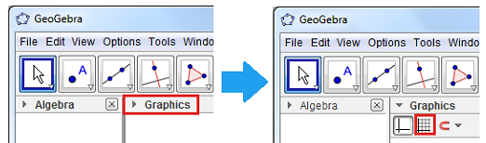

3. | 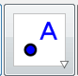 | Click the New Point tool and place the points on the coordinates given from question #1: A on (2, 3), B on (4, 1), C on (8, 1), and D on (12, 3).
4. | 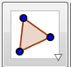 | Next, draw triangle ABC using the Polygon tool. To do this, click the Polygon tool and click the points in the following order: point A, point B, point C, point D i and point A again to close the polygon.
5. | 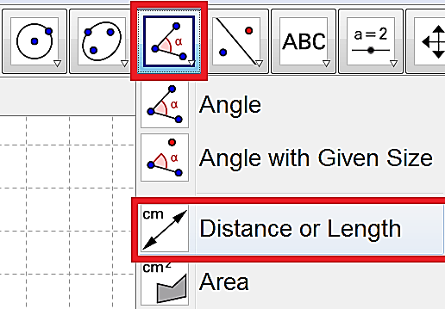 |  | Right click on the picture of the angle. In the drop down click on the Distance or Length tool.
6. | 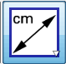 | Click on the center of the polygon and the perimeter should appear.  If you want to check the length of each side, the click on the side and the distance for that side will appear.  Did you get your answer correct? Circle Yes or No  If not, then go back to find your mistake and fix your work.

Steps to calculate the perimeter for Question #4 on page 1
1. Open a new window by clicking the File menu and choosing New Window.

2. Repeat all the same steps as above, but plot the appropriate points.

Steps to calculate the perimeter or area for Question #6, 7, and 8 on page 2.
1. Open a new window by clicking the File menu and choosing New Window.

2. Plot the appropriate points and follow the same steps as above to calculate the perimeter.

3. | 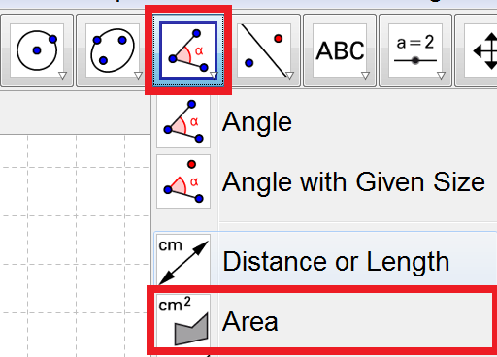 |  | To calculate the area, right click and select the Area tool in the drop down.
4. | 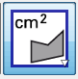 | Click on the center of the polygon and the area should appear.  If there are any answers you did not get correct, go back to find and fix your mistake.

