Activity 1.1.4 Using the Distance Formula

The Cartesian coordinate system was originally developed by the French mathematician René Descartes. His development of the coordinate plane helped to bring together the disciplines of algebra and geometry. The distance formula applies to points in the coordinate plane.

$$d=\sqrt{{\left(x_{2}-x_{1}\right)}^{2}+{\left(y_{2}-y_{1}\right)}^{2}}$$

Find the distance between each pair of points. Leave your answer in radical form.
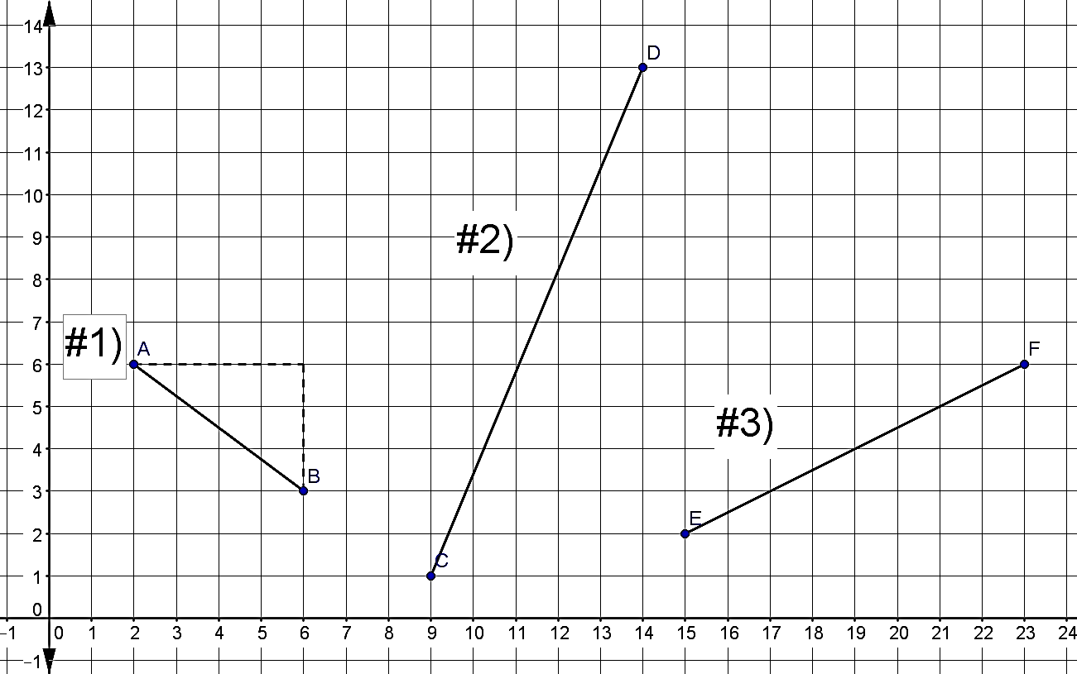
Show all work and solutions for # 1, 2 and 3 in the space below.

Applying distance to traveling – Part 1: Getting Captain Craig to the boat dock
Craig is the captain of a large cargo ship that is docked in New York City. He is staying at a hotel on the corner of 3rd Street and 7nd Avenue, while the boat is docked on the corner of 9th and 1st as shown below. The distance between each street and each avenue is one block and each block is 0.25 miles.

4) Approximately many miles is Craig’s hotel from the boat dock? Please round your answer to the nearest hundredth of a mile.

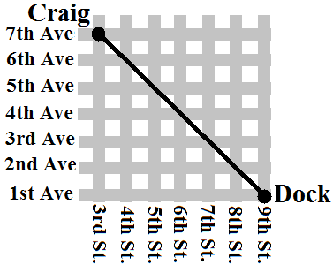

However, not all distances can use the distance formula in real life.

5) If Craig calls for a taxi to take him from the hotel to the dock, what is the least number of miles the taxi driver can take him? Assuming the cab needs to stay on the roads!

Applying distance to traveling – Part 2: Sailing from USA to UK
Craig’s cargo ship must travel from New York City, USA to Southampton, England. The two points are N(-3250, 2816) and S(-72, 3505) where x represents the miles west of the prime meridian and y represent the miles north of the equator.

6) Calculate the distance from NYC to Southampton. Note: These calculations will be slightly off because the distance formula is used on flat planes, while the Earth is round.

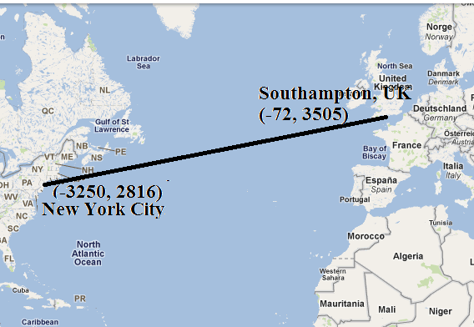

Applying distance to traveling – Part 3: Approximate fuel cost from USA to UK
Visit the link http://www.bunkerindex.com/prices/indices.php to research the cost of bunker fuel (also known as heavy oil fuel). Look for the abbreviation BIX and find the price for today. Label the price in $ per metric ton.

7) Write the price for bunker fuel (in $ per metric ton):

For a large cargo ship, approximately 0.1 metric tons of fuel is used for each mile sailing.
8) Calculate the approximate cost of fuel per mile (multiply 0.1 mt/mile to the price you researched).

9) Knowing the total mileage and the cost of fuel per mile, calculate the total cost of fuel for the cargo ship to sail from NYC to Southampton.

