Activity 1.1.3 Deriving the Distance Formula

Part 1: Calculating the distance between two points along horizontal and vertical lines

1) What is the distance between the two points on the number line below?

NOTE: To find the length of a horizontal segment, we can simply count the units or use the formula for the change in x: |x₂ – x₁|. This is similar to calculating the ‘run’ in our slope formula, with the exception that this is in absolute value bars because distance is always a positive value.

Simplify each expression. What do you notice?
2) |x₂ – x₁| = |4 – (-2)| =

3) |x₂ – x₁| = |-2 – 4| =

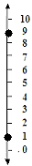
4) What is the distance between the points on the number line to the right?

NOTE: To find the length of a vertical segment, we can simply count the units or use the formula for the change in y: |y₂ – y₁|. This is similar to calculating the ‘rise’ in our slope formula.

Simplify each expression. What do you notice?
5) |y₂ – y₁| = |9 – 1|=

6) |y₂ – y₁| = |1 – 9| =

7) Find the distance between each pair of below, both by counting and by using the formulas provided above.
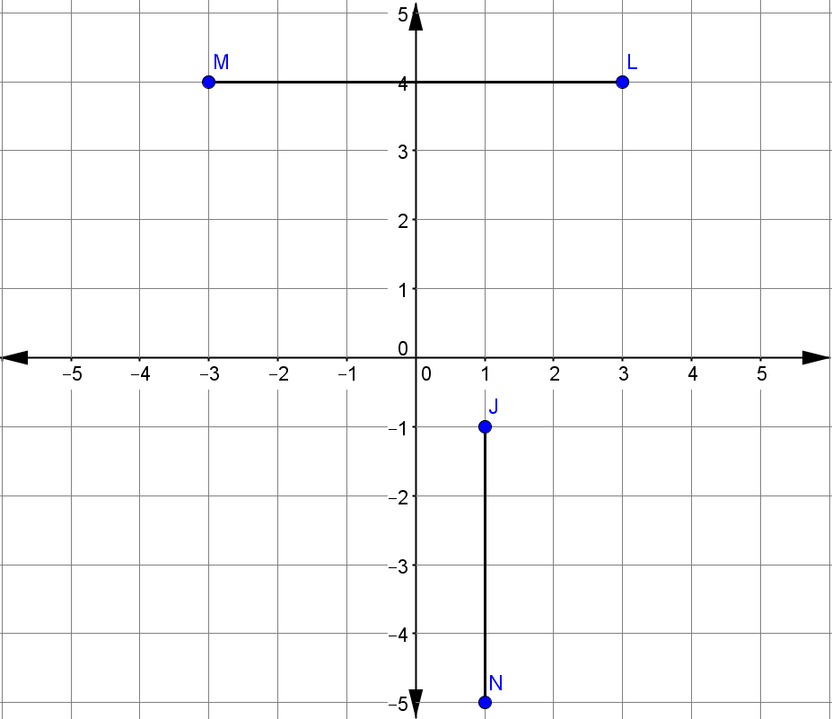
Part 2: Calculating the distance between any two points.

8) Find the distance between the points A(1, 3) and B(4, 7).
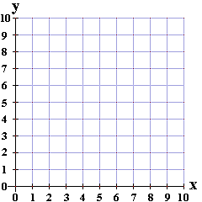 | Step 1: Plot and label the two points on the coordinate plane to the left. Connect them with a segment.  How far apart are the two points? What steps did you take to find the distance?
9) What is the distance between the points A(-2, 1) and B(4, 9)?
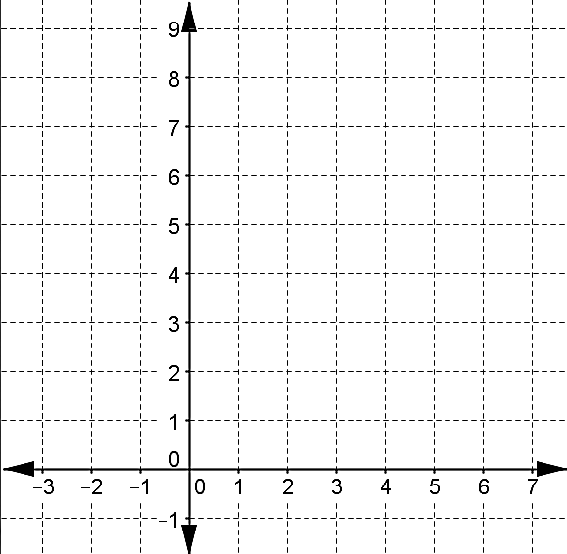
10) Find the distance between any two points, A(x₁, y₁) & B(x₂, y₂), by deriving a formula
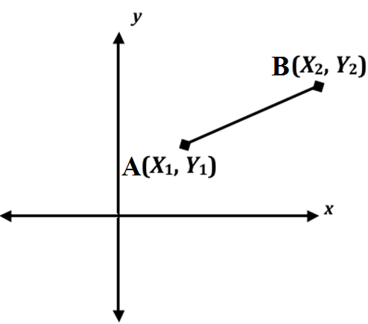 |  | Rewrite the Pythagorean Theorem in terms of distance.  Draw the right triangle using points A and B.  Finish the proof  1. (Leg)² + (Leg)² = Hypotenuse²  2. ( )² + ( )² = Distance²  3.
Find the distance between each pair of points. Leave your answer in radical form
(x₁, y₁) (x₂, y₂)  11) (-1, 7) and (8, 4) | 12) (-3, -2) and (4, -7) |  | 13) (-5, 2) and (3, -1)

Part 3: Applying the distance formula in various ways
15) Boulder dash at Lake Compounce in Bristol, CT, is one of the most exciting wooden roller coasters in the country. A linear portion of the roller coaster starts at the highest point (64, 82) and then drops to (110, 32). To the nearest foot, determine the distance of this linear section of the track. | 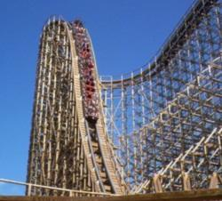  http://www.thecoastercritic.com/

16) The distance between each street and each avenue is one block. Each block is 2 miles.  You drive on Broadway from A to B in a car that uses 24 mpg. Approximately how many gallons did you use? | 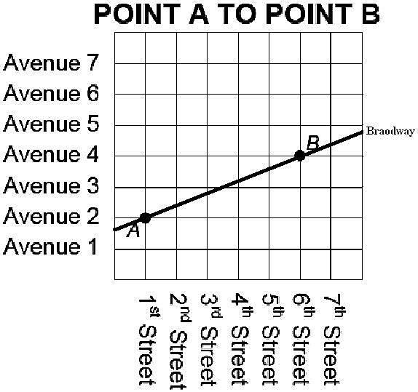

17) You are given the two points A(-2, 1) and B(x, 5). The two points are 5 units apart. What are two possible locations of point B?

18) You are given the two points A(1, 4) and B(13, y). The two points are 13 units apart. What are two possible locations of point B?

19) Superman is working at the Daily Planet Newspaper P(100, 40). He needs to fly to stop a bank robbery at B(40, 80) and then bring the criminals to jail at J(130, 105). Finally he needs to fly back to the Daily Planet to get back to work as ‘Clark Kent’. What is the total distance for the trip?

