Activity 1.1.2 Dissection Proof of Pythagorean Theorem
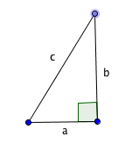
Given: Right triangle with legs a and b and hypotenuse c. Two squares with side lengths a and b next to each other.
Prove: The area of a square with side length a (a²) plus the area of a square with side length b (b²) equals the area of a new square with side length c (c²). Proving the Pythagorean Theorem a² + b² = c².

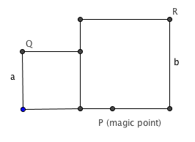
P
(Magic Point)

FIGURE 1

- Cut out FIGURE 1.
- Using a ruler, draw a line segment connecting Q and P. Draw a segment connecting P and R.
- Measure the lengths of $\overline{PQ}$and $\overline{PR}$ to the nearest tenths of a centimeter. What did you notice? This is why point P is the “magic point”.
- Cut along the lines you drew for $\overline{PQ}$and $\overline{PR}$ creating two triangles.
- Slide these two triangles to different sides until you create a square.

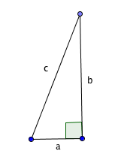
Now try the same thing with another right triangle. Notice that the ratio of b to a is greater than in the triangle on page 1.

- Cut out FIGURE 2. Follow steps 2 through 5. Will this work for the squares formed by the legs of any right triangle?

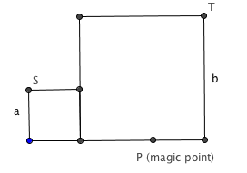

FIGURE 2

7. When you have two squares side by side as in figures 1 and 2, how would you locate the magic point?

