Exploring the Graph of $y=a⋅b^{x}$

Section 1: Reviewing the Linear Function $y=mx+b$

Earlier in the course we explored the linear function family, defined by the equation
$y=mx+b$. We studied the roles of the parameters m and b. We found that regardless of the numbers used to replace m or b, our graphs were always straight lines.

- Before summarizing the roles of m and b below, refresh your memory by graphing
y = 0.5x + 1, y = 2x + 1, and y = 4x + 1 and on your calculator. If m > 0, what can you say about the graph of the equation y = mx + b?

- As m increases, what happens to the graphs? Be specific.

- Now graph y = – 0.5x + 1, y = –2x + 1, and y = – 4x + 1 on your calculator. If m < 0, what can you say about the graph of the equation y = mx + b?

- As m decreases, what happens to the graphs? Be specific.

- Now let m = 0 and graph y = 0x + 1. How does this graph differ from the graphs in questions 1 and 3?

- Now consider the graphs of y = 2x + 3, y = 2x + 4 and y = 2x – 5. How are these graphs alike?

- How do the graphs in question 6 differ?

- Now summarize the roles of the parameters m and b in the equation $y=mx+b.$

- Without graphing, what can you say about the graph of y = 5x + 4?

In the next section, we wish to explore an equation that is very different from the linear equation $y=mx+b$. We now want to study the family of exponential functions modeled by the equation $y=a⋅b^{x}$. Parameter a is the “coefficient,” while parameter b is the “base.” We will use our calculators to explore the roles of parameters a and b.

Section 2: Exploring Parameter b

First we will select a number to replace parameter a, and then keep that number constant. Then, we will vary parameter b until we can explain the role of b on the graph of
$y=a⋅b^{x}$.

Case 1: a = 1 and b > 1

- Let a = 1 and b = 2 and type the resulting equation into Y1 on your calculator. (You are graphing $y=1⋅2^{x}$) Use the window settings –4.7 ≤ x ≤ 4.7 and –2 ≤ y ≤ 10 with an
x-scale and y-scale of 1. As a check, your equation and window should look as follows:

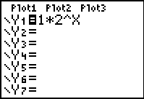
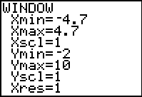

And, your graph should look like this:

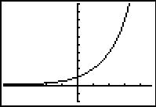

- Leave $y=1⋅2^{x}$ in Y1 and now place $y=1⋅3^{x}$ in Y2 and $y=1⋅5^{x}$ in Y3. Sketch the resulting images of Y2 and Y3 on the graph above.

- What point do all three graphs have in common?

- Focus on the portion of the graphs in the first quadrant (to the right of the y-axis). Based on this investigation where a = 1 and b > 1, how does the graph change as b gets larger?

Section 2: Exploring Parameter b, continued

Case 2: a = 1 and 0 < b < 1

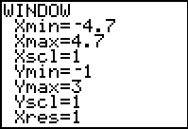
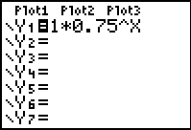
- We continue to let a = 1. Clear the equations from the case 1 investigation. Now replace b with 0.75 and type $y=1⋅{0.75}^{x}$into Y1. Adjust the window to settings to –4.7 ≤ x ≤ 4.7 and –1 ≤ y ≤ 3 with scales of 1. As a check, the equation and window should look as follows:

And, your graph should look like this:

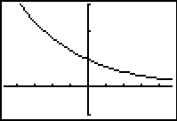

- What is the same about this graph compared to those in the case 1 investigation above?

- What is different?

- Leave $y=1⋅{0.75}^{x}$in Y1 and now place $y=1⋅{0.5}^{x}$ in Y2 and $y=1⋅{0.2}^{x}$ in Y3. Sketch the images of Y2 and Y3 on the graph above.

- Focus on the portion of the graphs in the first quadrant (to the right of the y-axis). Based on this investigation where a = 1 and 0 < b < 1, how does the graph change as b gets smaller?

Section 3: Exploring Parameter a

Now that we have a good idea of how parameter b impacts the graph of $y=a⋅b^{x}$, we may explore the role of parameter a. So, we will keep b constant and then vary parameter a until we can explain its impact.

Case 1: b = 2 and a > 0

- Let b = 2 and a = 0.5 and type the resulting equation into Y1 on your calculator. (You are graphing $y=0.5⋅2^{x}$) Use the window settings –4.7 ≤ x ≤ 4.7 and –1 ≤ y ≤ 5 with an x-scale and y-scale of 1. As a check, your equation and window should look as follows:
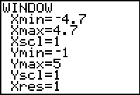
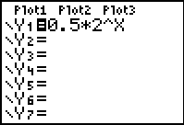

And, your graph should look as follows:

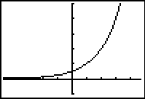

- Leave $y=0.5⋅2^{x}$ in Y1 and now let a = 1 by placing $y=1⋅2^{x}$ in Y2. Sketch the resulting image on the graph above. Repeat for a = 2 and a = 3.

- Identify the y-intercepts on each graph.

- How is the y-intercept related to parameter a?

- Based on this investigation where b = 2 and a > 0, how does the graph change as parameter a gets larger? Remember to use good mathematical vocabulary.

Section 4: Summary

If one were asked to summarize the role of parameter b in the equation $y=a⋅b^{x}$ where parameter a is held as a positive constant, here is what a response might look like:

“When b is greater than 1, the graph of $y=a⋅b^{x}$ increases as we move from left to right. As we make b larger, the graph becomes steeper and rises more quickly.”

- Continue with this response, but now summarize the role of parameter b when its value is between 0 and 1.

- Summarize what you have learned about the role of parameter a in the equation$y=a⋅b^{x}$. Include in your response the relationship between the y-intercept and the parameter a, if any.

