Dog Food
Kathy is dog sitting for her neighbor who is on vacation. Her first assignment is to feed the dogs. The neighbor gave Kathy a checklist of the dog names and how much food they eacheat, but one of the dogs thought it was a snack and bit a corner off!
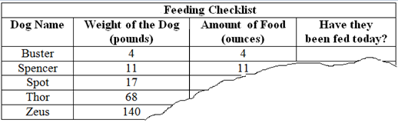
- Based on what you noticed, how many ounces do you think Kathy should give:
  - Spot: _____
  - Thor: _____
  - Zeus: _____
  - How did you come up with these predictions?
Spot finished his food, but Thor and Zeus had most of their food left over. Kathy called a vet who said: “Thor and Zeus have different feeding formulas than Buster, Spencer, and Spot. Adult dogs that weigh less than 20 pounds are classified as small dogs. Dogs that weight 20 to 100 pounds are classified as mid-size dogs. Dogs that weight more than 100 pounds are large dogs.”

Dog Food Chart  Small Mid or Large Weight of the Dog (pounds) Daily Amount of Food (ounces)  S 5 5  S 10 10  S / M 20 20  M 50 35  M / L 100 60  L 125 62.5  L 150 65  . | - Use the table provided to find an equation for feeding small dogs:  - Use the table provided to find an equation for feeding mid-size dogs.
- Thor is a mid-size dog. Use your equation from question 3 to determine how many ounces of dog food Thor should be fed. How many ounce did Kathy overfeed Thor?
- Use the table from the previous page to find the equation for feeding large dogs.

- What does the slope mean in the equation for large dogs?

- Zeus is a large dog. Use your equation from question 5 to determine how many ounces of dog food Zeus should be fed. How many ounces did Kathy overfeed Zeus?

Since there are 3-pieces to formula for feeding the dog, the data can be written as a piecewise function. The different feeding rules are considered to be the pieces of a single function.
- Help Kathy complete the piecewise function for any weight of a dog.
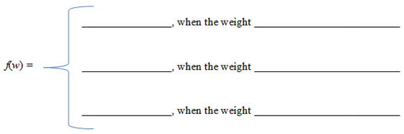
- Complete the table using the piecewise equation you wrote in question 8.
Dog’s Weight  (Pounds) | Amount of Dog Food  (ounces)
71
120
16
 | 75
- It is necessary to graph each piece of the function only for its appropriate domain. Graph the feeding function on the axes below. When you’re finished, the graph should consist of 3 line segments. (Small, midsize, and large).
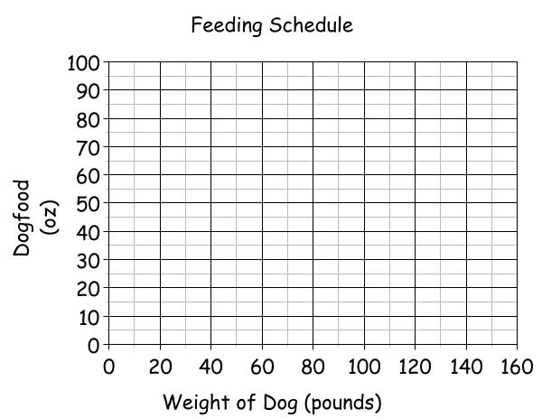

- Kathy has so much fun with the dogs that she decided to buy a 130-pound Great Dane. Kathy determines that she should feed the dog 63 ounces of food daily. Do you agree? Show your work to justify your answer.

- If Kathy is giving 40 ounces of food to a dog, how much does that dog weigh? Show your work and explain your answer in a sentence.

- By using the graph (not the equations), what is the approximate value of f(30)? Explain the meaning in a sentence.

- Using the graph (not the equations), what is the approximate value of w if f(x) = 30. Explain the meaning in a sentence.

- What is the range for small dogs?

- What is the range for midsize dogs?

- What is the range of large dogs?

