**Hurricanes**

Each year tropical storms that form in the Atlantic Ocean are given names. The first named storm starts with “A”, the second starts with “B”, and so on. A tropical storm becomes a hurricane if its wind speed reaches 74 miles per hour.

2005 was the most active year for hurricanes on record. In July of 2005, Cindy was the first tropical storm to become a hurricane. In August of 2005, Katrina made headlines worldwide as it wreaked havoc on the city of New Orleans. This chart shows the maximum wind speed, in miles per hour, for each of the fifteen Atlantic Ocean hurricanes of 2005.

|  |  |  |
| --- | --- | --- |
| **2005 Atlantic Ocean Hurricanes** | | |
| **Name** | **Dates** | **Max Wind Speed**  **(mph)** |
| Cindy | 7/3 - 7/7 | 75 |
| Dennis | 7/4 - 7/13 | 150 |
| Emily | 7/11 - 7/21 | 160 |
| Irene | 8/4 -8/18 | 105 |
| Katrina | 8/23 - 8/30 | 175 |
| Maria | 9/1 - 9/10 | 115 |
| Nate | 9/5 - 9/10 | 90 |
| Ophelia | 9/6 - 9/17 | 85 |
| Philippe | 9/17 - 9/23 | 80 |
| Rita | 9/18 - 9/26 | 180 |
| Stan | 10/1 - 10/5 | 80 |
| Vince | 10/8 - 10/11 | 75 |
| Wilma | 10/15 - 10/25 | 185 |
| Beta | 10/26 - 10/31 | 115 |
| Epsilon | 11/29 - 12/8 | 85 |

In previous courses you learned about three statistics called **measures of center**. These statistics are described in the box at the right.

1. For the maximum wind speeds, find the:
2. mean
3. median
4. mode

|  |
| --- |
| Three Measures of Center |
| The **mean** is the average that you're used to, where you add up all the data values and then divide by the number of values. |
| The **median** is the "middle" value in a list of numbers. To find the median, first list the numbers in numerical order. Then, if the number of values is odd, the median is the number in the middle. If the number of values is even, the median is the mean of the two numbers in the middle |
| A **mode** is a value that occurs most often. If no number is repeated, then there is no mode for the list. Some lists of numbers may have more than one mode. |

1. For these data, which measure of center is larger, the mean or the median? Why do you suppose this is?
2. What difficulty did you have answering question 1(c) above? What does that tell you about the mode of a set of values?

**Hurricane Categories**

Hurricanes are classified based on their maximum wind speed according to the Saffir-Simpson Hurricane Scale shown in this chart.

Saffir-Simpson Hurricane Scale

|  |  |
| --- | --- |
| **Category** | **Max Wind Speed (mph)** |
| 1 | 74–95 |
| 2 | 96–110 |
| 3 | 111–130 |
| 4 | 131–155 |
| 5 | 155+ |

1. Use the Saffir-Simpson Hurricane Scale to categorize the hurricanes in the chart below.

|  |  |  |  |
| --- | --- | --- | --- |
| **2005 Atlantic Ocean Hurricanes** | | | |
| **Name** | **Dates** | **Max Wind Speed**  **(mph)** | **Category** |
| Cindy | 7/3 - 7/7 | 75 | 1 |
| Dennis | 7/4 - 7/13 | 150 | 4 |
| Emily | 7/11 - 7/21 | 160 |  |
| Irene | 8/4 -8/18 | 105 |  |
| Katrina | 8/23 - 8/30 | 175 |  |
| Maria | 9/1 - 9/10 | 115 |  |
| Nate | 9/5 - 9/10 | 90 |  |
| Ophelia | 9/6 - 9/17 | 85 |  |
| Philippe | 9/17 - 9/23 | 80 |  |
| Rita | 9/18 - 9/26 | 180 |  |
| Stan | 10/1 - 10/5 | 80 |  |
| Vince | 10/8 - 10/11 | 75 |  |
| Wilma | 10/15 - 10/25 | 185 |  |
| Beta | 10/26 - 10/31 | 115 |  |
| Epsilon | 11/29 - 12/8 | 85 |  |

1. Find the mean, median, and mode of the category data.
2. Compare your results from questions 1 and 5. Describe any patterns you observe.
3. 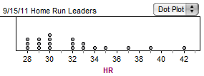Display the category data with a dot plot. The categories are shown on the number line. For every hurricane, place a dot above the appropriate location on the number line. (An example of a dot plot is given at the right. This dot plot shows the major league home run leaders in September 2011.)

**Distribution of Hurricane Categories in 2005**



1. On the dot plot locate the three measures of center for the category data. Place an asterisk (*) on the mean, put a square around the median, and put a circle around the mode.
2. Write three sentences about the conclusions you can make from the dot plot and your analysis of the data.

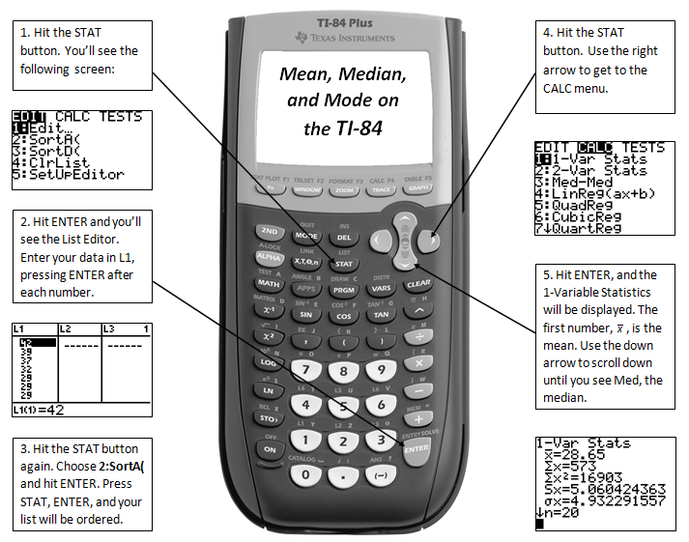

**Using Technology to Calculate Statistics**

Enter the maximum wind speed data into L1 as shown above. (Press STAT then select EDIT. Then select STAT 🡪 CALC and 1-Var Stats. Find the statistics for the list L1.)

The screen on the left will appear:

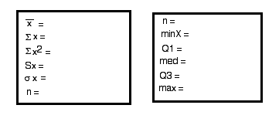

1. The first number to appear is the mean. (It appears as $\overline{x}$, which is called “*x* bar.”) Does this number agree with the mean you calculated in question 1(a)?
2. For now, ignore the four numbers below the mean. The last number on the screen is *n*. It tells you how many data values you have. What is the value of *n*? Is this correct?

Notice the arrow to the left of *n*. It suggests that you can scroll down. Scroll down until you see the statistics shown in the image at the bottom right of the previous page.

1. On this screen you will find the minimum (Min), the maximum (Max) and the median (Med). Do these results make sense? Explain.
2. The **range** of a dataset is the difference between the maximum and minimum values. The range measures the amount of spread in a dataset.

$$Range=Maximum-Minimum$$

Find the range for the maximum wind speed data.

**Histograms**

One way to display one-variable data is with a histogram. A **histogram** is like a dot plot, except that the values are grouped into intervals called *bins*. To create a histogram, we must have a **frequency table**. A frequency table contains a set of bins and the number of data values contained in each bin. The number of data values in a bin is called the *frequency* of the bin. We can draw a graph and represent each bin with a bar. The height of a bar shows the frequency of the bin.

It is important that all the bins are the same width. All data values must be placed in one of the bins.

1. A frequency table for the maximum wind speeds is shown below. Each bin has a width of 20 miles per hour. We must identify the number of data values in each bin. The data values contained in the first two bins and the frequency of the first two bins have already been identified. Fill in the rest of the table.

|  |  |  |
| --- | --- | --- |
| **Bin** | **Maximum Wind Speeds** | **Frequency** |
| 60 ≤ *x* < 80 | 75, 75 | 2 |
| 80 ≤ *x* < 100 | 90, 85, 80, 80, 85 | 5 |
| 100 ≤ *x* < 120 |  |  |
| 120 ≤ *x* < 140 |  |  |
| 140 ≤ *x* < 160 |  |  |
| 160 ≤ *x* < 180 |  |  |
| 180 ≤ *x* < 200 |  |  |

1. Use the data in the table to make a histogram of the maximum wind speeds. Notice the bins are on the *x*-axis and the frequencies are on the *y*-axis. The first bar is drawn for you.

**Maximum Wind Speeds in 2005**



1. Now use your calculator to make the same histogram. Follow these steps:

* In the Stat Plot menu, select Plot 1, turn it on, and select the histogram icon. Xlist should be L1 and Freq = 1.
* In the Window menu set Xmin = 60, Xmax = 200, Xscl = 20, Ymin = 0, Ymax = 8,

Yscl = 1.

* Press Graph. Describe what you see.

1. Now draw a histogram with a narrower bin width of 10 miles per hour. To change the bin width to 10, go to the Window menu, and set Xscl = 10. Then press Graph. What do you notice? How are the two histograms alike? How are they different?

**Hurricanes in 2012**

Now let’s do the same analysis with the hurricanes of 2012. The data in the table below are incomplete. Your teacher will give you the complete data set or you can find it yourself at Wikipedia.org/wiki/2012_Hurricane_Season.

|  |  |  |  |
| --- | --- | --- | --- |
| **2012 Atlantic Ocean Hurricanes** | | | |
| **Name** | **Dates** | **Max Wind Speed (mph)** | **Category** |
| Chris | 6/19-6/22 | 75 |  |
| Ernesto | 8/1-8/10 | 85 |  |
| Gordon | 8/15-8/20 | 110 |  |
| Isaac | 8/21-9/1 | 80 |  |
| Kirk | 8/28-9/2 | 105 |  |
| Leslie |  |  |  |
| Michael |  |  |  |
| Nadine |  |  |  |
| Rafael |  |  |  |
| Sandy |  |  |  |

1. Find the mean, median, and range for the maximum wind speeds of the 2012 hurricanes.
2. Make a dot plot of the categories of the 2012 hurricanes.

**Distribution of Hurricane Categories in 2012**



1. Make a histogram for the maximum wind speeds of the 2012 hurricanes.

**Maximum Wind Speeds in 2012**



1. Write a paragraph contrasting the 2005 and 2012 hurricane seasons. In your paragraph refer to the tables, the statistics (mean, median, and range), and your data displays (dot plots and histograms).