Making a Profit

- At Eisenhower High School’s home games, booster clubs will often hold raffles to raise money for the team or for special causes. The Girl’s Basketball Team had a gift basket filled with movie items to be raffled off at the Coaches Versus Cancer night. The girls decided to charge $2 a raffle ticket.

The gift basket contained: 4 tickets which cost $10.25 each, 12 boxes of candy which cost $2.50 each, a box of popcorn which costs $12, and 4 pairs of 3-D glasses which cost $4.25 each.

- Revenue is the amount of money the girls’ basketball team takes in – its income. In this case, revenue is a function of number of tickets sold. Let x be the number of tickets sold. What is the revenue function?

- Cost is how much money the girls’ basketball team spent. In this situation, cost is a constant function. What is the cost function? Hint: The cost function equals the expenses.

- Profit = Revenue – Cost. What is the profit function? (use the letter y for profit)

- What is the y-intercept of the profit function? Include units.

- What is the slope of the profit function? Include units. Remember slope is a rate of change.

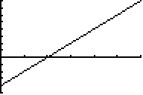
- Study the following window and graph. Number the axes.

- Does it match your profit function? How do you know?

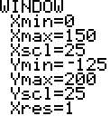

- ‘Breaking even’ means that the business neither loses nor gains any money. What number can you substitute in for y in the profit function to represent breaking even?

- How many tickets would the team have to sell to break even?

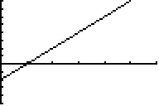
- The team decided that they would like to make more profit for fighting cancer. Study the graph to the right showing the team’s new plan. Number the axes.

a. How are the graphs the same? How are the graphs different?

b. Which parameter (slope or y-intercept) changed in their profit function? How do you know?

c. What does that tell you about the raffle’s ticket prices and operating costs? In other words, what did the team change about the raffle?

4. How else could the girls have raised more money? Would this be a change in the y-intercept or in the slope? How do you know?

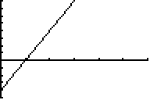
5. The team decided that they would try another idea to make a greater profit for fighting cancer. Study the following graph the team came up with. Number the axes.

- How are this graph and the original graph the same?

- How are the graphs different?

- Which parameter (slope or the y-intercept) must have changed in their profit function?

d. How do you know?

e. What does that tell you about the raffle’s ticket prices and operating costs? In other words, what did the team change about the raffle? If the team made this change, what must have happened?

