**What is Slope?**

What is slope? If you have ever walked up or down a hill, then you have already experienced a real life example of slope. Keeping this fact in mind, by definition, the slope is the measure of the *steepness of a line*. In math, **slope is defined from left to right**.

There are four types of slope you can encounter. A slope can be **positive**, **negative**, **zero**, or **undefined**.

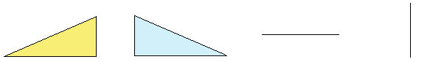

**Positive slope: Negative slope: Zero slope: Undefined slope:**

|  |  |  |  |  |  |  |
| --- | --- | --- | --- | --- | --- | --- |
| If you go from left to right and you go up, the line has a positive slope. |  | If you go from left to right and you go down, the line has a negative slope. |  | If you go from left to right and you don’t go up or down, the line has a zero slope. |  | If you can only go up or you can only go down, the line has an undefined slope. |

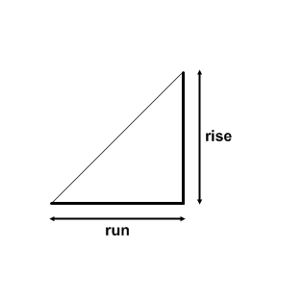

Here is one method of finding the slope of a line. Remember, **slope is a measure of how steep a line is**. That steepness can be measured with the following formula.



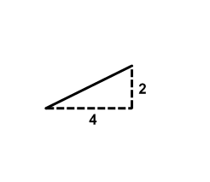

Let’s illustrate with two examples:

For this situation, we see that the **rise is 2** and the **run is 4**.

So, the slope =  after simplification. Since  is positive,

you are going uphill. Every time you go up 1 unit, you go across

or horizontally to the right 2 units.

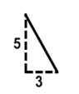

For this situation, we see that the **rise is -5** and the **run is 3**.

So, the slope = . Since is negative, you are going downhill.

Every time you go down 5 units, you go horizontally to the right 3 units.

1. 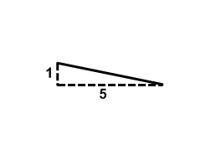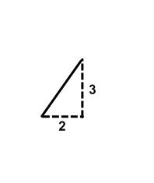Find the rise and the run for each solid line. Then state the slope of the solid line. Remember, slope is defined from left to right.

a. b.

Rise = ________ Rise = ________

Run = ________ Run = ________

Slope = ________ Slope = ________

1. Starting at point *A* find the rise and run to get to point *B*. Then connect the points to make a solid line. Identify the rise, run, and slope for the line segment between each pair of points below.
2. b.



Rise = ________ Rise = ________

Run = ________ Run = ________

Slope = ________ Slope = ________

1. Use the coordinate plane below.



1. Connect the points using a straightedge. Extend the line past points *A* and *C* and place arrows at each end.
2. Find the slope between points *A* and *B*.

Rise = ________ Run = ________ Slope = ________

1. Find the slope between points *B* and *C*.

Rise = ________ Run = ________ Slope = ________

1. Find the slope between points *A* and *C*.

Rise = ________ Run = ________ Slope = ________

1. What can you conclude about the slope of this line looking at your results in parts b thru d?
2. Starting at point *C* find a fourth point which would belong to the same line. Label your fourth point *D* and explain how you arrived at it using what you know about slope.
3. Now, let’s see how to find the slope when we don’t know the rise and the run. If we graph the slope on the coordinate system, we will be able to derive another formula for slope using the *x* and *y* values of the coordinates.



* 1. Let’s put a line with a slope of  on the

coordinate system.

* Begin by plotting the point (1, 3) and

labeling it point *A*.

* From point *A* do the rise and run for

the slope that is 1/2. Plot this second

point, and label it point *B*.

* Connect the points using a straight edge

and name the coordinates of point *A*

and point *B*.

* Extend the line past points *A* and *B* and place arrows at each end.
  1. Write the ordered pair for the points: *A* (_____,_____) *B* (_____,_____)
  2. The two coordinates for points *A* and *B* can be used to get the slope of .

*Let us find the difference in the y-coordinates:*

Since we cannot call both coordinates *y*, we can call one  and call the other .

Let  represent the *y*-coordinate of point *A*. Therefore,  = ________

Let  represent the y-coordinate of point *B*. Therefore,  = ________

Now subtract *y*2 – *y*1=________

The difference in the y-coordinates can be expressed as . This is the **RISE**.

*Let us find the difference in the x-coordinates:*

Since we cannot call both coordinates *x*, we can call one  and call the other .

Let  represent the *x*-coordinate of point *A*. Therefore,  = ________

Let  represent the *x*-coordinate of point *B*. Therefore,  = ________

Now subtract *x*2 – *x*1=________

The difference in the *x*-coordinates can be expressed as . This is the **RUN**.

The **formula for the slope** between the two points A and B can be found by using the *x* and *y* coordinates of the two points. Call the ordered pair for point A (*x*1,*y*1) and the ordered pair for point B (*x*2,*y*2).

1. Use the formula above to find the slope of the line passing through the given points. Show your work.

a. (1, 5) & (2, 9) b. (2, 4) & (1, 1)

 

 

c. (4, 0) & (8, -2) d. (-8, 6) & (3, 4)

 

 

e. (-3, -5) & (-1, -2) f. (0, 7) & (5, 0)

 

 

Slope is a measure of **steepness** and **direction**.Slopedescribes a **rate of change**.

1. Todd had 5 gallons of gasoline in his motorbike. After driving 100 miles, he had 3 gallons of gasoline left. The graph below shows Todd’s situation.



1. What are the coordinates of two points that you could use to find the slope of the line?

*A* (_____,_____), *B* (_____,_____)

1. What is the slope of the line? Write in fraction form and use the units of measure you find on the *y* and *x* axes.

1. Write the slope as a *unit rate* that will be in gallons per mile.

A **rate** is a ratio that compares two units of measure.

An example of a rate in fraction form is $\frac{170 dollars}{20 hours}$. Slopes are rates.

You can rename rates like you rename fractions. In this example divide the numerator and denominator by 10, to obtain an equivalent rate of $\frac{17 dollars}{2 hours}$.

Divide the numerator and denominator by 2 to obtain $\frac{\frac{17}{2 } dollars}{1 hour}$. This is a **unit rate**, because 1 is in the denominator.

Writing the fraction in decimal form gives $\frac{8.5 dollars}{1 hour}$. In every day language, we say “$8.50 per hour is the rate of pay.” This is also a **unit rate.**

One way to obtain a **unit rate** is to rewrite the fraction so the denominator is 1. You can also think of renaming the fraction to decimal form.



1. Sam and Kim went on a hike. The graph

at the right shows their situation.

1. Find the slope of Kim’s hike.

(Always include units of measure.)

1. Write Kim’s slope as a unit rate.
2. Find the slope of Sam’s hike.
3. Write Sam’s slope as a unit rate.
4. Who is hiking at a faster speed, Kim or Sam? Explain how you know by looking at the graph and by using the numbers for slope that you obtained above.