Stories and Graphs

- On a separate sheet of paper, write a story that describes the following graph. (Assume that your motion takes place along a straight line.)

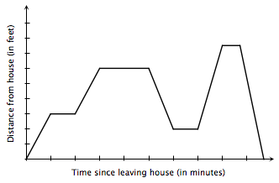

- Draw a graph that represents the following story.

You and your father are leaving Valley Plaza on your way home. On the way home you stop at McDonald’s for a bite to eat. After that, you drive three blocks to the gas station but discover that you accidentally left your shopping bag at McDonald’s. So while your father pumps the gas, you walk back to McDonald’s, get your bag, then walk back to the gas station. After your car is filled up you both drive home. (Assume that Valley Plaza, McDonald’s, the Gas Station, and your house are all on the same street).

