More Motion Graphs

In a distance-time graph, the time that has elapsed since the motion began is the independent variable and is on the horizontal axis. The distance from the starting point is the dependent variable and is on the vertical axis.

The rate of change is how far the unit moves compared to how much time it took to move that far:
$$RATE OF CHANGE=\frac{DISTANCE travelled}{Lenght of TIME it took to travel that distance}$$

- How do you have to walk so the motion detector graphs a straight line? Explain as clearly as you can.

- What determines the steepness of the lines we created as a class using the motion detector?

- What determines whether the graph is increasing or decreasing?

- Is it possible to create a vertical line with the motion detector? Explain.

- Sketch the distance-time graphs for the following situations:

- You start 4 m from the motion detector and immediately walk away from it at 1 m/s.  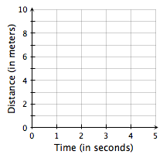 | - You are sitting still about 3 m from the motion detector and don’t move.
- Describe what’s happening in the following distance-time graphs. Include values!

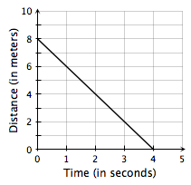 | 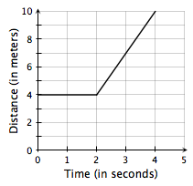

- Describe what’s happening in the following distance-time graphs. Include values!

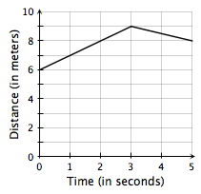 | 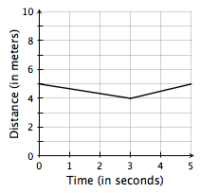

- Sketch a distance-time graph of your own design and describe the situation below.

Describe the situation.

- Describe your trip to school this morning starting with your walking out your front door and ending with your arrival at school. (Assume that your path to school is a straight line.)

- Sketch a distance-time graph based on your description of your trip to school this morning. Label and scale the axes appropriately.

