Piecewise Functions

Piecewise functions assign different rules to different inputs. Consider the piecewise function below and its corresponding graph. Note that the inequalities tell you which part of the domain is used for each rule.
$$f\left(x\right)=\left\{\begin{aligned}\begin{aligned}2x+1 \\ x^{2}\end{aligned} \\ -x+6\end{aligned} | \begin{aligned}x<-2 \\ -2≤x<2 \\ x>2\end{aligned}\right\}$$  - Find f(-4) and identify this ordered pair on the graph.  - Find f(-1) and identify this ordered pair on the graph.  - Find f(3) and identify this ordered pair on the graph. | 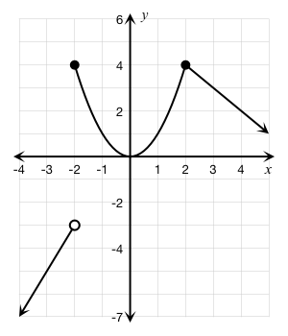

- Find f(10).

- The cost of a speeding ticket is related to the number of miles per hour that a driver is caught traveling above the speed limit. The speed limit on a section of Interstate 91 in Windsor, CT, is 65 miles per hour (mph). Consider the following hypothetical rules:

- If the driver is caught traveling less than five mph above the speed limit a warning is issued but there is no fine.
- If a driver is caught traveling 5–14 mph above the speed limit, the fine is $120.
- If a driver is caught traveling 15–24 mph above the speed limit, the fine is $15 per mph over 65 mph.
- If a driver is caught traveling 25 mph or more above the speed limit, the fine is $450.

- Complete the table below.  Speed (mph) Cost of Fine ($)  65  70  75  78  80  85  88  90  95  105 | - Graph the function on the axes below.  