Celsius and Fahrenheit

Many functions can be determined by performing experiments in which measurements are taken to study the relationship between variables. Today you will gather data in class.

There are two containers of water, one with hot and one cold. You will need ten students to conduct this experiment:

- One time keeper
- Four students at the hot water station: two will read the Celsius thermometer and two will read the Fahrenheit thermometer
- Four students at the cold water station: two will read the Celsius thermometer and two will read the Fahrenheit thermometer
- One recorder

The time-keeper will call “hot” or “cold” each minute (See table below). Everyone should keep quiet so the time keeper can be heard.

When “hot” is called, two students at the hot water station will read the Celsius thermometer and agree on a reading they will give to the recorder. At the same time the other two students at the hot water station will agree on a Fahrenheit reading to give to the recorder. Two readers are used for each reading so that reading and recording errors can be reduced. When “cold” is called, the same approach is used. Readings for the hot and cold will alternate to give the recorders a chance to get both measurements.

- Once the experiment has been completed, the recorders will share the data for the Celsius and Fahrenheit readings.
Table 1 – Temperature Readings
Minute | Hot or Cold | Reading °C | Reading °F
0 | Hot
1 | Cold
2 | Hot
3 | Cold
4 | Hot
5 | Cold
6 | Hot
7 | Cold
8 | Hot
9 | Cold
- Complete Table 2 below. Place Fahrenheit values in the domain, listing them in increasing order. Then fill in the corresponding Celsius values in the range.

Table 2 – Temperature Data
°F | °C

- Graph the data in Table 2 below. Label the axes.
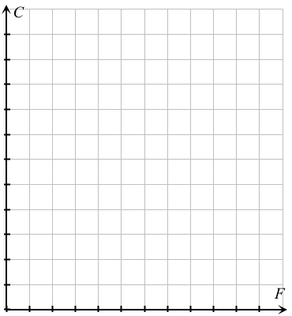

- Do you notice any trend in the graph above? Explain.

- Complete Table 3 using the data from Table 1. Place Celsius values in the domain, listing them in increasing order. Then fill in the corresponding Fahrenheit values in the range.

Table 3 – Temperature Data
°C | °F

- Graph the data in Table 3.
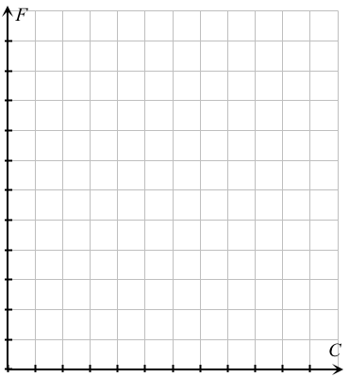

- Do you notice a trend? Explain.

- Are the graphs in questions 3 and 6 the same? Does changing the domain and range make a difference?

