Epic Fail, Epic Win
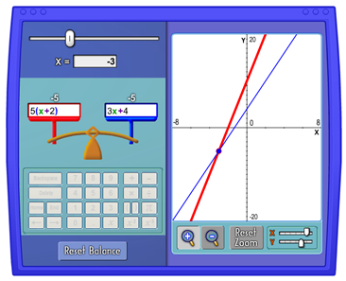
- Solve the following equation.

$$5\left(x+2\right)=3x+4$$

- Using the Pan Balance Applet at NCTM Illuminations, I entered one side of the equation in the left pan and the other side in the right pan. What does the image above tell you about the value(s) of x that makes the pans balance?

- Solve the following equations.

- $2\left(x-2\right)=3+2x$ (b) $3x+7=-(4-3x)$

- What happened? We get false statements and cannot find a real number that makes the statements true.

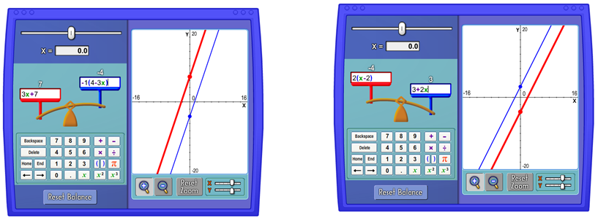
- EPIC FAIL!
What do the following images tell you about the value(s) of x that make the pans balance?

- Solve the following equations.
- $2\left(x-2\right)=-4+2x$ (b) $0.2x-4=\frac{1}{5}(x-20)$

- What happened? We get true statements. The expressions on both sides are identical.

EPIC WIN!
- What do the following images tell you about the value(s) of x that make the pans balance?
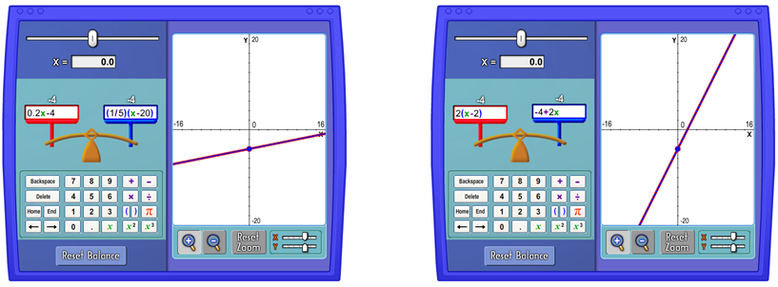

Vocabulary:
Equations where no value of x can make them true are called contradictions (EPIC FAILS!), and equations where any value of x can make them true are called identities (EPIC WINS!).

- Write down everything you see about the equations, the graphs and the solutions for the above problems.

