Evaluating Algebraic Expressions

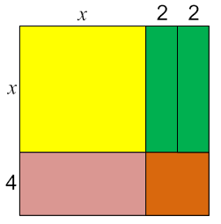
When we evaluate expressions, we follow the order of operations. We will find the perimeter and area of geometric figures that have an unknown dimension.

- Given the following group of tiles:

- Write an expression for the perimeter of the
outer square.

- Find the value of the perimeter when x = 3.

- Find the value of the perimeter when x = 5.

- Write an expression for the area of the outer square.

- Find the value of the area when x = 3.

- Find the value of the area when x = 5.

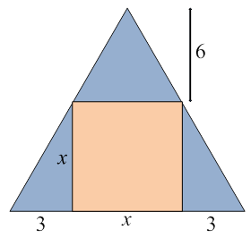
- The figure on the right shows a pink square inside a larger triangle.

- Write an expression for the area of the square.

- Write an expression for the area of the large triangle.

- Write an expression for the area that is shaded in blue.

- Find the area of the blue region when x = 6.

