Stack of Cups

Your team works for a paper products company that creates different-size paper cups. You are responsible for designing the packaging for a new paper cup design. Your design team must design a cardboard carton that could be used to package the cups for sale. Since this is a new product for your team, you must study the cups to determine which features of the cup affect the height of a stack of cups.

You will be given a set of cups. First measure the height of one cup. Then add additional cups and measure the height of resulting stack. Continue until you have at least five measurements.

# of Cups | Height of Stack (cm)
1
2
3
4
5

- Graph your data on the coordinate plane below. Include a title, and label and scale the axes appropriately.

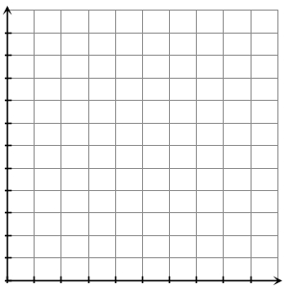

- Describe a rule that fits the pattern.

- What would happen if you moved to the left on the graph? (What height corresponds to a stack of zero cups?)

- Write a formula for the height h of your stack of n cups.

- Another team at the company performed a similar experiment with a different cup. They came up with the formula, h = 8.2 + 0.5n, where h is the height of a stack of n cups. What information can you get from this formula?

- A third team at the company did a similar experiment with a different cup. They came up with the rule: start with a height of 5.25 for the first cup and add 0.75 for each additional cup.

  - What information can you get from this rule?

  - Write a formula based on the information you got from the rule.

8. Your boss just gave your team the following data on a new cup design. Your job is to determine the heights of cartons that would hold stacks of 25, 50, and 100 cups.

# of Cups | Height of Stack (cm)
1 | 14.2
2 | 14.8
3 | 15.4
4 | 16.0
5 | 16.6

- Write a rule and a formula that model the boss’s data, using n for the number of cups and H for the height of the stack.

Rule:

Formula:

- Find the stack height for 25 cups.

- Find the stack height for 50 cups.

- Find the stack height for 100 cups.

