Patterns in Arithmetic

When you first learned to multiply, you learned that multiplication is repeated addition. This means that 4(3) is equal to 3 + 3 + 3 + 3, and 3(8) is equal to 8 + 8 + 8.

Represent each sum as a product.
1. 5 + 5 + 5 + 5 + 5 + 5 = 2. 7 + 7 + 7 + 7 =

3. 2.4 + 2.4 + 2.4 = 4. 2 + 2 + 2 + 2 + 2 =

Represent the following situations using multiplication for repeated addition.

5. Add together eight fours.

6. Add together n threes.

7. Start with twenty and add ten 5 times.

8. Start with two and add seven 3 times.

9. Start with fifty and add six n times.

10. Complete the following statement:

We can use ________________________________ to shorten how you represent repeated addition.

Does it work the same way for repeated subtraction? Yes. Represent the following situations using multiplication for repeated subtraction.

11. Start with zero and subtract three 2 times.

12. Start with eighty and subtract five 10 times.

13. Start with 10 and subtract four 8 times.

Exponents are a short-hand notation for multiplication; they tell us how many times to use the base as a factor. (Recall that factors are the numbers you multiply together to get a product.) | 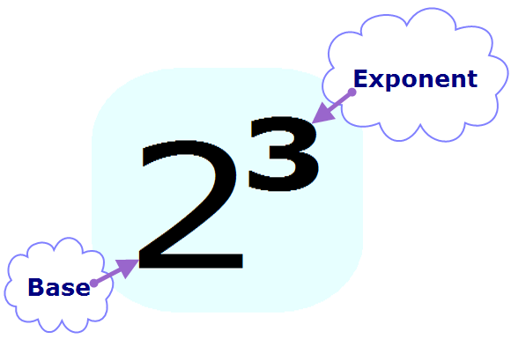
Look at the following examples:

Represent each product using exponents.

14. $5∙5∙5∙5=$

15. $7∙7∙7=$

16. $2.7∙2.7$ =

17. $9∙9∙9∙9∙9∙9$ =

Represent the following situations using exponents for repeated multiplication.

18. Multiply together eight fours.

19. Multiply together n threes.

20. Start with twenty and multiply by ten 5 times.

21. Start with two and multiply by seven 3 times.

22. Start with fifty and multiply by six n times.

23. Complete the following statement:

We can use ___________________________ to represent repeated multiplication.

Can we represent repeated division using exponents? Yes, but we must first change the division to a multiplication. Instead of dividing by a number several times, we must multiply by the reciprocal of that number several times.
$\frac{100}{x}=100∙\frac{1}{x}$ , assuming $x≠0$

Change the division to a multiplication, and then use exponents to represent repeated multiplication.

24. Divide one by six.

25. Start with thirty and divide by three 2 times.

26. Start with eighty and divide by five 10 times.

27. Start with 90 and divide by ten 3 times.

Indicate whether the following situations can be represented by repeated addition or repeated multiplication.

28. Your phone bill has a charge of $29.95 and an extra $0.10 per minute for the n minutes you went over your plan. Write an expression for the cost of your phone bill if you exceed your plan by n minutes.

29. You put the wrong soap in the dishwasher, and strange things happened. Your dishwasher started with 100 bubbles, and for n minutes, the number of bubbles tripled each minute. Write an expression for the number of bubbles in your dishwasher after n minutes.

