Modeling Algebraic Expressions – Lifting Weights

Many teenagers and adults go to gyms to lift weights. They will often gradually increase the weights that they use to increase their strength. Hector lifts weights regularly, and he has a plan to increase the size of the weight plates he uses on his weight bar. To keep the weight bar balanced he always puts two plates of the same weight on each side of the bar. The plates are not labeled but you know the bar weighs 20 kg.

- Let w represent the weight (in kilograms) of one plate. Explain what each of the expressions represents in relation to this problem.

  - w + w + 20 + w + w

  - 2w + 20 + 2w

  - 4w +20

- Simplify the following:

  - w + w + 20 + w + w b. 2w + 20 +2w

- How does your answers in 2a and 2b compare with 1c?

- Can we simplify 4w + 20? Why or why not?

- What does the 4 represent in the expression 4w + 20?

- Complete the table below. Note: the first row is done for you

Weight of one plate (kg) | Weight of plates + bar | Total weight lifted (kg)
1 | 4(1) + 20 | 24
2
3
4
w

- What would be the total weight lifted if:
  - One plate weighed 6 kg? b. One plate weighed kg?

- Use the coordinate plane below to draw a graph that shows the relationship between the weight of one plate and the total weight lifted. Label and scale the axes accordingly.

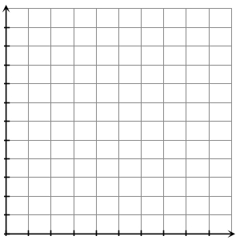

- Suppose Hector decides to put three plates of weight w on each side of his weight bar. Find an expression for the total weight lifted?

