**Review Questions for Final Examination**

**Unit 1**

* 1. Sketch an example of a polygon with 120° rotational symmetry. Explain why it has rotational symmetry.
  2. In the graph below, ∆*ABC* is translated by the vector [5, –3].

1. Sketch ∆*A’B’C’* on the gird.
2. Find the perimeters of ∆*ABC* and ∆*A’B’C’*. What do you notice?
3. Find the areas of ∆*ABC* and ∆*A’B’C’*. What do you notice?

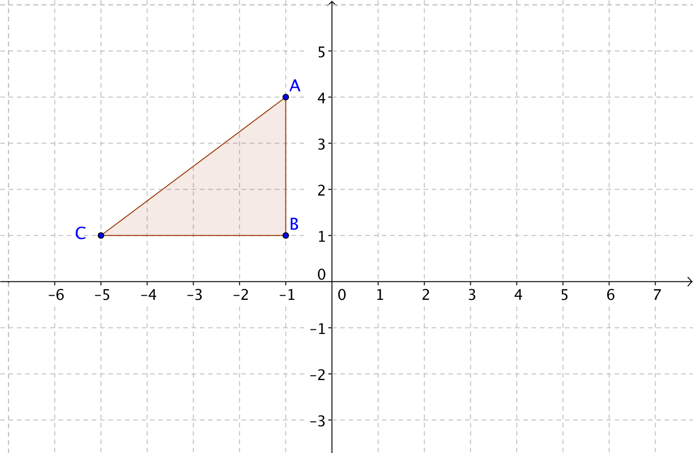

* 1. Suppose you reflect the dog over vertical line *g* and then again over vertical line *h*. If lines *g* and *h* are 6 units apart, what is one transformation you could have applied to the dog to obtain the same result as these two reflections?

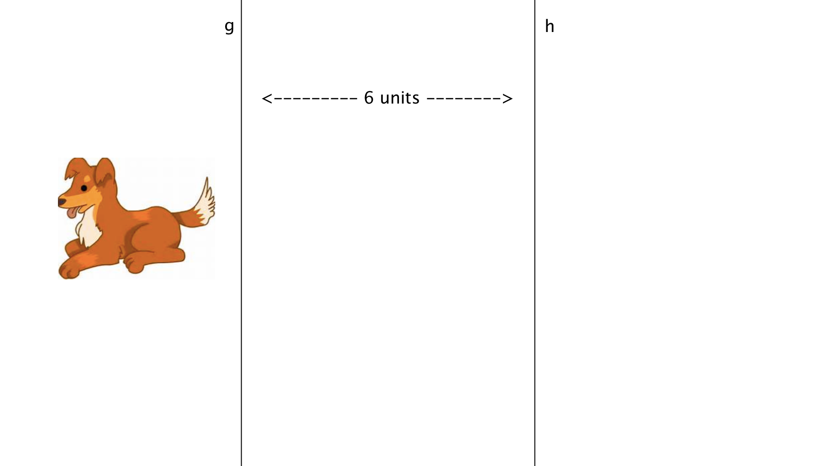

Image from clipartsheep.com

* 1. 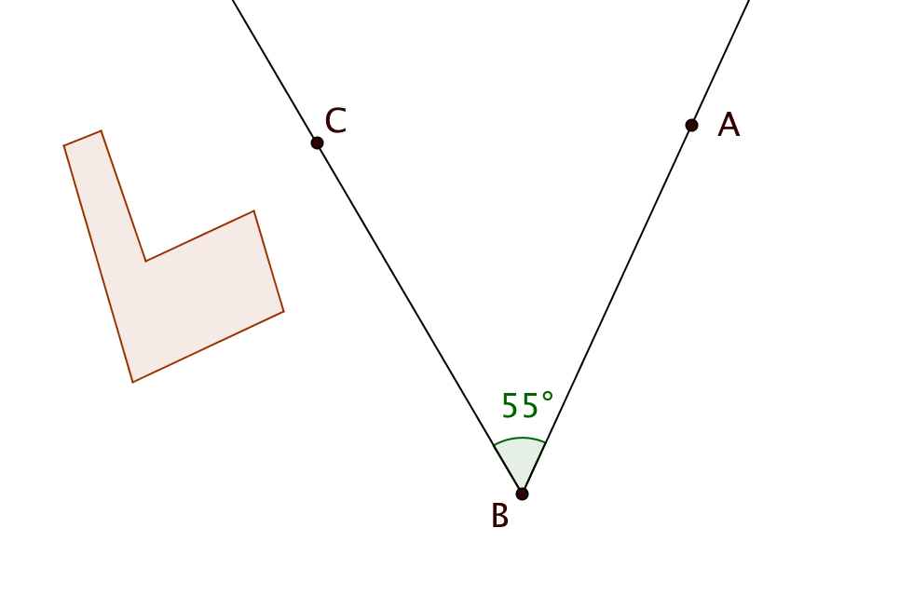 = 55°. Suppose you reflect the “chair polygon” first over line $\overset{⃡}{BC}$ then over line $\overset{⃡}{BA}$. What is a single transformation that would result in the same final image?
  2. Write mapping rules for each of these transformations:

1. A 90° counter-clockwise rotation about the origin.

1. A reflection about the line *y = –x.*

1. A reflection about the *x*-axis, followed by a translation by the vector [2, –4].
   1. Suppose you are tutoring a student in geometry. Explain, in simple terms, what a glide reflection is.
   2. Give an example of a transformation that IS NOT an isometry. Explain why.

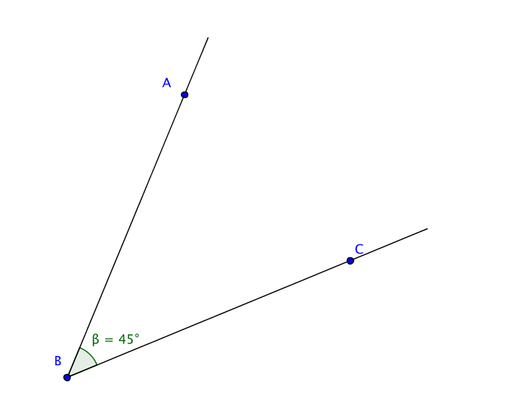

* 1. When you measure this angle with GeoGebra, you get 45° by clicking on *C*, *B*, and *A* in that order. What measure will you get if you select the points with the opposite order: *A*, *B*, *C*? Explain your reasoning.
  2. 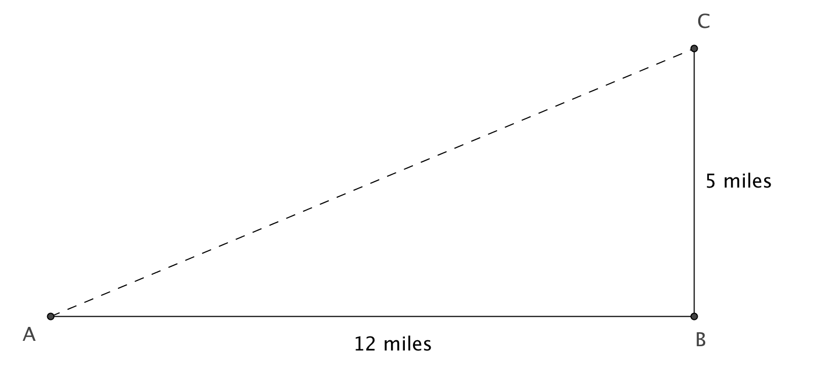A person is critically injured in an automobile accident at point *A*. The nearest hospital is located at point *C*. The shortest route for an ambulance is to drive 12 miles due east from *A* to *B*, and then 5 miles due north from *B* to *C*. A helicopter can fly directly from *A* to *B*. By how many miles is the helicopter’s route shorter than the ambulance’s route?
  3. ∆*ABC* lies in the coordinate plane with coordinates *A*(–1, –6), *B*(5, –4), and *C*(–2,–3).

1. Find the slopes of the lines containing each of the three sides.

Slope of $\overset{⃡}{AB}$ = ___________ Slope of $\overset{⃡}{AC}$ = ___________ Slope of $\overset{⃡}{BC}$ = ___________

1. Show that ∆*ABC* is a right triangle.

1. Find the length of the hypotenuse two ways: (1) by using the distance formula and (2) by the Pythagorean Theorem.

1.11. A quadrilateral has four lines of symmetry.

1. Sketch the quadrilateral showing the location of the lines of symmetry.
2. What type of special quadrilateral must it be?

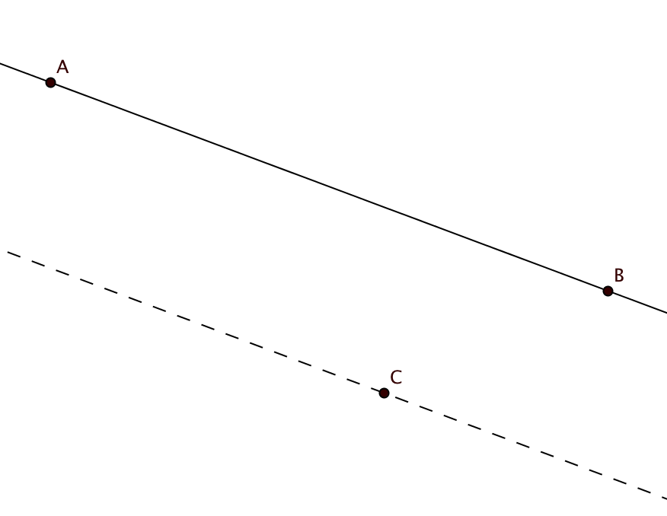

* 1. In the diagram, the dashed line through *C* is parallel to $\overset{⃡}{AB}$.

1. Suppose $\overset{⃡}{AB}$ is reflected about the dashed line. Will the image $\overset{⃡}{A’B’}$ be parallel to $\overset{⃡}{AB}$?
2. Suppose $\overset{⃡}{AB}$ is rotated counter-clockwise 180° about point C. Will $\overset{⃡}{A’B’}$ be parallel to $\overset{⃡}{AB}$?
3. Suppose $\overset{⃡}{AB}$ is rotated 90° counter-clockwise about point C. Will $\overset{⃡}{A’B’}$ be parallel to $\overset{⃡}{AB}$?
4. Suppose $\overset{⃡}{AB}$.is dilated with dilation center at *C* by a scale factor of 2. Will $\overset{⃡}{A’B’}$ be parallel to $\overset{⃡}{AB}$?
5. Suppose $\overset{⃡}{AB}$ is translated by the vector from *C* to *A*. What happens to $\overset{⃡}{A’B’}$?
6. Suppose $\overset{⃡}{AB}$ is translated by the vector from *B* to *A*. What happens to $\overset{⃡}{A’B’}$?

**Unit 2**

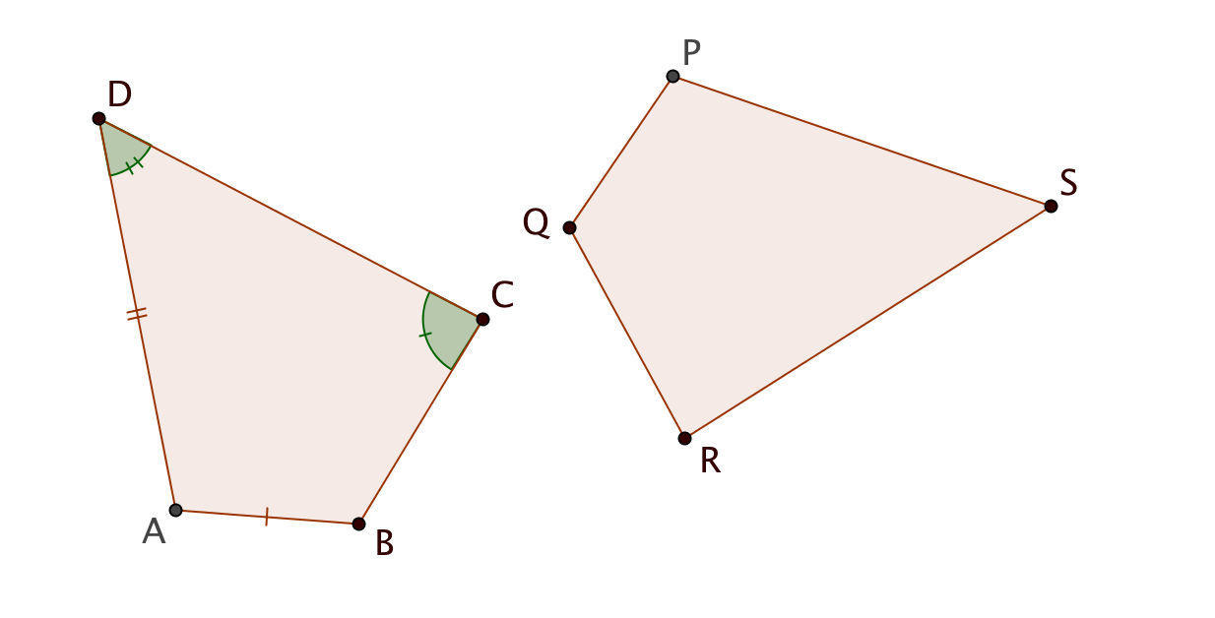

2.1 Quadrilateral *ABCD* is congruent to quadrilateral *PQRS*.

a. Two sides and two angles of *ABCD* have been marked. Use the same marks for the corresponding sides of *PQRS.*

b. Fill in the blanks to show relations between the two figures.

*BC* =

$$∠PQR ≅ ∠ _____$$

 ______

m $∠DAB=m ∠ _____$

$\overline{RS}$ $≅$

____

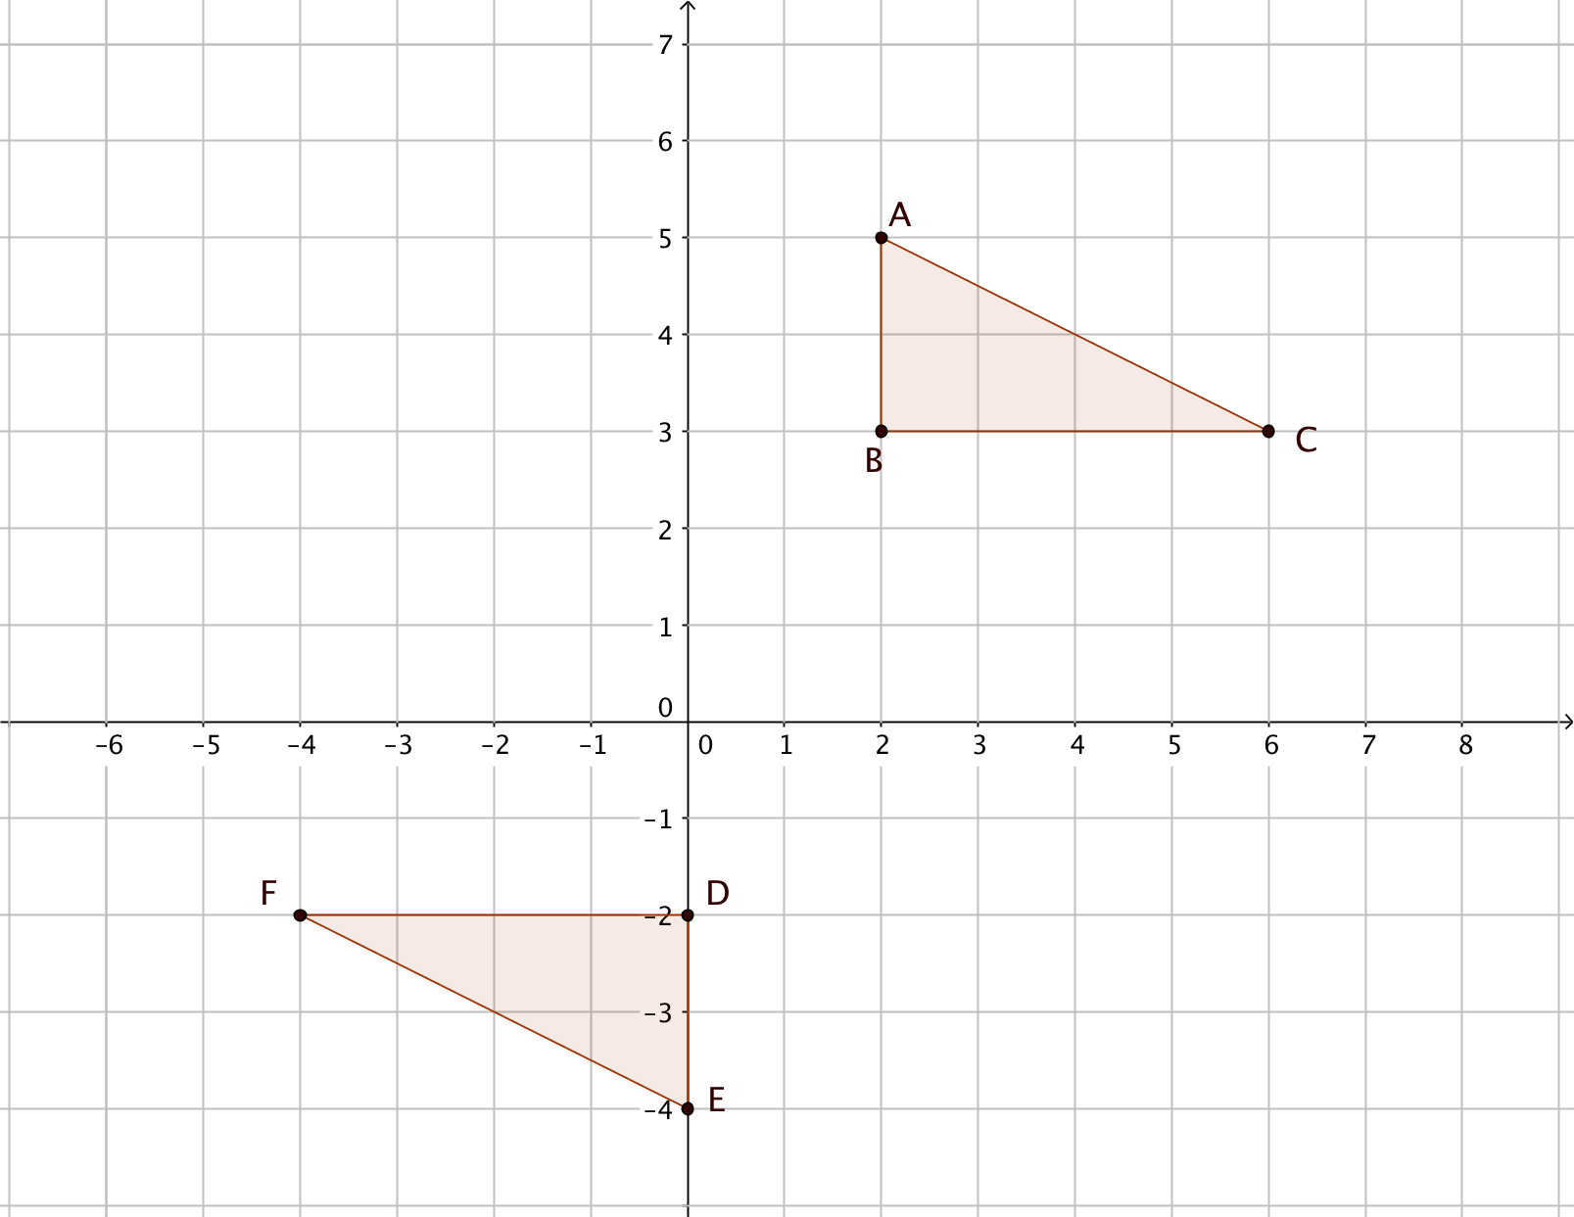

2.2 Describe a transformation or a set of transformations that will map ∆*ABC* onto ∆*DEF.*

2.3 Under what conditions are two circles congruent? Justify your answer.

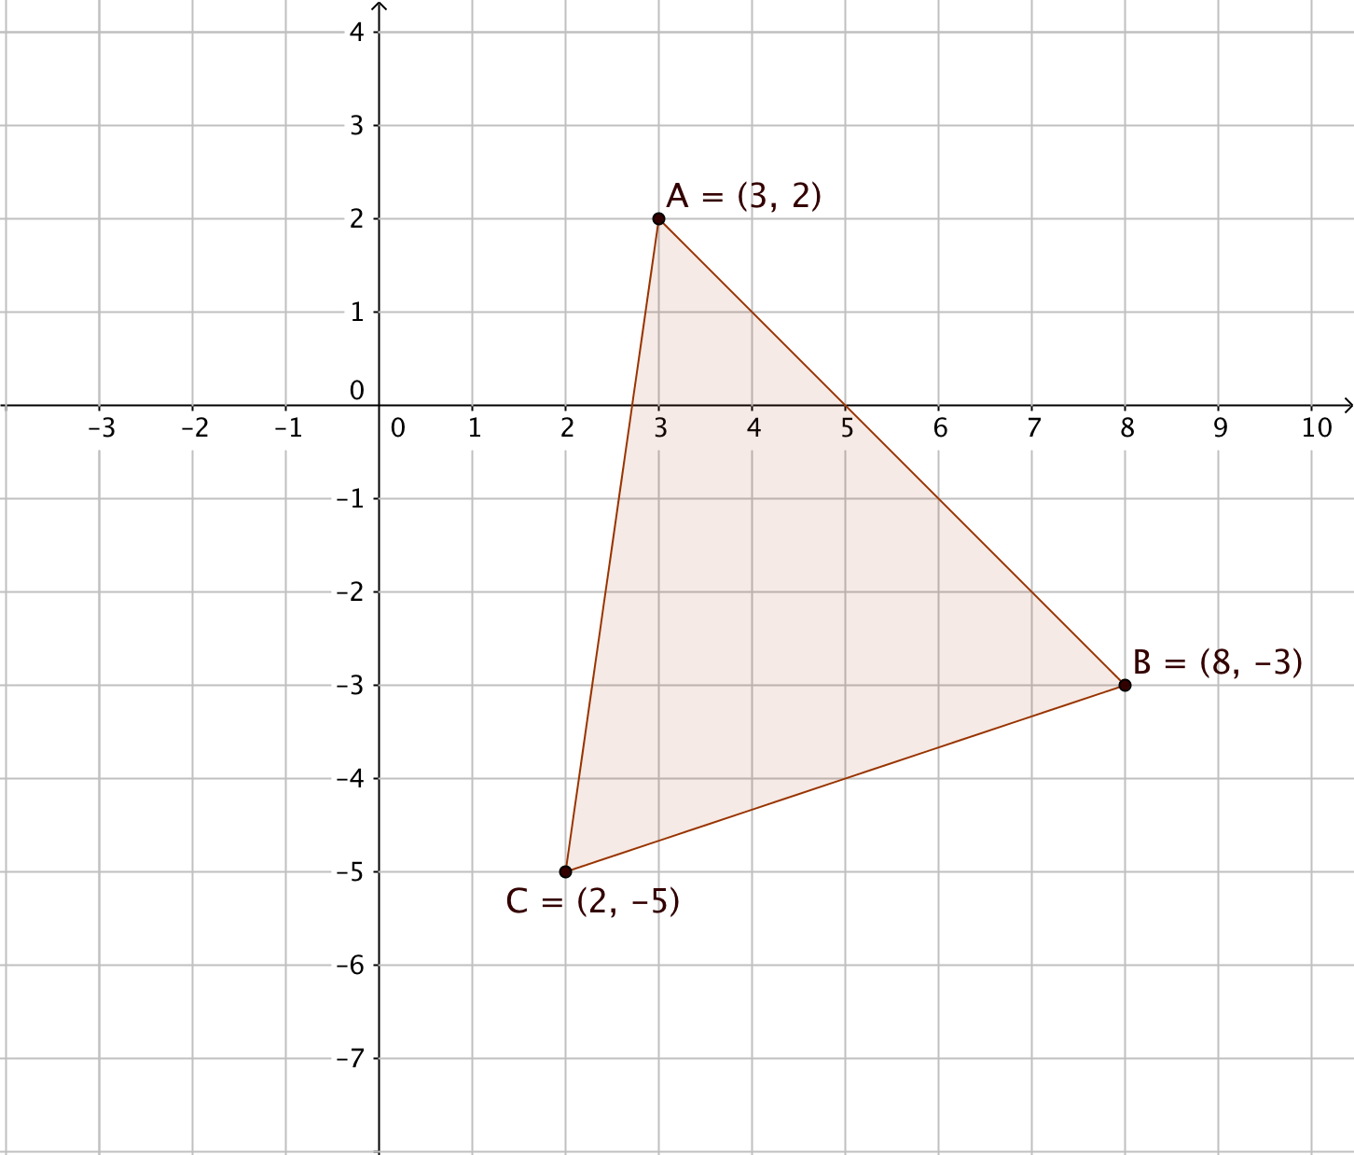

2.4 The coordinates of the vertices of ∆ABC are given in the figure.

1. Is ∆*ABC* isosceles? Explain.
2. Is ∆*ABC* equilateral? Explain.
3. Name two congruent angles.

2.5 Decide whether each pair of triangles may be proved to be congruent with the given information. If they can be proved congruent, identify the theorem you would use.

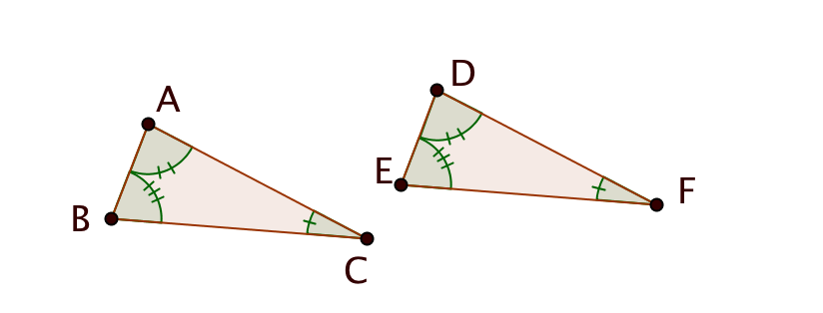

1. 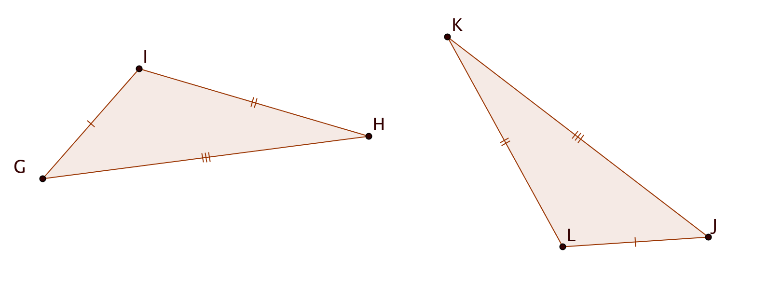Given $∠A ≅ ∠D$ $$∠B ≅ ∠E \\ ∠C ≅ ∠F$$ Can you prove ∆*ABC $≅$* ∆*DEF*?  
     
   If so, which theorem?
2. Given $\overline{IG}≅$ $\overline{LJ}$ $\overline{HI}≅$ $\overline{KL}$ $\overline{GH}≅$ $\overline{JK}$
      
      
   Can you prove ∆*GHI $≅$* ∆*JKL*?  
     
   If so, which theorem?

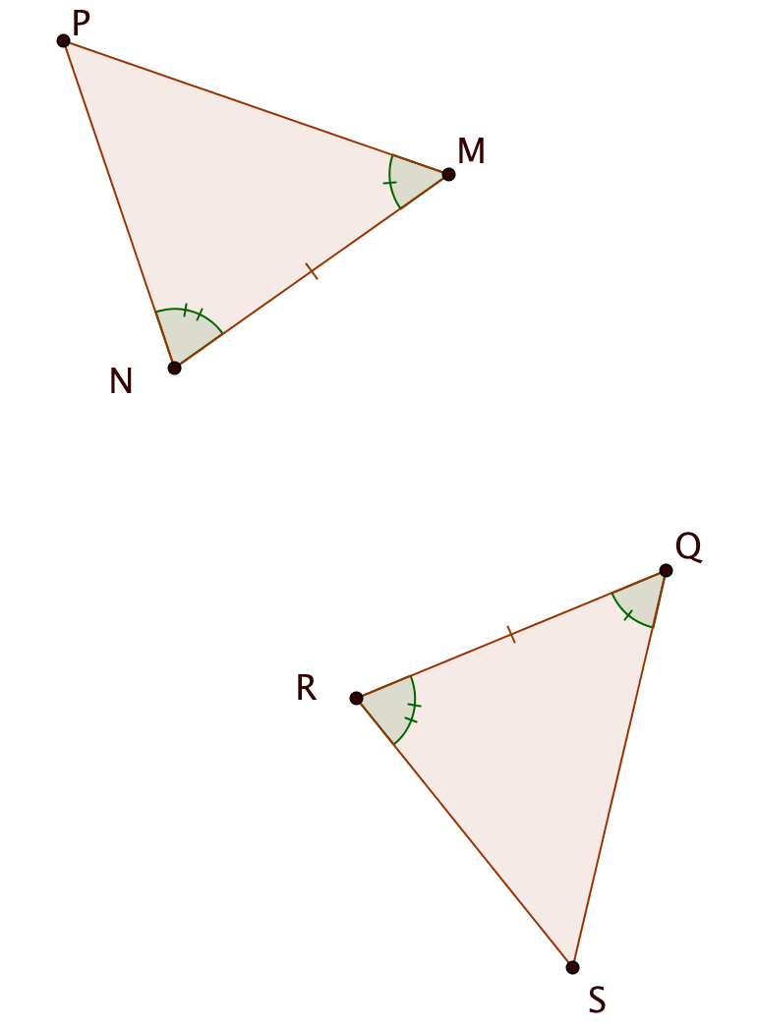

1. Given $\overline{MN}≅$ $\overline{QR}$ $$∠M ≅ ∠Q \\ ∠N ≅ ∠R$$
   Can you prove ∆*MNP $≅$* ∆*QRS*?  
     
   If so, which theorem?

1. 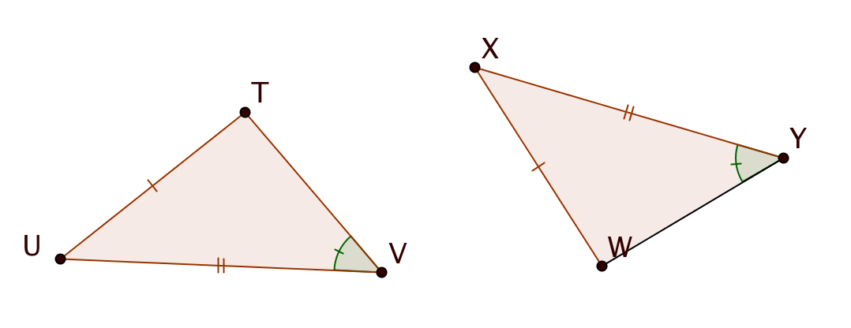Given $\overline{TU}≅$ $\overline{WX}$ $\overline{UV}≅$ $\overline{XY}$ $$∠V ≅ ∠Y$$
      
   Can you prove ∆*TUV $≅$* ∆*WXY*?  
     
   If so, which theorem?  
     
     
     
      
   2.

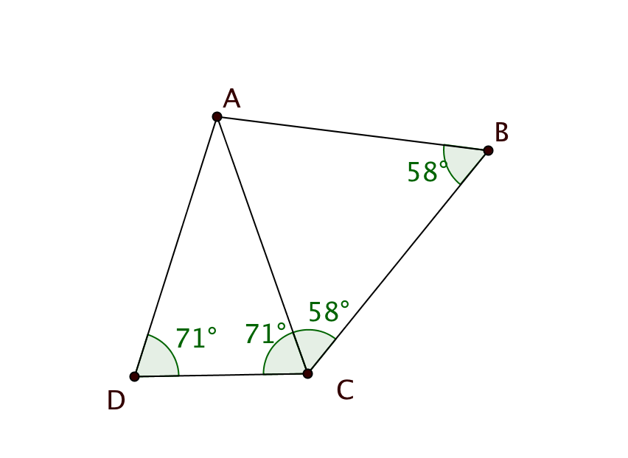2.6

Given: m $∠ADC$ = m $∠ACD$ = 71°

m $∠ACB$ = m $∠ABC$ = 58°

Prove: *AD* = *AB*

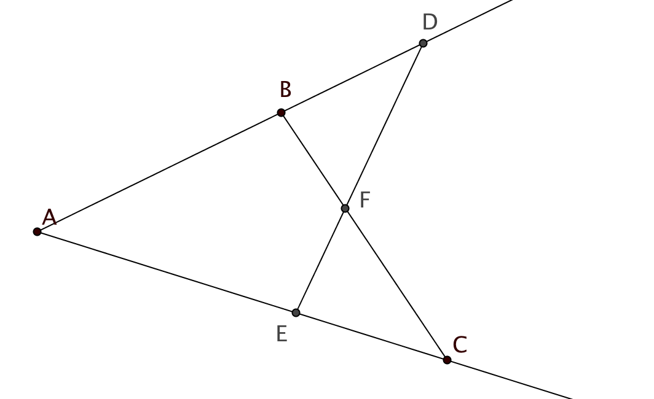

2.7

Given: *AB = AE*

*AC = AD*

Prove ∆*ABC $≅$* ∆*AED*

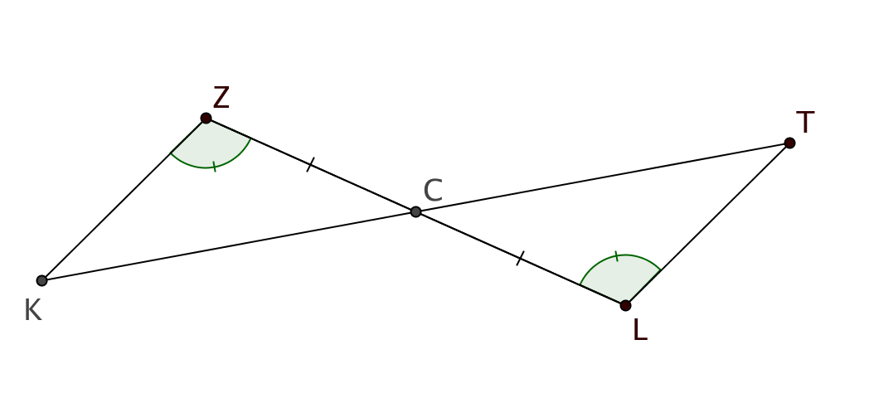2.8

Given: m $∠KZC$ = m $∠TLC$ 
 *C* is the midpoint of $\overline{LZ}$

Prove: m $∠ZKC$ = m $∠LTC$

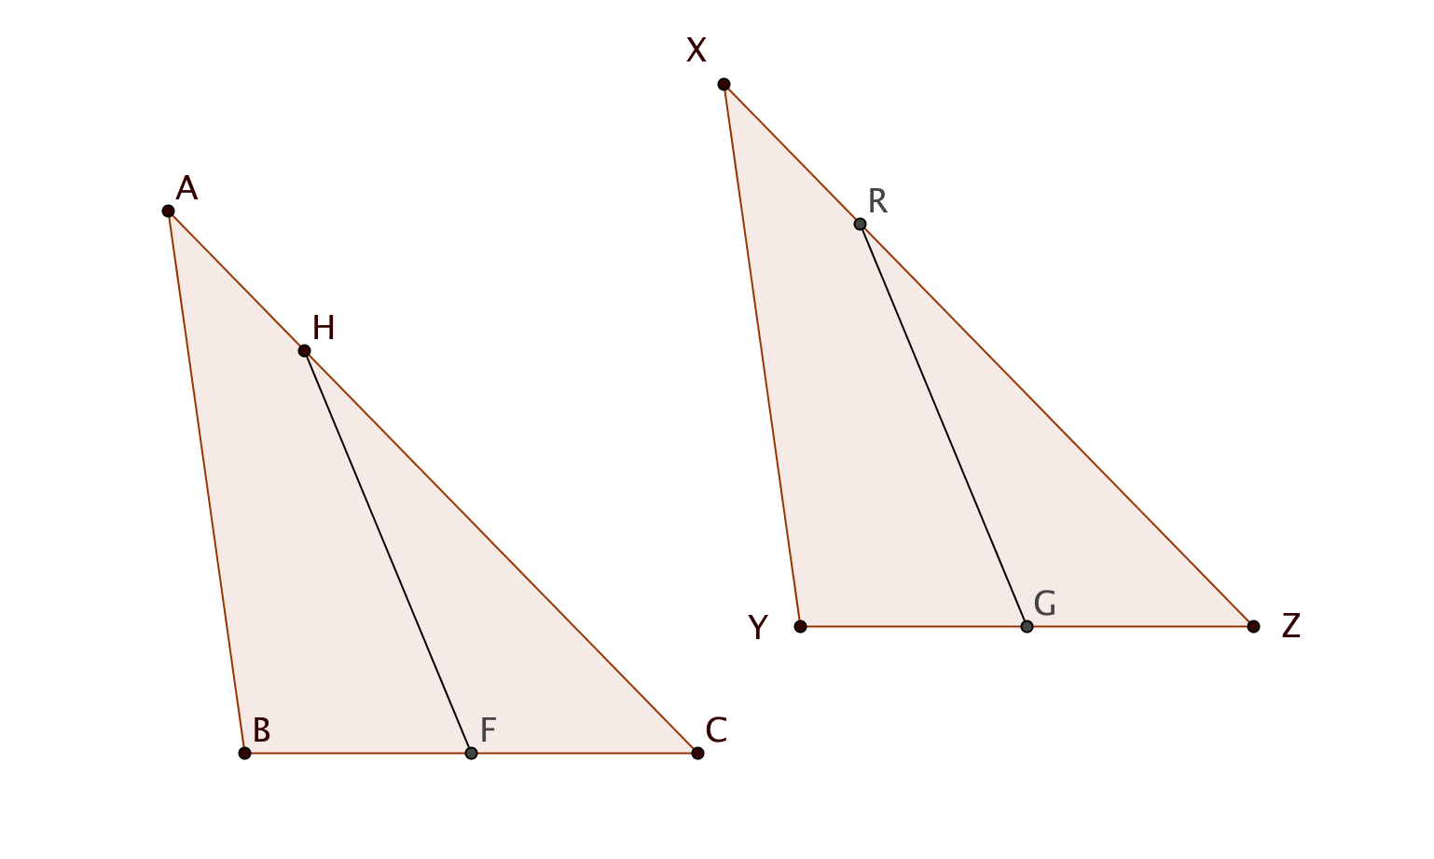

2.9

Given: ∆*ABC $≅$* ∆*XYZ*

*F* is the midpoint of $\overline{BC}$

*G* is the midpoint of $\overline{YZ}$

*CH =ZR*

Prove: ∆*HFC $≅$* ∆*RGZ*

2.10

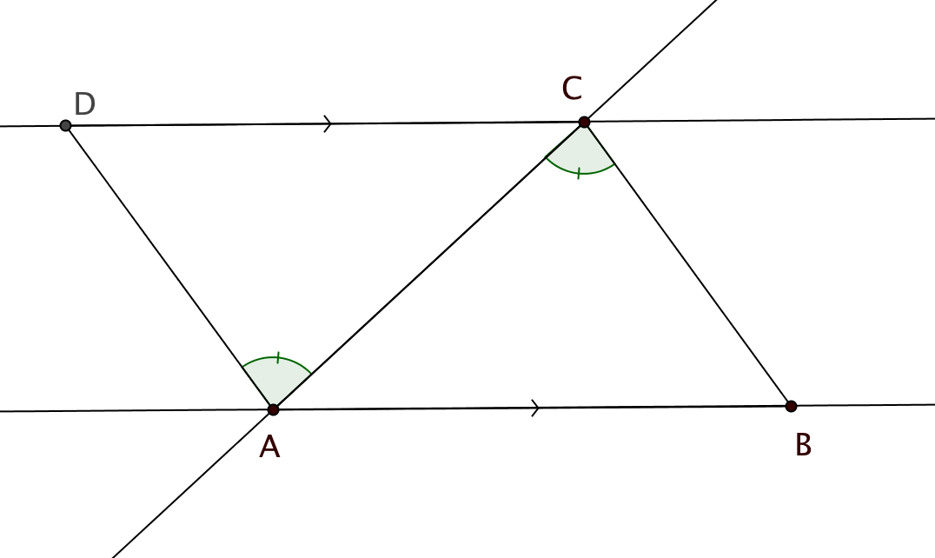

Given: ||

Prove: $\overline{AD}$ $≅$ $\overline{CB}$

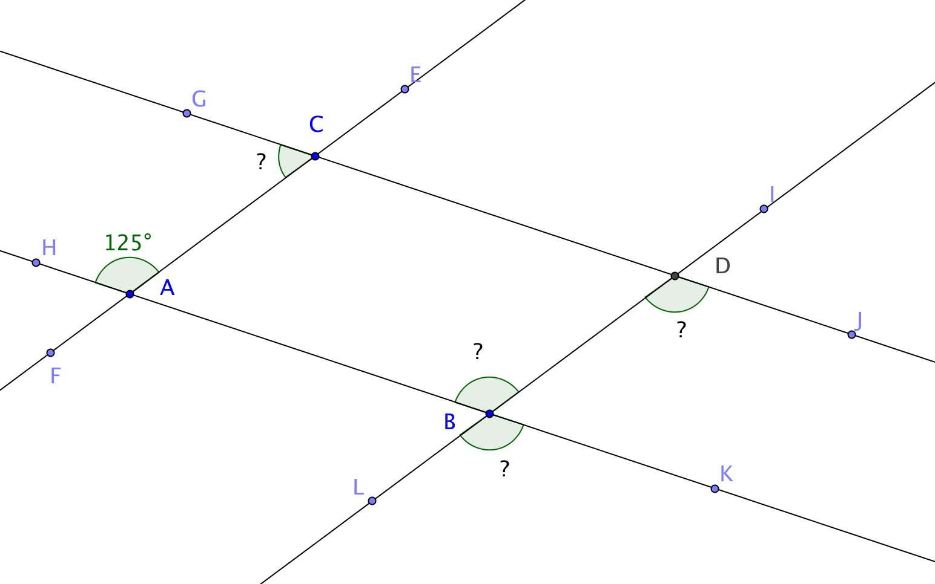2.11

Given: ||

||

m $∠HAC$ = 125°

Find the measure of each angle and justify your answers.

1. m $∠ABD$ = _____
2. m $∠BDJ$ = _____
3. m $∠LBK$ = _____
4. m $∠GCA$ = _____

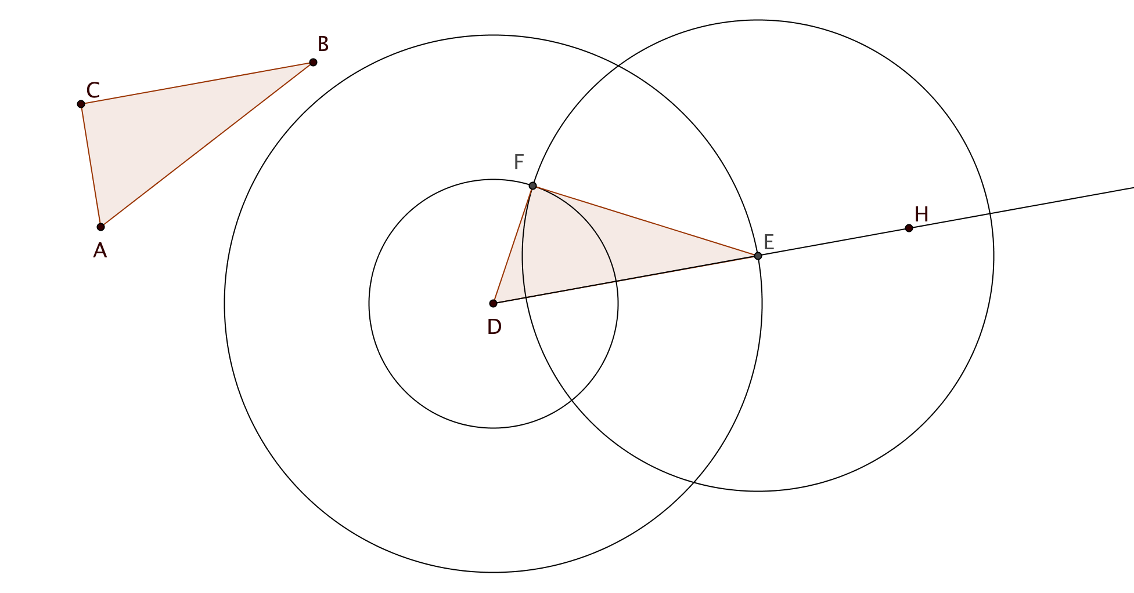2.12 A student was given ∆*ABC* and asked to construct ∆*DEF* so that side $\overline{DE}$ lies along ray $\vec{DH}$.

Here is what she did:

1. She drew a circle with center *D* and radius = *AB*. She labeled point *E* where this circle intersects $\vec{DH}$.
2. She drew a circle with center *D* and radius = *AC.*
3. She drew a circle with center *E* and radius = *BC.*
4. She labeled *F* as one of the points where the last two circles intersect and drew segments $\overline{DE}$ and $\overline{EF}$.

Prove that her construction works; that is, ∆*DEF $≅$* ∆*ABC*.

2.13 With a compass and straightedge, construct an angle measuring 120° OR explain how you would construct an angle measuring 120° with a compass and straightedge.

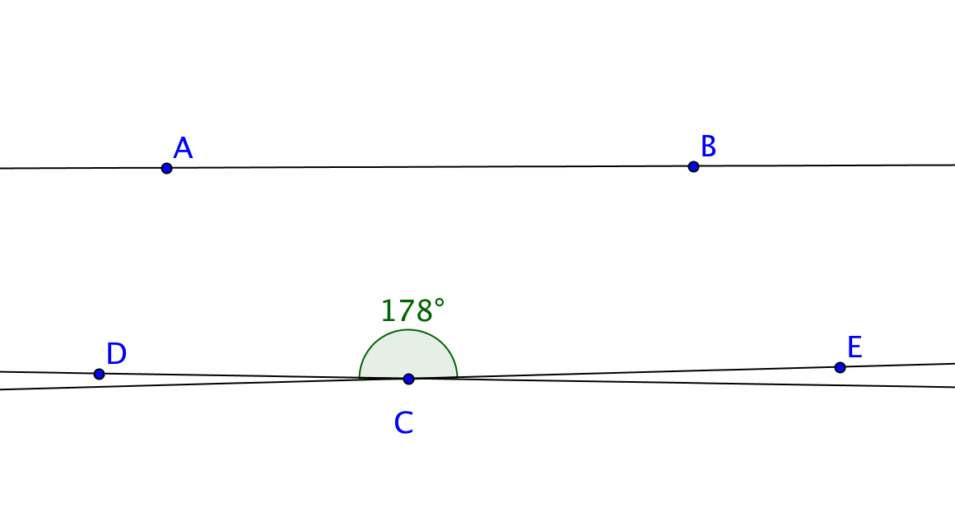

2.14 Two lines $\overset{⃡}{DC}$ and $\overset{⃡}{EC}$ intersect at point *C* and form an angle measuring 178°. Is it possible for both $\overset{⃡}{DC}$ and $\overset{⃡}{EC}$ to be parallel to $\overset{⃡}{AB}$? Explain.

**Unit 3**

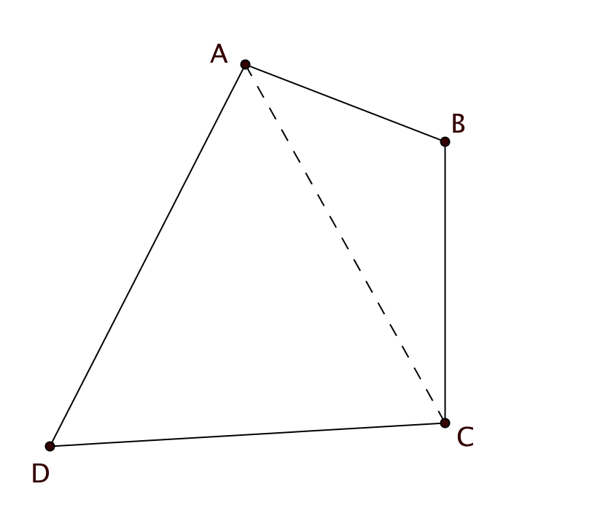

* 1. Use this diagram to explain how the Quadrilateral Sum Theorem can be proved using the Triangle Sum Theorem.
  2. Here is another way to prove the Quadrilateral Sum Theorem:

1. Start with Quadrilateral *ABCD*. (See figure at the bottom of the page.) Rotate it about *E*, the midpoint of $\overline{BC}$, to produce *A’B’C’D’*.
2. Rotate *ABCD* about *F*, the midpoint of $\overline{CD}$, to produce *A’*1 *B’*1 *C’*1 *D’*1.
3. Translate *ABCD* by the vector from *A* to *C*.  
     
   a. Explain why m $∠BCD$ + m *A’B’C’* + m *B’*2*A’*2*D’*2+ m *C’*1*D’*1*A’*1 = 360°

b. Explain why m $∠BCD$ + m $∠$*ABC* + m *BAD* + m $∠$*CDA* = 360°

* 1. 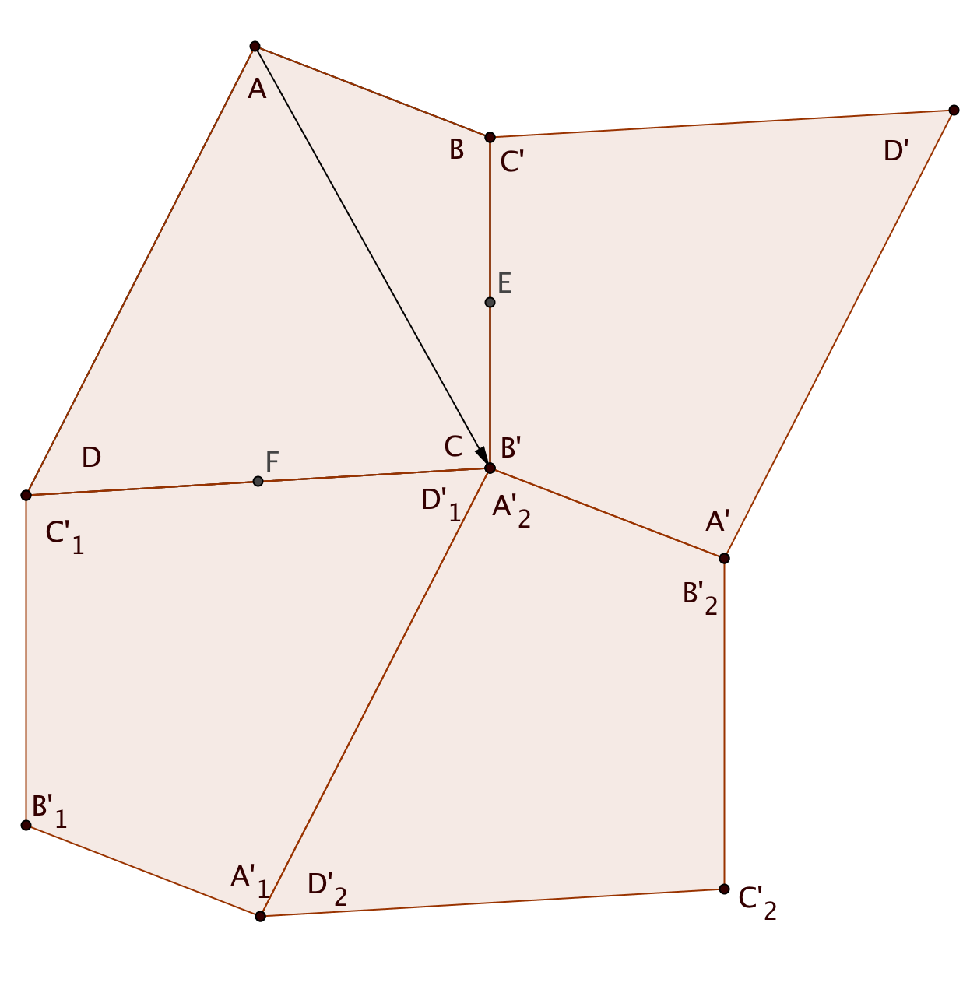On the figure below show how additional copies of *ABCD* can be added to create a tessellation. (Show at least four more quadrilaterals)

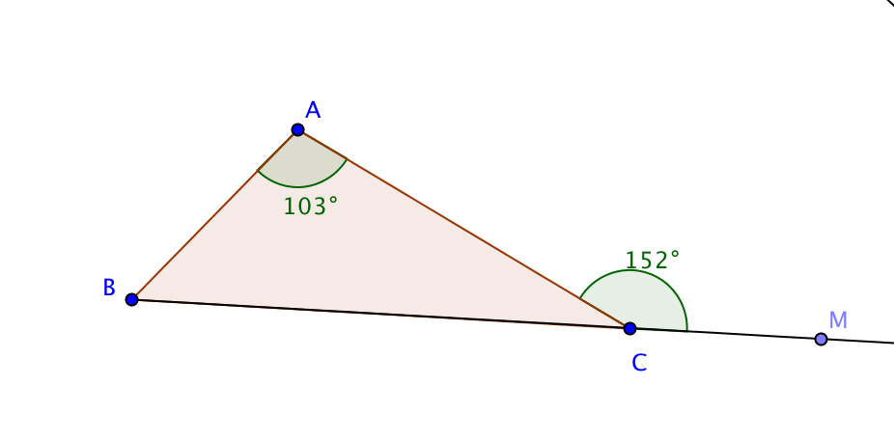3.4 Find the measure of each indicated angle using information given on the figures. Justify each answer.

1. 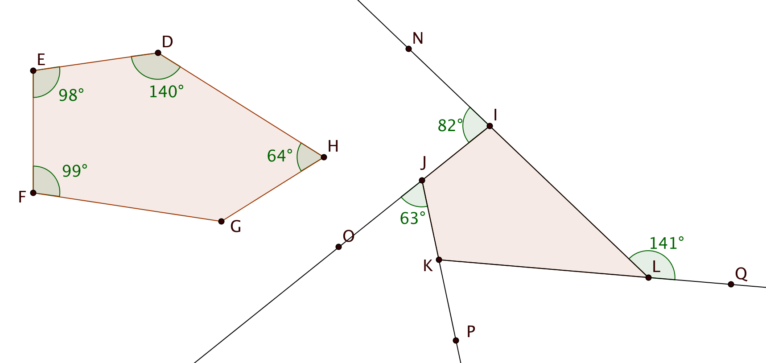m $∠ABC= ________$
2. m $∠FGH= ________$
3. m $∠LKP= ________$
4. m $∠JKL= ________$

3.5 Find the number of sides in a regular polygon when:

a. each interior angle measures 108°

b. each exterior angle measures 36°

c. the sum of the interior angles is twice the sum of the exterior angles.

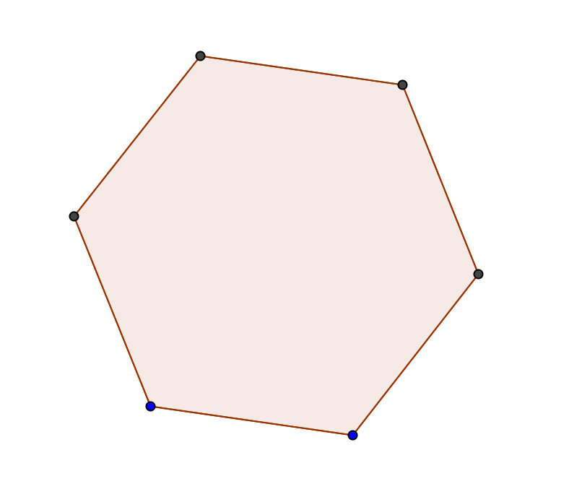3.6 Show all lines of symmetry for this regular hexagon.

3.7 Something is wrong in the diagrams based on the information given. Explain the error in each case.

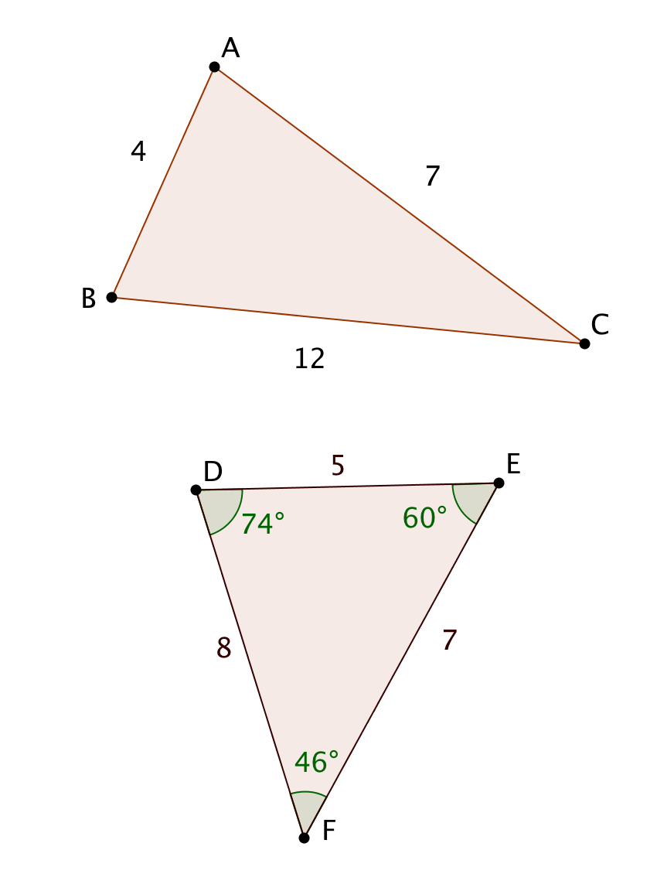

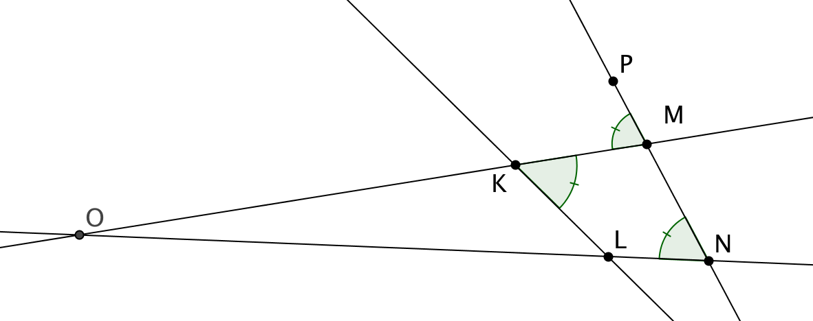a. b.

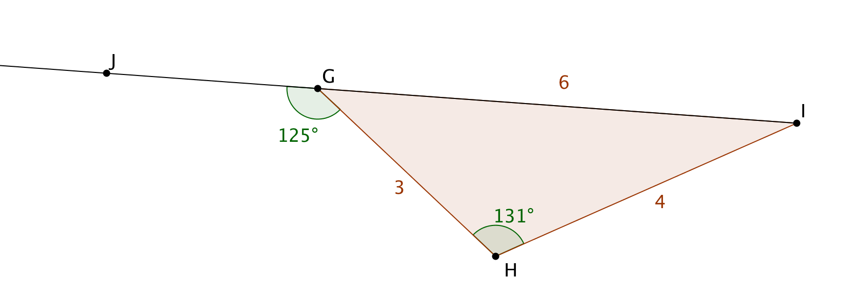

c. d.

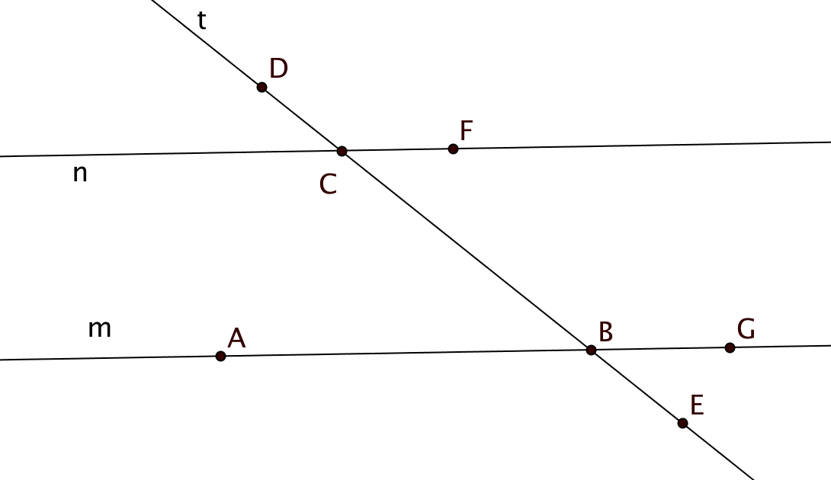3.8 Complete this proof of the statement: If two lines are intersected by a transversal and one pair of same side exterior angles are supplementary, then the lines are parallel.

Given: Lines *m* and *n* are intersected by transversal *t*.  
 m $∠DCF$ + m $∠EBG$ = 180°

Prove: *m* || *n*

Complete the proof here:

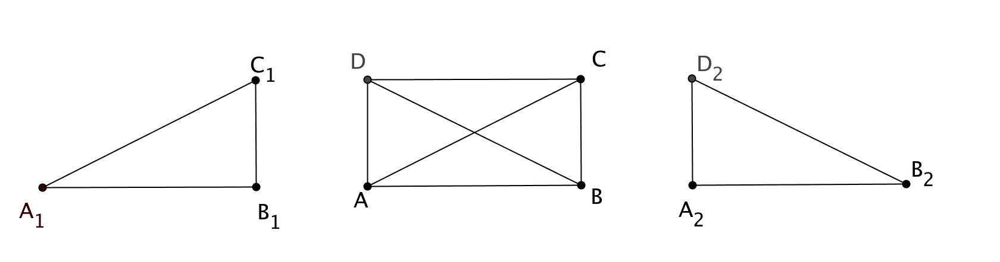3.9 Given *ABCD* is a parallelogram.

∆*ABD $≅$* ∆*BAC*

Prove: *ABCD* is a rectangle.

(Hint: to help you visualize the congruent triangles, ∆*A*1*B*1*C*1 and ∆*A*2*B*2*C*2 have been drawn to the left and right of the parallelogram.)

3.10 A middle school student says to you “We are learning about area. I know that the formula for the area of a triangle is $\frac{1}{2}$ base times height, but where does the $\frac{1}{2}$ come from? How would you answer her question?

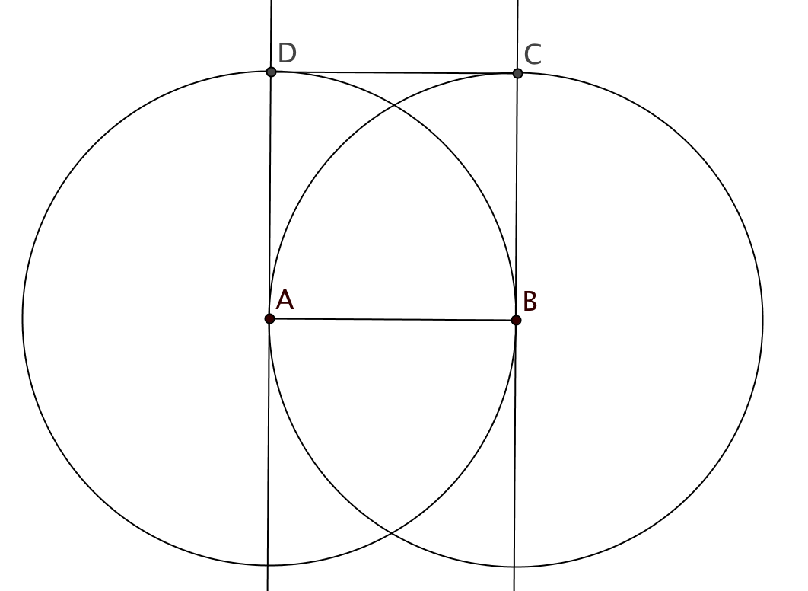

3.11 A student constructs a square with side $\overline{AB}$ with the following steps. First he constructs a line perpendicular to $\overline{AB}$ at point *A* and another line perpendicular to $\overline{AB}$ at point *B*. Then he draws a circle with center *A* passing through *B* and another circle with center *B* passing through *A*. He labels points *C* and *D* where the circles intersect the perpendicular lines. He draws segment $\overline{CD}$ and claims that *ABCD* is a square. Do you agree with his claim? Defend your answer.

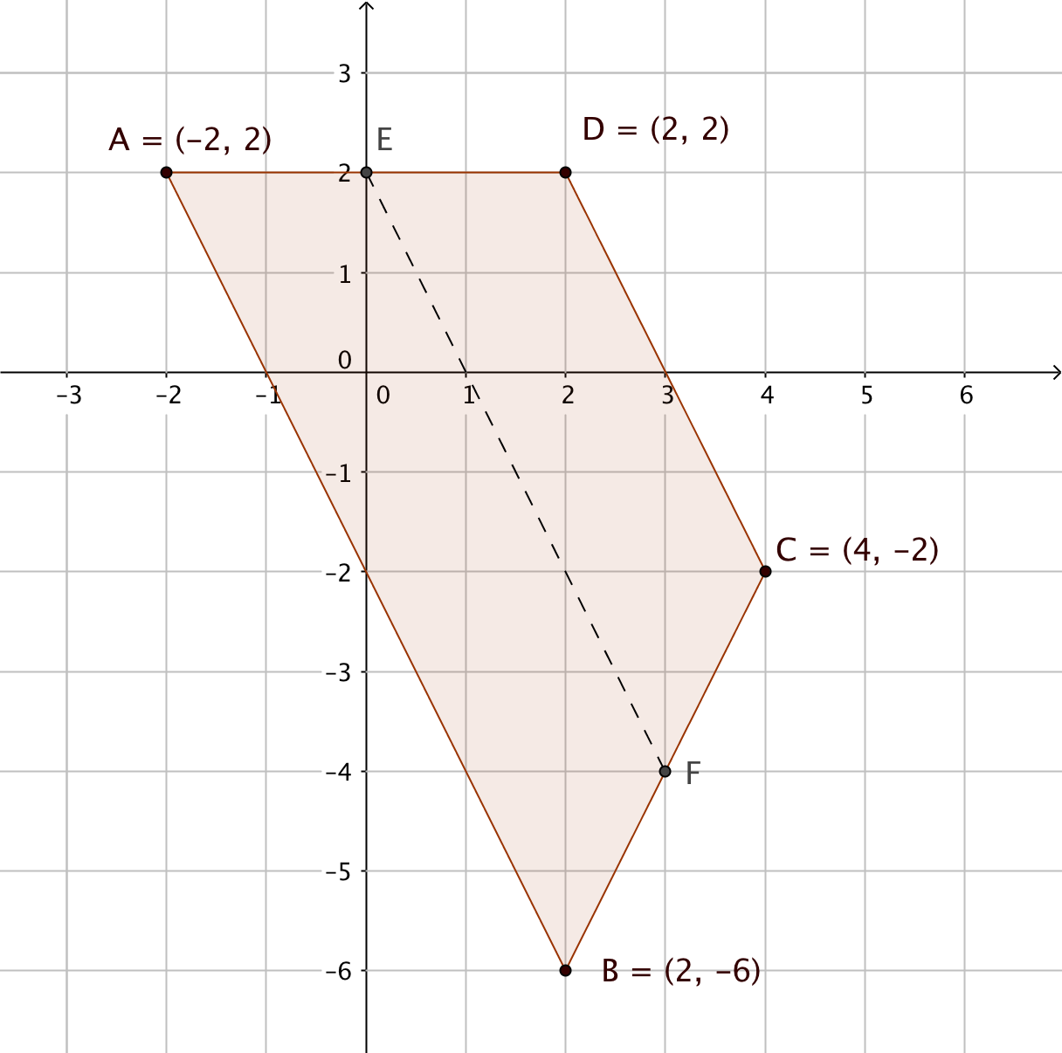3.12 Quadrilateral *ABCD* lies in a coordinate plane. The coordinates of the vertices are shown.

1. What kind of special quadrilateral is *ABCD*? Explain.
2. Let *E* be the midpoint of $\overline{AD}$ and *F* be the midpoint of $\overline{BC}$. Use the distance formula to show that $\frac{AB+CD}{2}$ = *EF.*
3. Show that || .
4. What theorem is illustrated by the results in (b) and (c)?

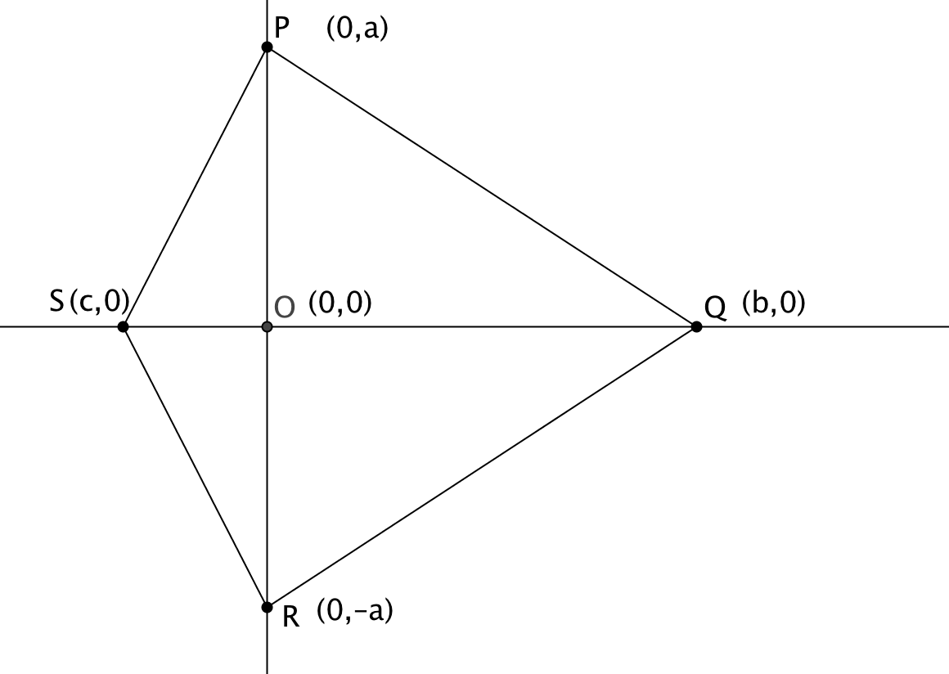

3.13 Quadrilateral *PQRS* is placed in the coordinate plane with coordinates *P*(0, *a*), *Q*(*b*, 0), *R*(0, – *a*) and *S*(*c*, 0).

1. Prove that *PQRS* is a kite.
2. Suppose that *c* = – *b*. What kind of special quadrilateral is *PQRS* now? (Give the most specific category.) Explain.
3. Suppose that *c* = – *b* and *a* = *b*. What kind of special quadrilateral is *PQRS* now? Explain.

**Unit 4**

4.1 Quadrilateral *PQRS* ~ quadrilateral *JKLM.*

1. Find the scale factor.
2. Find the values of *w*, *x*, and *y.*
3. Name an angle congruent to $∠$*KLM*.

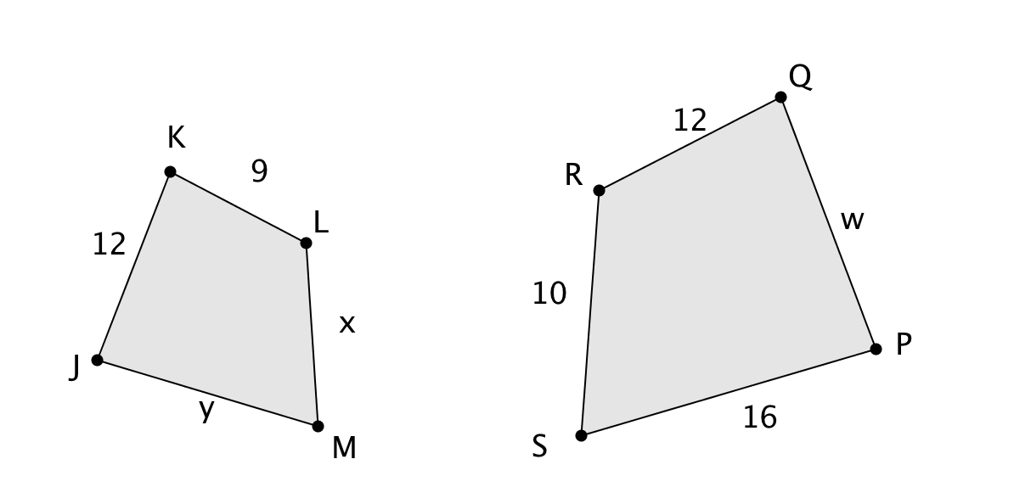

4.2 A group of scouts are camping near a pond. They would like to know how wide the pond is. From point *P* they use clinometers to measure the distances to points *C* and *D*. They extend rays $\vec{CP}$ and $\vec{DP}$ in straight lines to points *A* and *B*. Then they pace off the distances *PA, PB*,and *AB.* All their measurements are shown on the figure below.

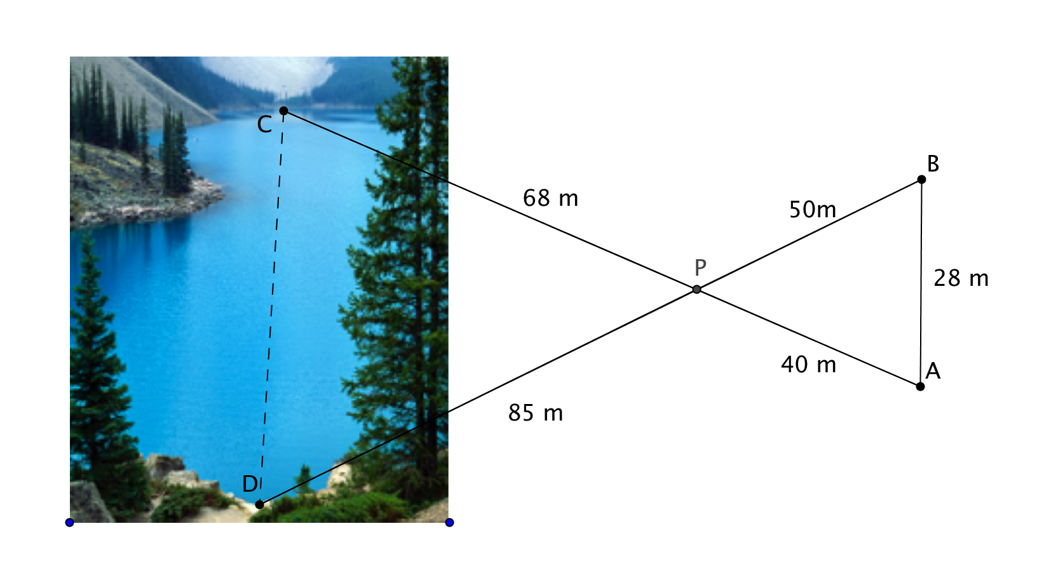

1. Prove that ∆*ABP* ~ ∆*CDP*.
2. Find the width of the pond, *CD*, to the nearest meter.

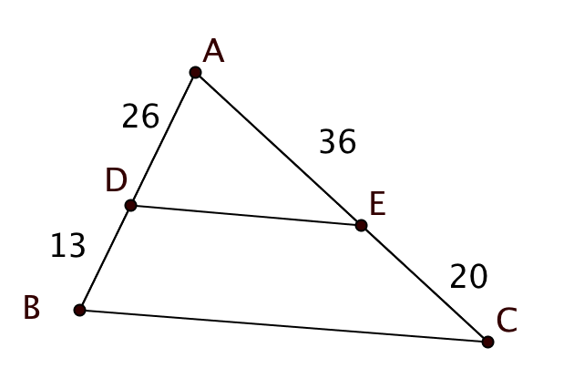4.3 In each case decide whether the given triangles are similar. Justify your answer.

1. Is ∆*ABC* similar to ∆*ADE*? Explain.

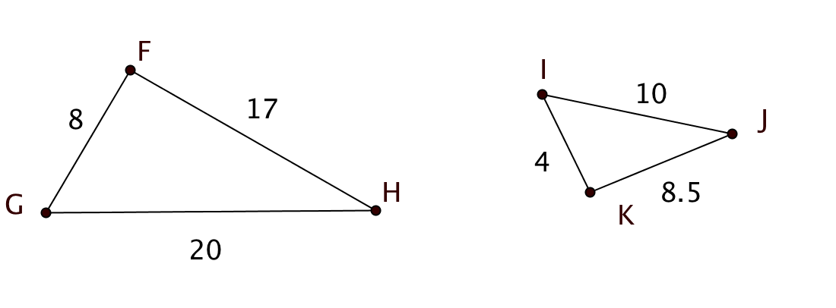

1. 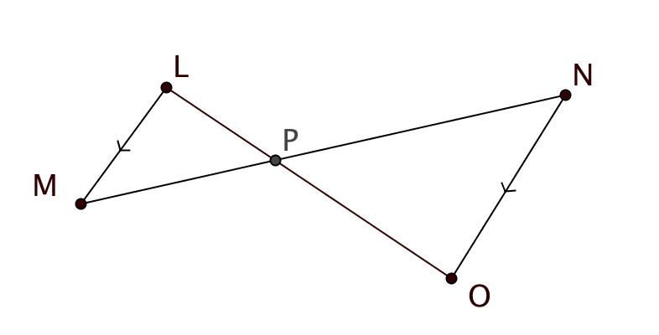Is ∆*FGH* similar to ∆*KIJ*? Explain.
2. || .   
   Is ∆*LMP* similar to ∆*ONP*?  
   Explain.

4.4 In the figure, $∠RSV ≅∠RTU.$

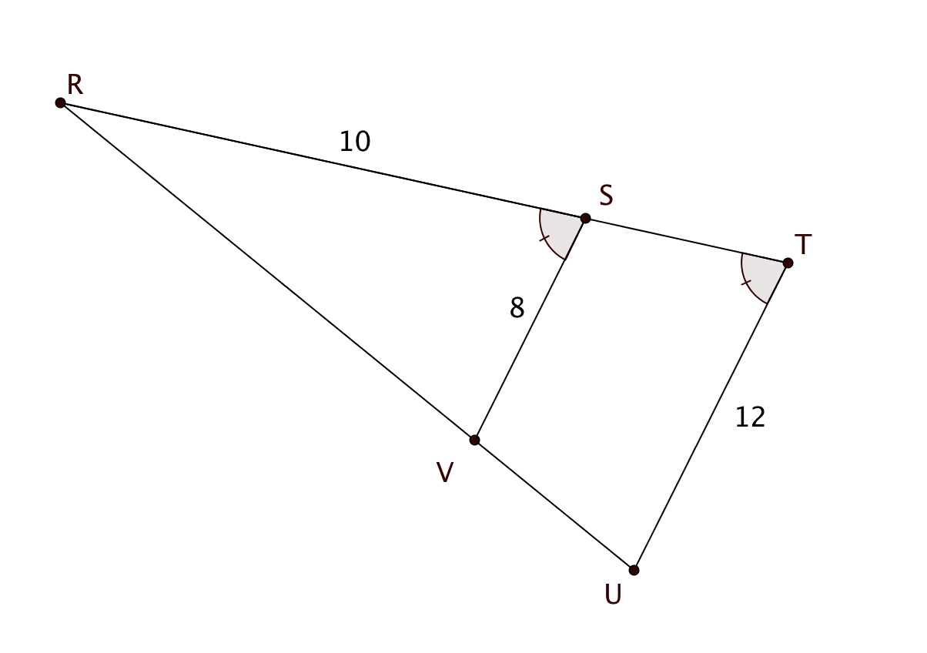*RS* = 10, *VS* = 8, and *UT* = 12.

Find *RT* and the ratio $\frac{UV}{ RV}$. Justify your answers.

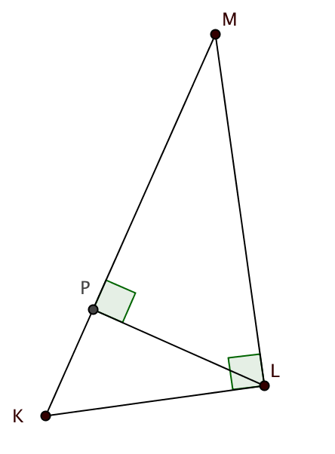4.5 In the figure at the right, $\overline{LP}$ is the altitude to the hypotenuse of right triangle *KLM*.

Fill in the blanks to make the proportions correct:

1. $\frac{KL}{LM}$ = $\frac{PK}{}$ = $\frac{}{PM}$
2. $\frac{KM}{}$ = $\frac{KL}{PK}$ = $\frac{}{PL}$

4.6 *A’B’C’D’* is the image of trapezoid *ABCD* under a dilation.

1. On the grid below, locate the center of dilation.
2. Find the scale factor for this dilation. Explain your reasoning.

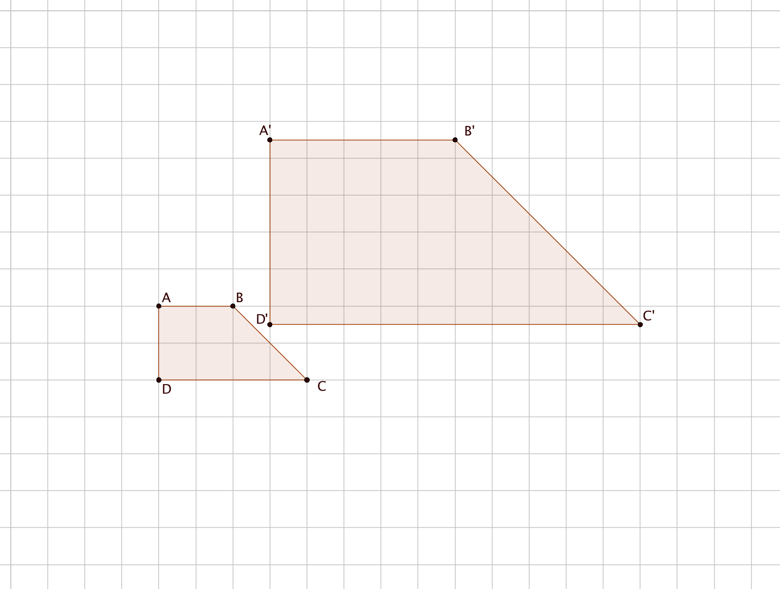

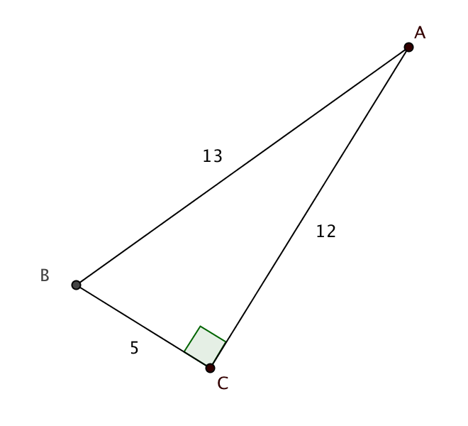4.7 In right triangle *ABC*, *AB* = 13, *BC* = 5 and *AC* = 12. Find:

1. sin *A* =
2. sin *B* =
3. cos *A* =
4. cos *B* =
5. tan *A* =
6. tan *B* =

4.8 A 24 foot-long ladder is resting against the roof of a house that is 20 feet high. What is the angle at which the ladder meets the house? Answer to the nearest 0.1 degree.

[www.clipartsheep.com](http://www.clipartsheep.com)

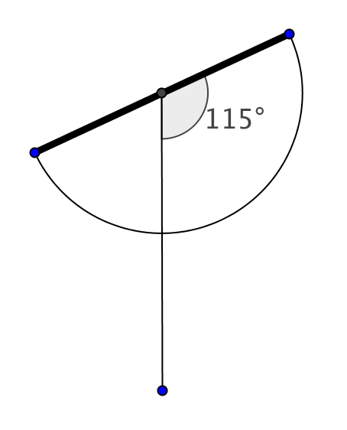

4.9 Jane is measuring the height of a flagpole. Her eyes are 5 ft 2 in above the ground. Jane is standing 121 feet from the base of the pole looking at the top of the pole using her clinometer. The clinometer displays  as shown. Find the height of the pole to the nearest inch. Give your answer in feet and inches.

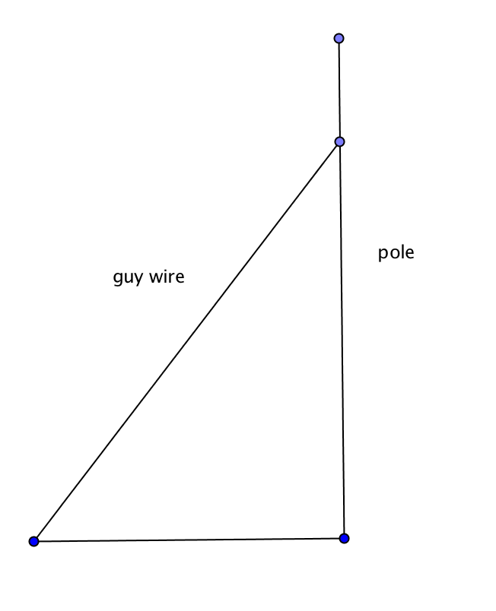

4.10 A 60-foot guy wire is attached to a pole 12 feet from the top of the pole. If the wire is at a  angle with the ground, what is the length of the pole?

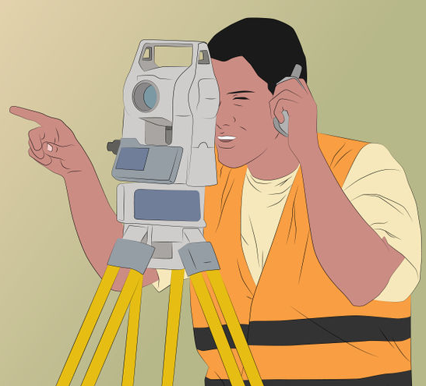4.11 To find the height of a pole, a surveyor moves 80 feet away from the base of the pole and then, with a transit 4 feet tall, measures the angle of elevation from the top of the transit to the top of the pole to be 57° . What is the height of the pole? Round answer to the nearest tenth of a foot.

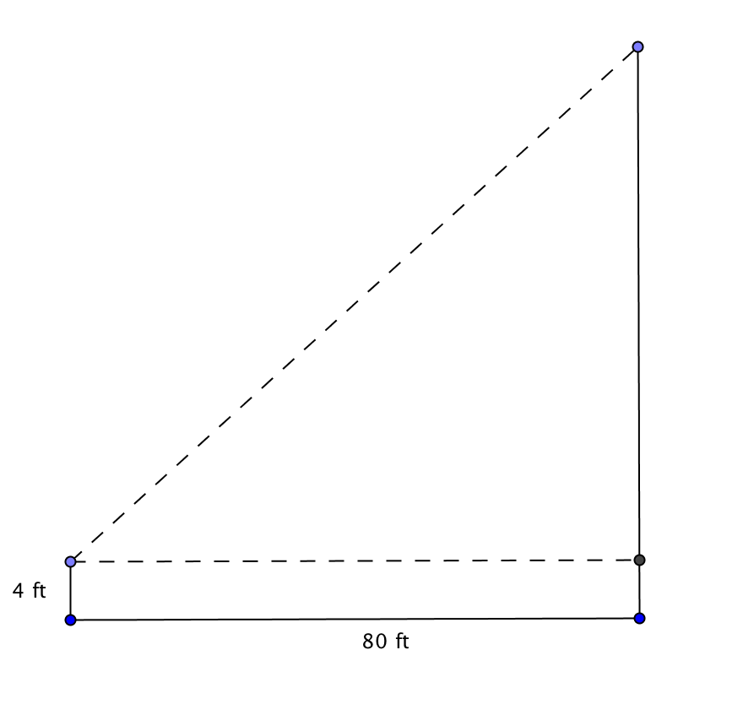

<http://www.wikihow.com/Use-a-Surveyor's-Transit>

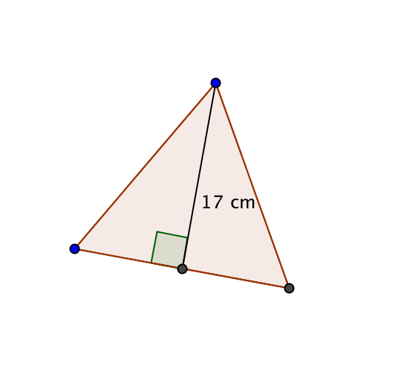

4.12 An altitude of an equilateral triangle is 17 cm.

a. Find the length of a side to the nearest centimeter.

b. Find the area of the triangle to the nearest square centimeter.

**Unit 5**

5.1 Find an equation of the circle in the coordinate plane with center at the origin and radius = 6.

5.2 A circle in the coordinate plane has the equation $x^{2}+8x+ y^{2}-12y=48.$ Find its center and radius.

5.3 Coordinates of points *A*, *B*, and *C* are given in the figure below.

1. Find the midpoint of $\overline{AB}$.
2. Find an equation for the perpendicular bisector of $\overline{AB}$.
3. Without performing any calculations, explain why the circle with center *C* passing through point *A* must also pass through point *B*.
4. Find an equation for the circle described in part (c) and show that *B* lies on the circle.

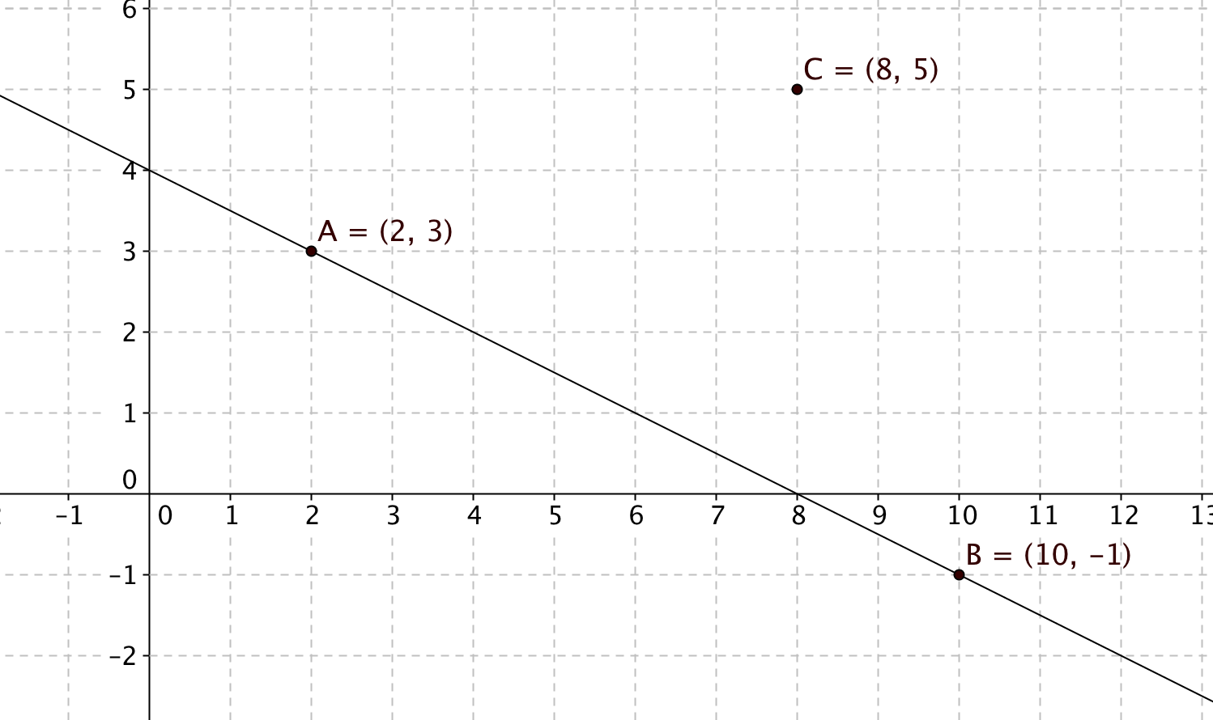

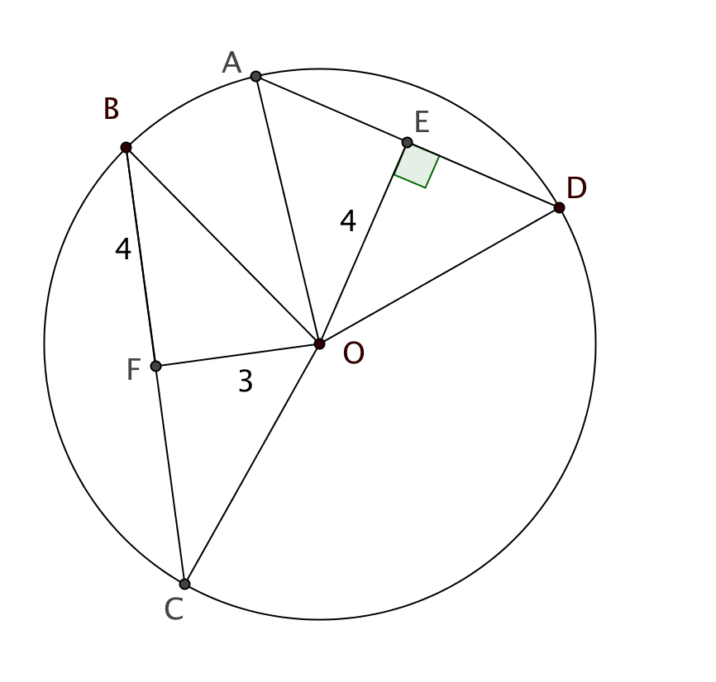5.4 Chords $\overline{AD}$ and $\overline{BC}$ are drawn in a circle with center *O*. $\overline{OE}$ is an altitude of ∆*AOD.* *F* is the midpoint of $\overline{BC}$. *OF* = 3, *BF* = 4 and *OE* = 4.

1. Find the radius of the circle.
2. Find *AD.*
3. In this circle the longer chord is closer to the center than the shorter chord. Is this always true for two chords in the same circle? Explain.

5.5 Vinyl records, which were popular in the mid-20th century, fell out of use when compact disks became available. They are now making a comeback. A “long playing” final record is placed on a turntable that makes $33\frac{1}{3}$ revolutions per minute. Through how many radians does the record pass in one second?

Image from www.clipartsheep.com

5.6 A flowerbed in front of a hotel has the shape of a sector of circle with a 150° central angle and a radius of 15 feet.

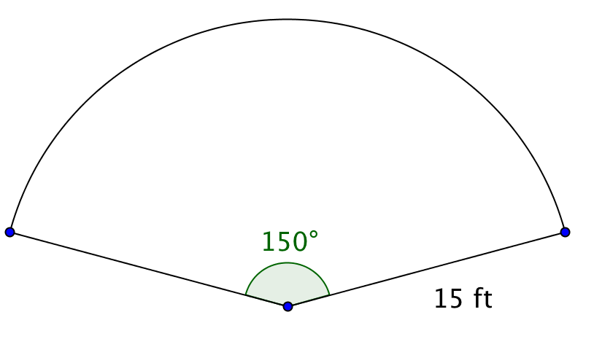

1. Find the area of the flowerbed.
2. Find the perimeter of the flowerbed

5.7 In the figure m $∠ABC$ = 22°. $\overset{⃡}{GF}$ is tangent to circle *A* at point *C*. Secant $\overset{⃡}{AE}$ intersects the circle at points *B* and *D*. Find the following:

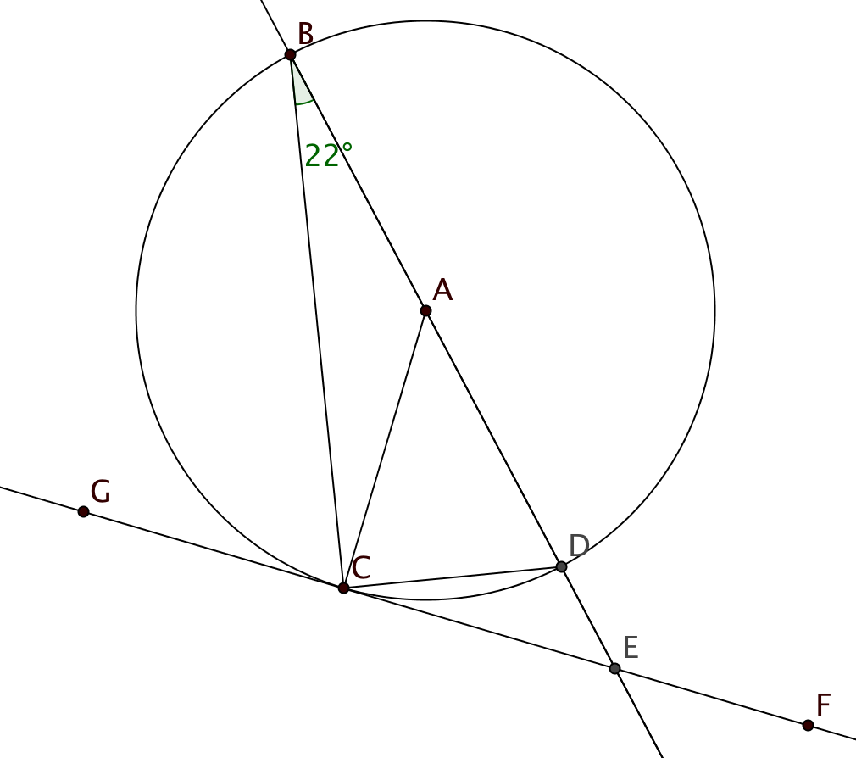

* 1. The measure of central angle $∠CAD$.
  2. m $∠$*BCD*.
  3. m $∠$*ACB*.
  4. m $∠$*DCE*.
  5. m $∠$*BEC*.
  6. Suppose the diameter of the circle is 14 cm. Find the lengths of minor arc $CD$ and major arc *DBC.*

5.8 Describe the locus of points in a plane that satisfy each of these conditions:

1. Equidistant from the sides of an angle
2. Equidistant from the endpoints of a segment
3. Equidistant from a given point and a given line
4. The same distance from a given point.
   1. In the diagram below segments $\overline{JG}$, $\overline{JM}$ and $\overline{MG }$ are tangent to circles with centers *A*, *E*, and *C* as shown. Segments $\overline{RS}$, $\overline{SQ}$ and $\overline{SP}$ are also tangent to the circles. The lengths of some segments are given with the diagram. Find the perimeter of ∆*GJM*.



* 1. Explain, step by step, how you would construct the circumscribed circle for a given triangle.
  2. 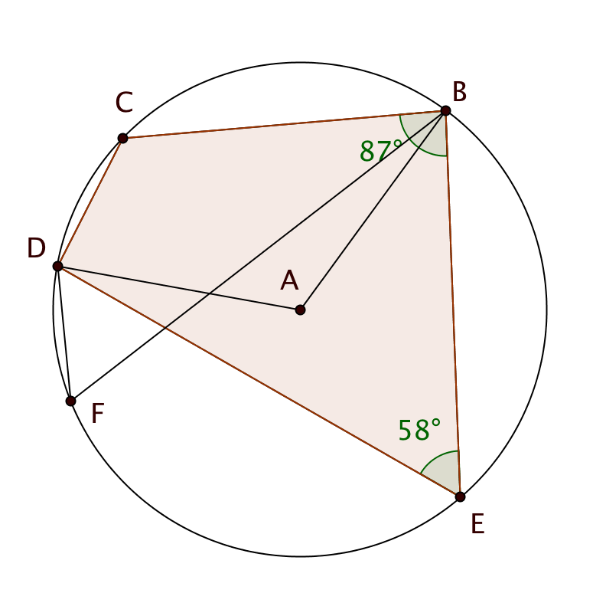Points *B*, *C*, *D*, *E*, and *F* lie on circle *A*.   
     m $∠$*CBE* = 87° and m $∠$*BED* = 58°.  
       
     Find  
       
     a. m $∠$*BCD*  
       
       
     b. m $∠$*CDE*

c. m $∠$*DFB*  
  
  
d. Measure of reflex *BAD*.

* 1. 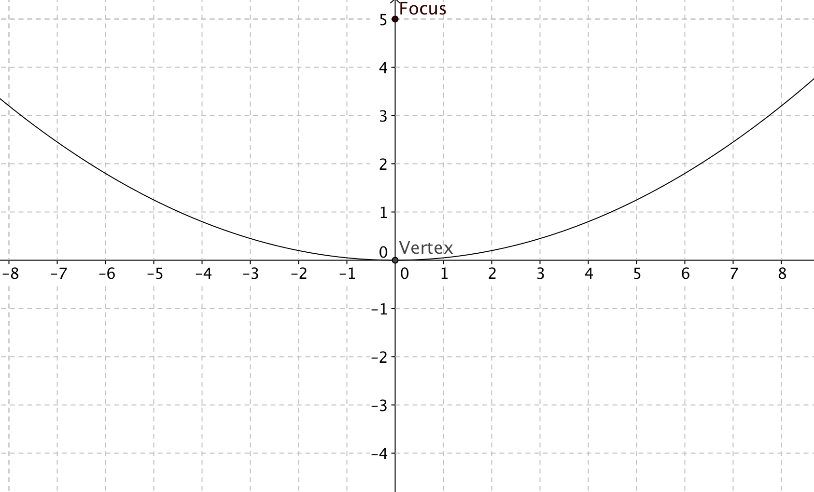Prove or disprove: If the vertices of a rhombus lie on a circle, then the rhombus must be a square.
  2. The vertex of a parabola is at the origin and its focus is at (0,5).  
       
     a. Find an equation for the parabola.  
       
       
     b. Find an equation for its directrix.

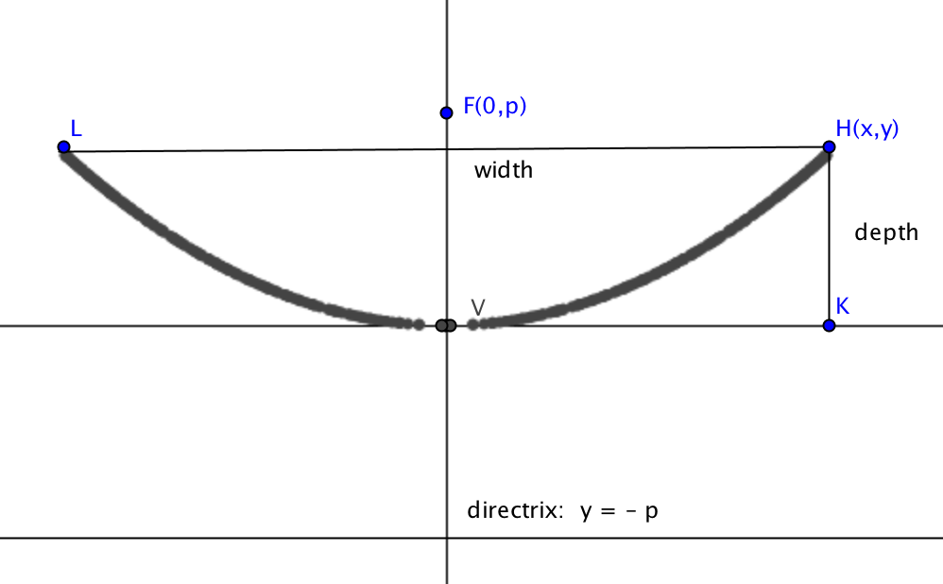

* 1. A reflecting telescope has a mirror with a cross-section shaped like a parabola. If the distance across the top of the mirror is 16 feet, and the distance from the vertex to the focus is 5 feet, how deep is the mirror in the center?

**Unit 6**

* 1. Identify the type of polyhedron formed by each of these nets:

a. b. c.

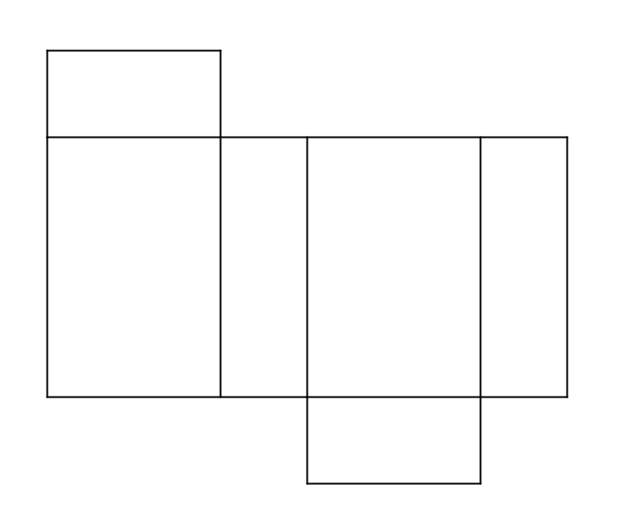

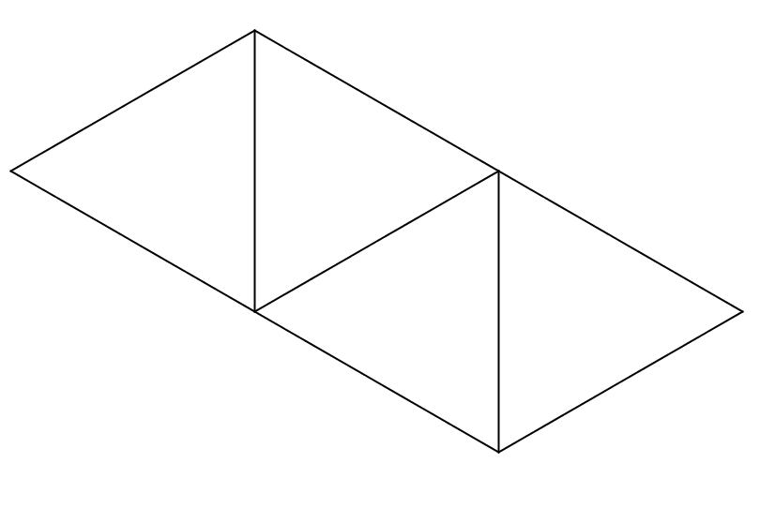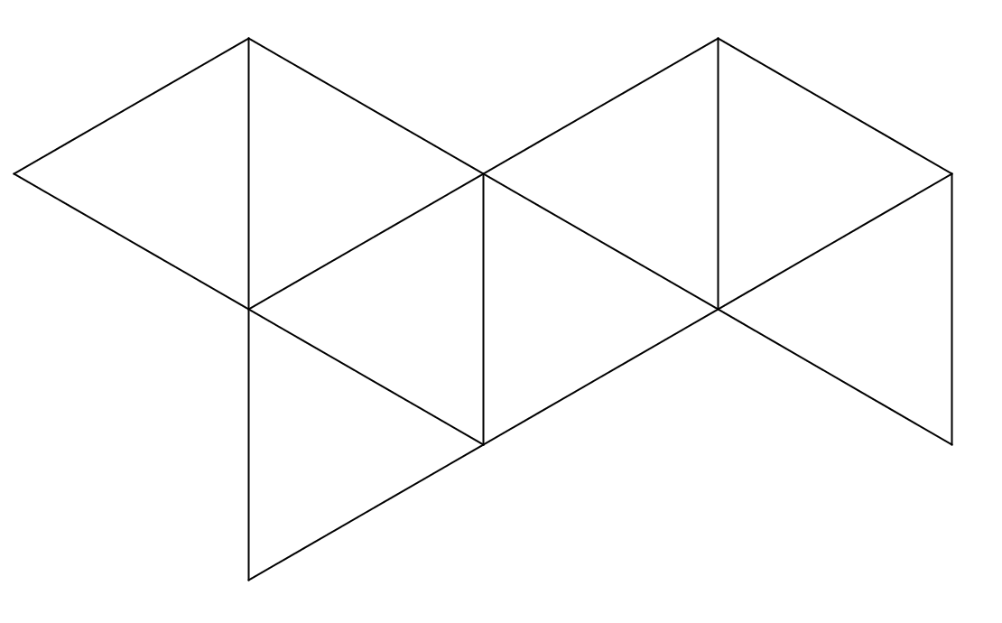

* 1. Sketch a net for each of these solid figures

1. Triangular prism b. Pentagonal pyramid
2. Cylinder d. Frustum of a Cone
   1. Sketch each of these figures. Then find the surface area and volume. Leave π in your answer where appropriate.
3. A sphere with radius = 3 units
4. A cube with edge = 4 units
5. A square pyramid with the side of the base = 6 units and height = 4 units
6. A cone with the slant height = 13 units and the radius of the base = 5 units
7. A prism with a height of 10 units and a regular hexagonal base that is 3 units on a side.
   1. Is it possible to fit a 9-foot pole inside a closet that is 3 feet wide, 2 feet deep, and 8 feet high? Explain your reasoning.

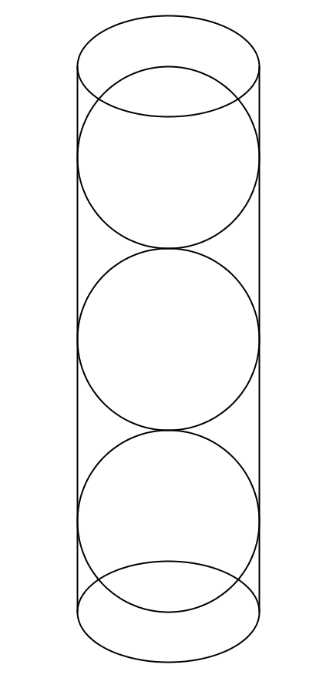

* 1. Three tennis balls are stacked on top of each other and fit tightly in a cylindrical can.   
       
     a. Find the surface area of the can if the diameter of each ball is 10 cm.

b. The lateral surface is made from a clear plastic, which comes in square sheets that are 1 meter on a side. How many cans can be made with one sheet? Be sure to show not only that you have enough area, but that the lateral surfaces will all fit within the sheet.

* 1. For each plane figure, identify one or more solids for which it could be a cross-section. (Try to find as many as you can!)  
       
     a. square

b. circle  
  
  
  
c. triangle  
  
  
  
d. non-square rectangle

e. trapezoid with only one pair of parallel sides

* 1. Explain how the entire surface of the earth may be divided into eight spherical triangles each with three 90° angles.
  2. Describe how each of these solid figures could be generated by revolving a plane figure about an axis of rotation.  
       
     a. A cylinder  
       
       
       
     b. A cone  
       
       
       
     c. A sphere  
       
       
       
     d. A frustum
  3. 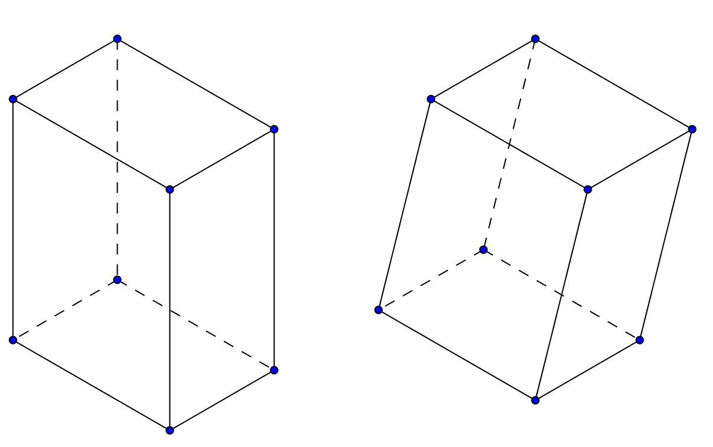 Two prisms have the same base and the same height, but one is a right prism and the other is an oblique prism. Explain how Cavalieri’s principle is used to show that the two prisms have the same volume.

6.10 The edge of a regular tetrahedron is 6 cm. Follow these steps to find the volume of the tetrahedron.

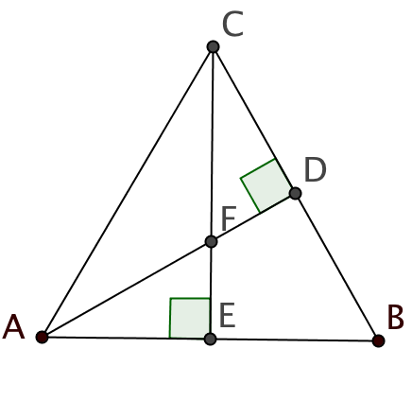

1. 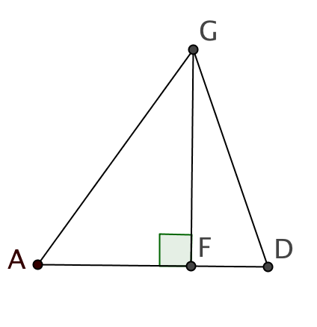First consider the base of the tetrahedron, equilateral ∆*ABC*. Altitudes $\overline{AD}$ and $\overline{CE}$ intersect at point *F* as shown. Use your knowledge of 30°-60°-90° triangles to find *AF*.
2. Now look at a cross section of the tetrahedron passing through vertex *G* and segment $\overline{AD.}$ Use this figure to find *GF,* the height of the tetrahedron.
3. Find the volume of the tetrahedron.
4. A student says that the height of a regular tetrahedron is the same as the altitude of one of the faces. Is she correct? Explain.

**Unit 7**

7.1 Students formed a sample space from the room numbers/labels corresponding to rooms in a hallway of their school:

*S* = {Janitor, Girls, Boys, Media Center, 1, 2, 3, 4, 5, 6, 7, 8, 9}

a. Consider the following events:

* Event *A* consists of the even numbered rooms.
* Event *B* consists of the rooms that have labels rather than numbers.
* Event *C* consists of rooms numbered less than 6 or labeled with words that would appear in a dictionary before the word Excellent.

Specify the outcomes in each of these events using set notation.

b. Events *A*, *B*, *C* and sample space *S* are represented by the Venn diagram in Figure 1. Enter the outcomes from the sample space *S* in the appropriate regions on the Venn diagram.

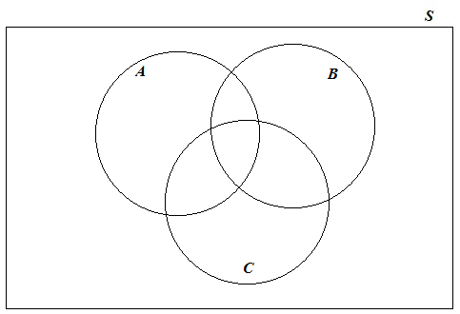

Figure 1. Venn diagram representing events *A*, *B*, and *C*.

Use your answer in (b) to find the following events. Write the events using set notation.

c. $C^{C}$

d. $A∪B$

e. ($A∪B)∩ C^{C}$

7.2 The entire student body of a high school consists of 75 9th-graders, 82 10th-graders, 70 11th-graders, and 65 12th-graders. A student is randomly selected from the school. Find the following probabilities. Show how you determined your answers.

a. *P*(Student is in the 12th grade)

b. *P*(Student is not in the 12th grade)

c. *P*(Student is either in the 9th or 10th grade

7.3 Return to the information on the high school in question 7.2. Suppose that two students were randomly chosen from this high school. Find the probabilities below. Show how you arrived at your answers.

a. What is the probability that both students were in the 12th grade?

b. What is the probability that at least one of the two students was in the 12th grade?

7.4 Suppose that you have the following six Scrabble tiles: 

1. What is the total number of arrangements of all six letters?

b. How many 4-letter sequences can be made from these letters?

c. According to an online Scrabble Word Finder, there are 18 real words that can be made from 4 of the scrabble tiles that spell SQUARE. Suppose that you randomly select four of the tiles from SQUARE and lay them down in the order you selected them. What is the probability that your sequence of tiles makes an actual word?

7.5 A high school swim team consists of 15 female swimmers and 21 male swimmers. Six team members are randomly selected as a delegation to represent the team at a state swim meet.

a. How many different delegations are possible?

b. What is the probability that the delegation that is chosen is all male?

c. How many delegations are half male and half female? What is the probability that the randomly selected six-person delegation will be half male and half female?

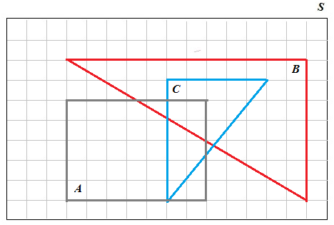

Figure 2. Area model for three events *A, B*, and *C*.

7.6. Figure 2 shows an area probability model for three events:

* *A*, the rectangular region
* *B*, the large triangular region
* *C*, the smaller triangular region

Determine the probabilities for (a) – (d):

a. *P*(*A*), *P*(*B*), and *P*(*C*).

b. $P\left(A∩B\right)$

c. $P({(A∩B)}^{C})$

d. $P\left(B∪C\right)$

e. What fraction of *B*’s outcomes overlap with *A*? What probability does this fraction give?

f. What fraction of *A*’s outcomes overlap with *B*? What probability does this fraction give?

7.7 A survey of pet owners was conducted to see if gender affects what type of pet they own. The results of the survey are recorded in the table below.

|  |  |  |  |  |
| --- | --- | --- | --- | --- |
|  |  | Animal | Owned |  |
| Pet Owner | Cat only | Dog only | Cat and Dog | Other |
| Female | 75 | 250 | 400 | 20 |
| Male | 50 | 280 | 320 | 30 |

a. How many pet owners completed the survey?

b. What percentage of the pet owners who completed this survey was female? What percentage was male? Show your calculations.

c. Does gender affect what type of animal is owned? To answer this question, calculate the conditional percentages for animals owned for each gender and enter your percentages into the table below. Show your calculations.

|  |  |  |  |  |
| --- | --- | --- | --- | --- |
| Pet Owner | Cat only | Dog only | Cat and Dog | Other |
| Female |  |  |  |  |
| Male |  |  |  |  |

d. Discuss the gender differences in pet ownership that you find most striking.

7.8 Joanne wanted to find out how likely it was to win her town’s lottery. She purchased 120 scratch cards at $5.00 a card and recorded her results in the table below.

|  |  |  |
| --- | --- | --- |
|  | Frequency | Relative Frequency |
| Lost | 65 |  |
| Purchase price returned | 43 |  |
| Win $15 | 12 |  |

a. Compute the relative frequencies (round to 3 decimal places) and enter them into the table above.

b. Use the relative frequencies as estimates for the probabilities. Determine the expected value of her town’s lottery game from the player’s point of view. On average, how much will Joanne win or lose per ticket if she continues to play the game?

c. On average, how much will the town win or lose per ticket? How much would the town expect to receive in revenue from its lottery in a week when 1000 scratch cards were sold?

7.9 Let *A* and *B* be two independent events with *P*(*A*) = 0.7 and *P*(*B*) = 04. Find the following probabilities. Justify your answers.

a. $P\left(A∩B\right)$

b. *P*(*A*|*B*)

c. $P\left(A∪B\right)$

d. $P\left(A^{C}∩B^{C}\right)$

7.10 The table below gives probabilities of the birth weights of babies. (These probabilities are based on Massachusetts hospital data.)

|  |  |
| --- | --- |
| Weight | Probability |
| 0 lb – 4 lb 15 oz | 0.046 |
| 5 lb – 5 lb 15 oz | 0.077 |
| 6 lb – 6 lb 15 oz | 0.227 |
| 7 lb – 7 lb 15 oz | 0.350 |
| 8 lb – 8 lb 15 oz | ? |
| 9 lb – 9 lb 15 oz | 0.066 |
| 10 lb or more | 0.010 |

a. Determine the probability that a randomly selected baby weighs between 8 pounds and 8 pounds 15 ounces. Explain how you determined your answer.

b. What is the probability that a randomly selected baby weighs less than 7 pounds?

c. What is the probability that a randomly selected baby weighs 5 pounds or more?

d. Given a randomly selected baby weighs 5 pounds or more, what is the probability that the baby weighs under 7 pounds? Explain how you got your answer.

e. Explain the difference between the probability you calculated in (d) and the probability that a baby weighs 5 pounds or more given the baby weighs under 7 pounds.

7.11 Flint Michigan made the news in 2016 due to elevated levels of lead found in the drinking water. In response to Flint’s water crisis, Connecticut’s Department of Public Health sent out a press release saying that 99% of the public water systems in Connecticut are in compliance with federal standards for lead levels (less than 15 parts per billion (ppb) of lead in public water systems). Suppose the public water system in your area is being tested. Your water system could meet federal standards or have elevated lead levels. The test for lead in your area’s water system could turn out to be positive (+) indicating lead levels are elevated and hence, the drinking water is unsafe or negative (–). However, these tests are not perfect. False positives as well as false negative test results are possible.

a. Draw a tree diagram showing the possibilities for the lead levels in the drinking water and the test results.

b. Explain what a false positive means.

c. Suppose that the probability of getting a positive test result given the levels of lead are elevated is 0.95 and the probability of getting a negative test result given the levels of lead meet federal standards is 0.90. Assume that the probability of having lead in Connecticut water supplies is 0.01. Add probabilities to your tree diagram in (a).

d. Suppose a water system is tested and the results are positive. What is the probability that this water system actually has elevated levels of lead? In other words, find *P*(elevated lead | (+)). Show how you can use your diagram to help find this probability. Interpret your results.

e. Suppose you are in an area where the likelihood of lead in the drinking water is much higher than in Connecticut. Assume that the probability of lead in the water supply is 0.30. Rework your answer to (d).