 | Energy Assistance | Matching Payment Plan | New Start (Eversource) | MaPP  (UI)
Type of assistance | Heating assistance – direct payment to heating utility | Gas or electric (heating) utility past due balance forgiveness | Reduces past due balance by 1/12th each month customer makes payment | Reduces past due balance by 1/12th each month customer makes payment
Maximum benefit | $725 for basic needs (additional crisis and safety net assistance for eligible delivered fuels customers) | Two matches made to equal six months’ of payments, as well as energy assistance award match, up to zero balance | 12 months of reducing past due balance, up to $20,000, or zero balance | 12 months of reducing past due balance, up to zero balance
Utility Customer | Primary heat source - Electric or gas (also covers delivered fuels) | Primary heat source - Electric heating or gas | Electric customer | Electric customer
Eligibility | At or below 60% SMI (financial hardship) | Financial hardship eligible; apply for  and receive  energy assistance award | Financial or medical hardship eligible;  $100 past due & more than 60 days delinquent | Financial hardship eligible;  $500 past due & more than 90 days delinquent
Enrollment period | November 1  through May 1 (customers may schedule visit to CAA beginning August 1st to apply) | November 1  through May 1 | Year-round | Year-round
How to apply | Contact CAA or call 211 to find CAA | Contact utility | Contact Eversource at 1-800-286-2828 | Contact UI at  1-800-722-5584

Eversource – 1-800-286-2828
UI – 1-800-722-5584

Yankee Gas - 1-800-438-2278
CNG - 860-524-8361
SCG - 1-800-659-8299

Connecticut Community Action Agencies

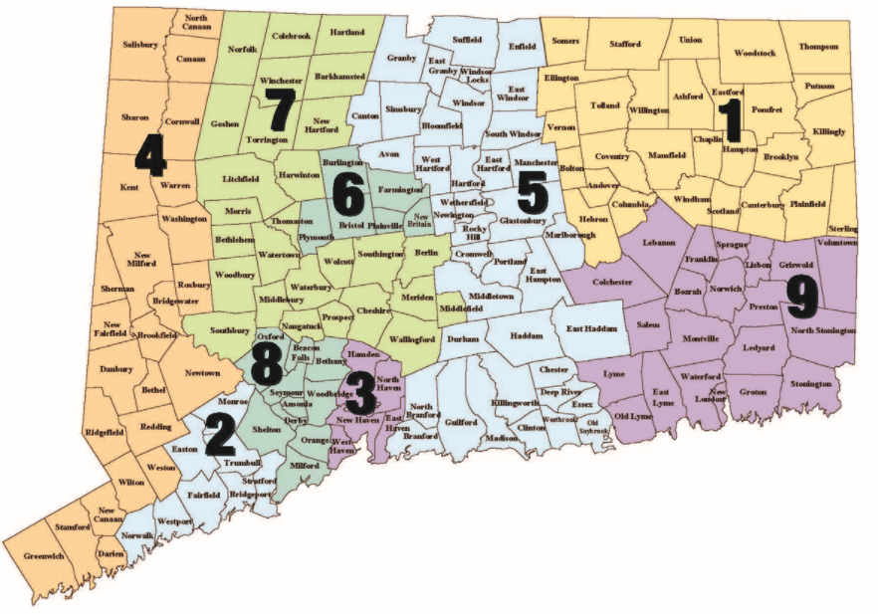

1 Access Community Action Agency – Willimantic (860) 450-7400; Danielson (860) 412-1600
2 Alliance for Community Empowerment, Inc. – Bridgeport (203) 384-6904;
Norwalk (203) 384 – 6904 ext. 3027
3 Community Action Agency of New Haven - (203) 387-7700
4 Community Action Agency of Western CT, Inc. – Danbury (203) 748-5422;
Stamford (203) 357-0720
5 Community Renewal Team – Hartford (860) 560-5800; Middletown (860) 347-4465
6 Human Resources Agency of New Britain, Inc. - (860) 356-2000
7 New Opportunities, Inc. – Waterbury (203) 756-8151; Meriden (203) 235-0278;
Torrington (203) 756-8151
8 TEAM, Inc. - (203) 736-5420
9 Thames Valley Council for Community Action, Inc. - (860) 425-6681

Information on applying for Connecticut Energy Assistance Program - https://portal.ct.gov/dss/Economic-Security/Winter-Heating-Assistance/Energy-Assistance---Winter-Heating

Client must engage with a CAA to apply for CEAP. CEAP application can be downloaded from the website and mailed to the CAA, or schedule a meeting with the CAA to help with the application. When applying for CEAP, client will need information that can verify income. Receipt of other government benefits can automatically qualify a client for CEAP, but the customer still must apply for CEAP (i.e., CEAP is not awarded automatically based on receipt of other government benefits; it requires a separate application).

Eligibility criterion is for CEAP basic benefit. See DSS 2020-2021 LIHEAP Plan for additional eligibility criteria that may apply, depending on the household’s income level.

