PSA/POS EVAULATIONS
User Guide
PSA/POS Evaluations using SharePoint Database Site

The Basics
What is SharePoint?
Microsoft SharePoint is a collaboration software product that enables individuals working on a project team or in a functional group to share information and communicate with one another from a central location. It allows users to work in a web-based collaborative environment. SharePoint provides specialized sites that contain elements including databases, calendars, task lists, libraries of documents, discussion boards, etc. The site is accessible via a web browser from their PC or PDA. SharePoint also integrates seamlessly with Microsoft Office applications (such as Word, Excel, or Outlook) in a single environment.
Why Am I Using This?
Your agency has the ability to use one or more client licenses for Microsoft SharePoint. The software can be used to provide various web-based tools to you and your agency, such as:
- Data Collection and Reporting
- Document Management and Sharing
- Calendars
- Project Tracking
- Task Lists
- Discussion Boards
Under Connecticut General Statute 4-217, OPM is charged with creating standards and procedures for state agencies to follow in entering into personal service agreements. Section 6 is to monitor and evaluate personal service contractor performance. Through this PSA/POS Evaluation site, you will be using SharePoint for data collection and reporting. Your agency’s PSA Request submitter will be entering information in this database. The information entered here will be used to perform the function of submitting evaluations when PSA’s and POS’s expire according the OPM’s Procurement Standards. In addition, this tool will be shared by State agencies as a means of tracking the performance of the contractors within State government.

Accessing the Site
How Do I Log In?
To access the PSA Evaluation SharePoint Database Site, click the following link:
http://spopm.ct.gov/Finance/PSAEvaluations/Lists/PSA%20Evaluations/AllItems.aspx
To access the POS Evaluation SharePoint Database Site, click the following link:

You will be prompted to login with a screen similar to this, please use your login for your computer:
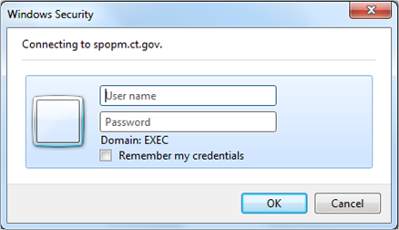

Enter the username and password that you use for Outlook.
If you have trouble accessing the site, please contact one of the following individuals:
john.vittner@ct.gov
chris.smith@ct.gov
Valerie.clark@ct.gov

PSA/POS Contracts:
When you’ve successfully logged into site, you will see a screen that looks like this:

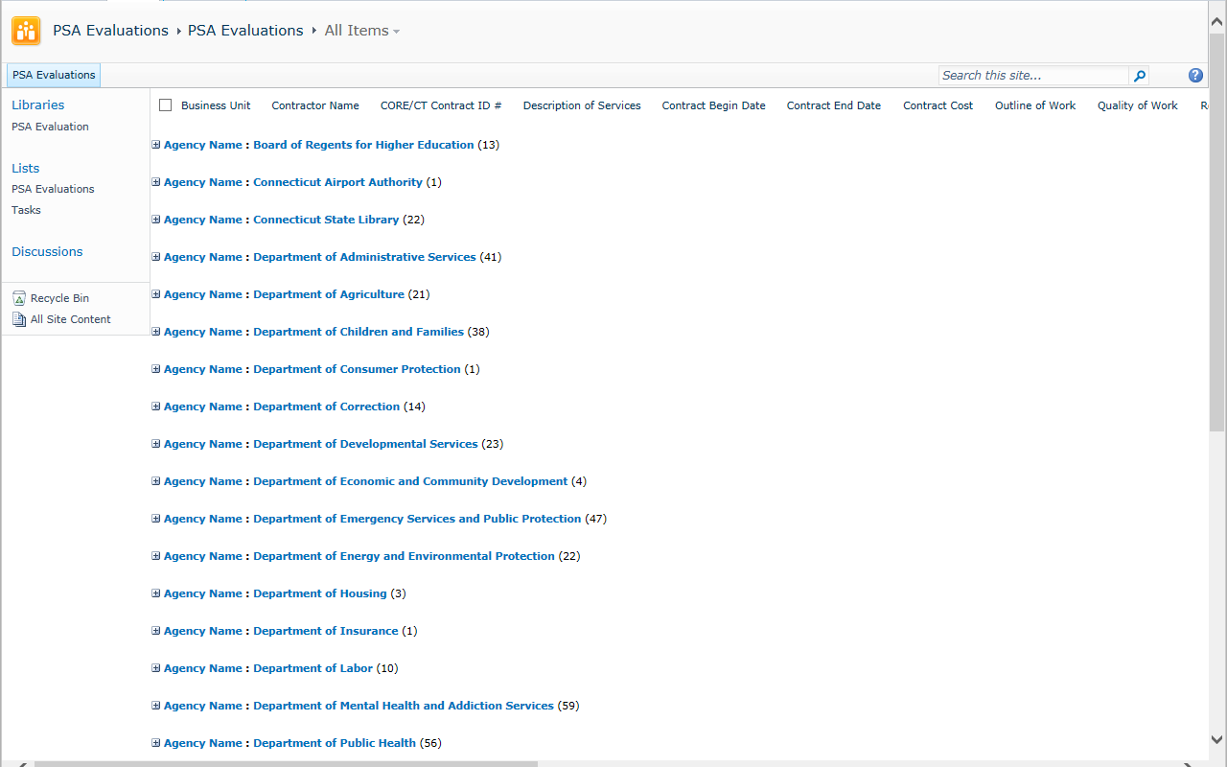
The agency list will appear. The parenthesis is the number of contracts that have expired or will expire this year.

Filter the agency list by selecting the + sign next to your agency name to view the PSA/POS Contracts. You will have “read only” access to all agencies and editing ability for your agency, only.

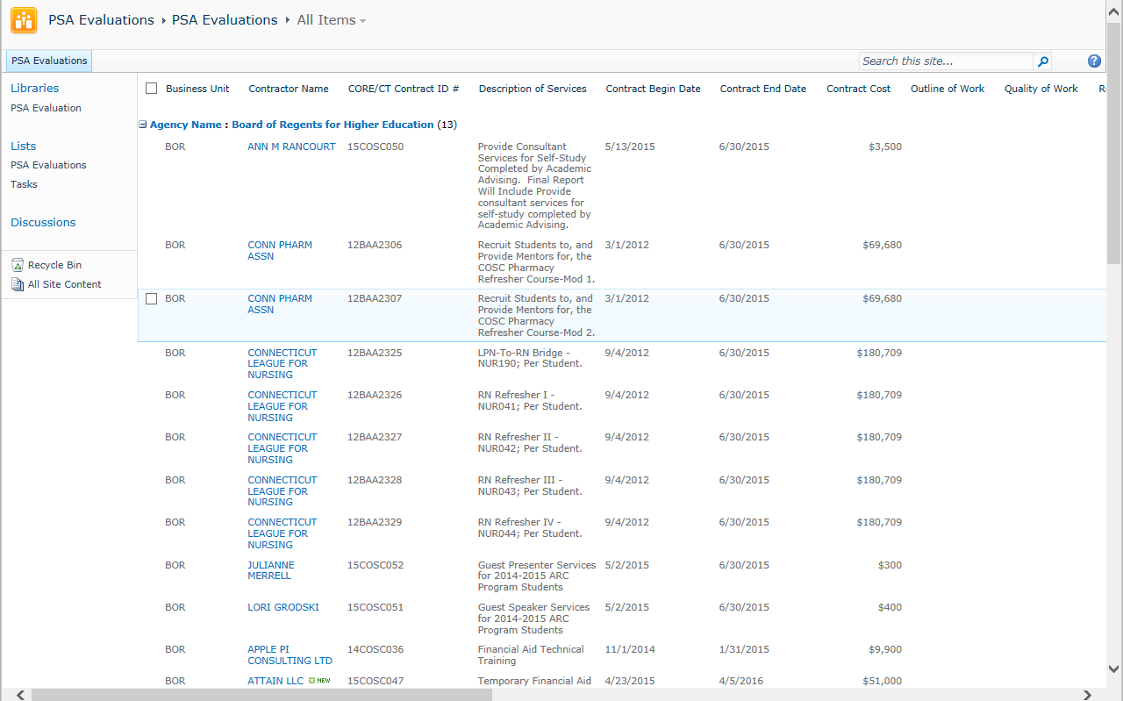
The list is now expanded so you can select your contract.

Select the contract by slecting the contractor name that you want to enter the evaluation for and a new window will open then select edit item. This form is an online version of the same form filled out on paper.
Select Edit Item.

The fields will now become open to edit. Please verify the information that pre-filled about the contract is correct. Begin with the contractor name, and continue to the contract #, then the description of services, dates and amount. Was the contract competitively bid? If so, please check the box. The evaluator name and phone number can be anoymous if you choose. Finally enter the date the form is being completed.
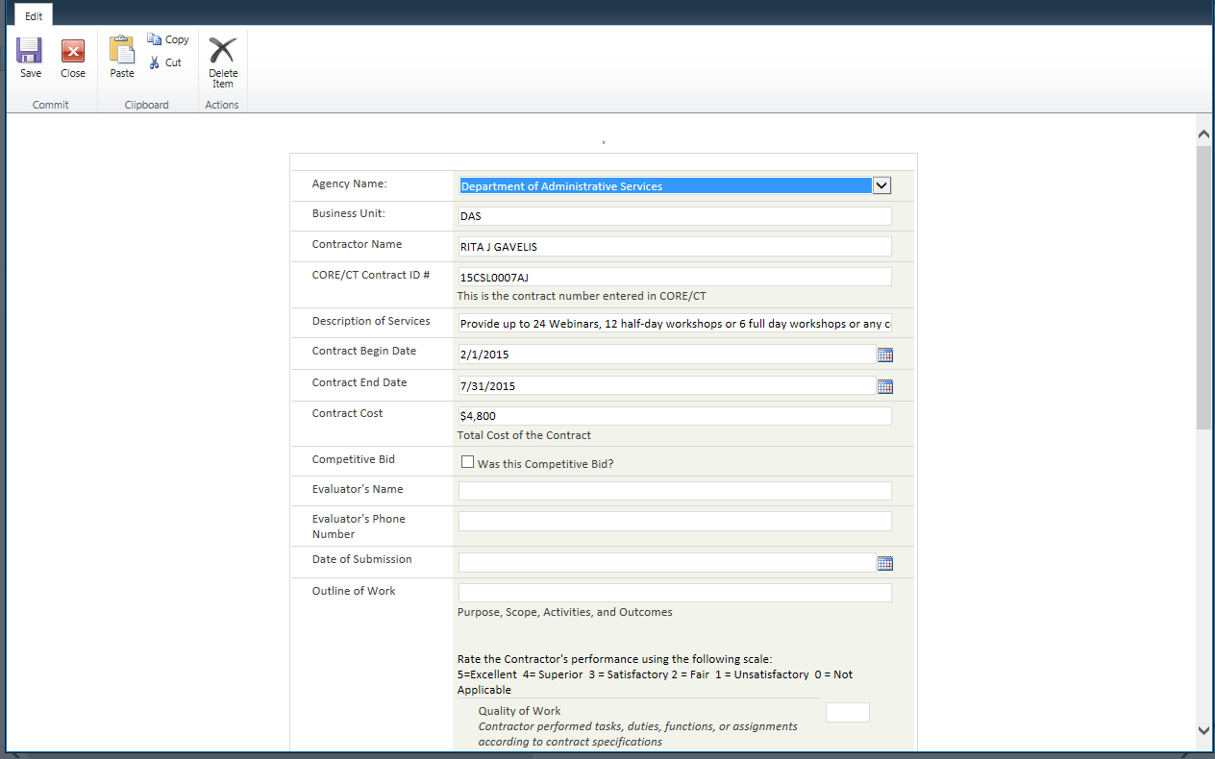

This is the section where you will be conducting the evaluation. Please begin with the outline of work and list the purpose, scope activities and outcomes of the contract. You can copy and paste from another document if you have it saved somewhere else. For the next 8 categories you will rating from a 0 to a 5. The system will allow you to add any other numbers, however when you go to save the document you will receive an error, it will tell you to fix the number because it is programmed to only accept 0-5. The total rating is automatic and when you save the total will appear. The last steps will be to explain any areas wherer the contractor’s performace was less than satisfactory and add any additional comments you may want to share. Once the form is complete, select save.

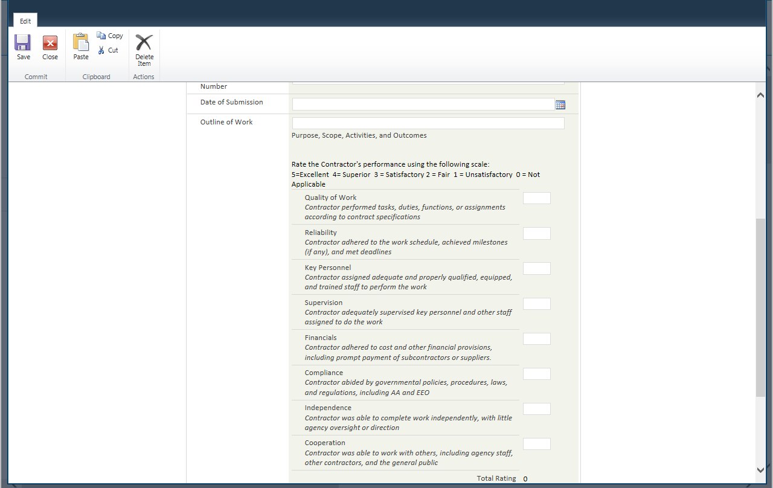
Begin the evaluation here.

Field Definitions
Agency Name (Drop Down): | Pre-filled from CORE/CT, verify it is correct otherwise change and select ONE agency from the list (REQUIRED FIELD).
Business Unit: | Pre-filled from CORE/CT, verify it is correct otherwise, change the acronym for your Agency.
Contractor Name: | Pre-filled from CORE/CT, verify it is correct otherwise, change the full legal name of the contractor.
CORE/CT Contract ID#: | Pre-filled from CORE/CT, verify it is correct otherwise, change contract number listed in CORE/CT.
Description of Services: | Pre-filled from CORE/CT, verify it is correct otherwise, change the description.
Contract Begin Date: | Pre-filled from CORE/CT, verify it is correct otherwise change the date from the calendar icon listed to the right of the box.
Contract End Date: | Pre-filled from CORE/CT, verify it is correct otherwise change the date from the calendar icon listed to the right of the box.
Contract Cost: | Pre-filled from CORE/CT, verify it is correct otherwise change the dollar amount.
Evaluator’s Name: | Enter the name of the person who completed the evaluation (may not be the same person who is entering the data). In addition, you can enter “anonymous” or just list the program name the contract was for.
Evaluator’s Phone Number: | Enter the phone number of the person who would be best to contact regarding this project (if there are questions). If you entered anonymous, please leave this blank.
Date of Submission: | Enter the date the evaluation is being completed from the calendar icon on the right of the box.
Outline of Work: | Enter the outline of work. This can include the purpose, scope, activities and outcomes of the contract.
Rating the Contractor’s Performance 0-5 (0=Not applicable; 1=Unsatisfactory; 2=Fair; 3=Satisfactory; 4=Superior; 5=Excellent)  Quality of Work: | Enter the rating based on how the Contractor performed tasks, duties, functions, or assignments according to contract specifications.
Reliability: | Enter the rating based on how the Contractor adhered to the work schedule, achieved milestones (if any), and met deadlines.
Key Personnel: | Enter the rating based on how the Contractor assigned adequate and properly qualified, equipped, and trained staff to perform the work.
Supervision: | Enter the rating based on how the Contractor adequately supervised key personnel and other staff assigned to do the work.
Financials: | Enter the rating based on how the Contractor adhered to cost and other financial provisions, including prompt payment of subcontractors or suppliers.
Compliance: | Enter the rating based on how the Contractor abided by governmental policies, procedures, laws, and regulations, including AA and EEO .
Independence: | Enter the rating based on how the Contractor was able to complete work independently, with little agency oversight or direction.
Cooperation: | Enter the rating based on how the Contractor was able to work with others, including agency staff, other contractors, and the general public.
Explain area’s with performance was less than satisfactory: | Include any narrative you feel was the reason the Contractor may have scored a less than satisfactory in any of the above fields.
Other Comments: | Include any additional comments you may have.

Delete an Item: There should not be a reason to delete an entry unless the contract was cancelled.
To delete an item in your agency’s list, you have two options.
Option #1:
- Run your mouse over the project you’d like to delete and check the box to the left it.
- Select the delete item from the toolbar (this is very helpful when you want to delete several).

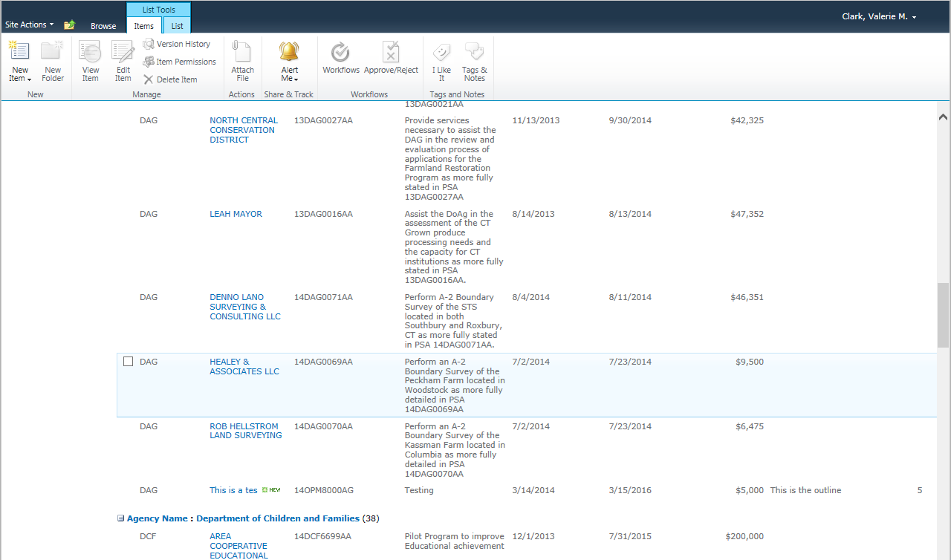

Option #2:
- When you are entering the evaluation there are 2 places where you can delete. The first one is when the form first opens there is the delete item. Also, when you are editing the form you have the option to delete.
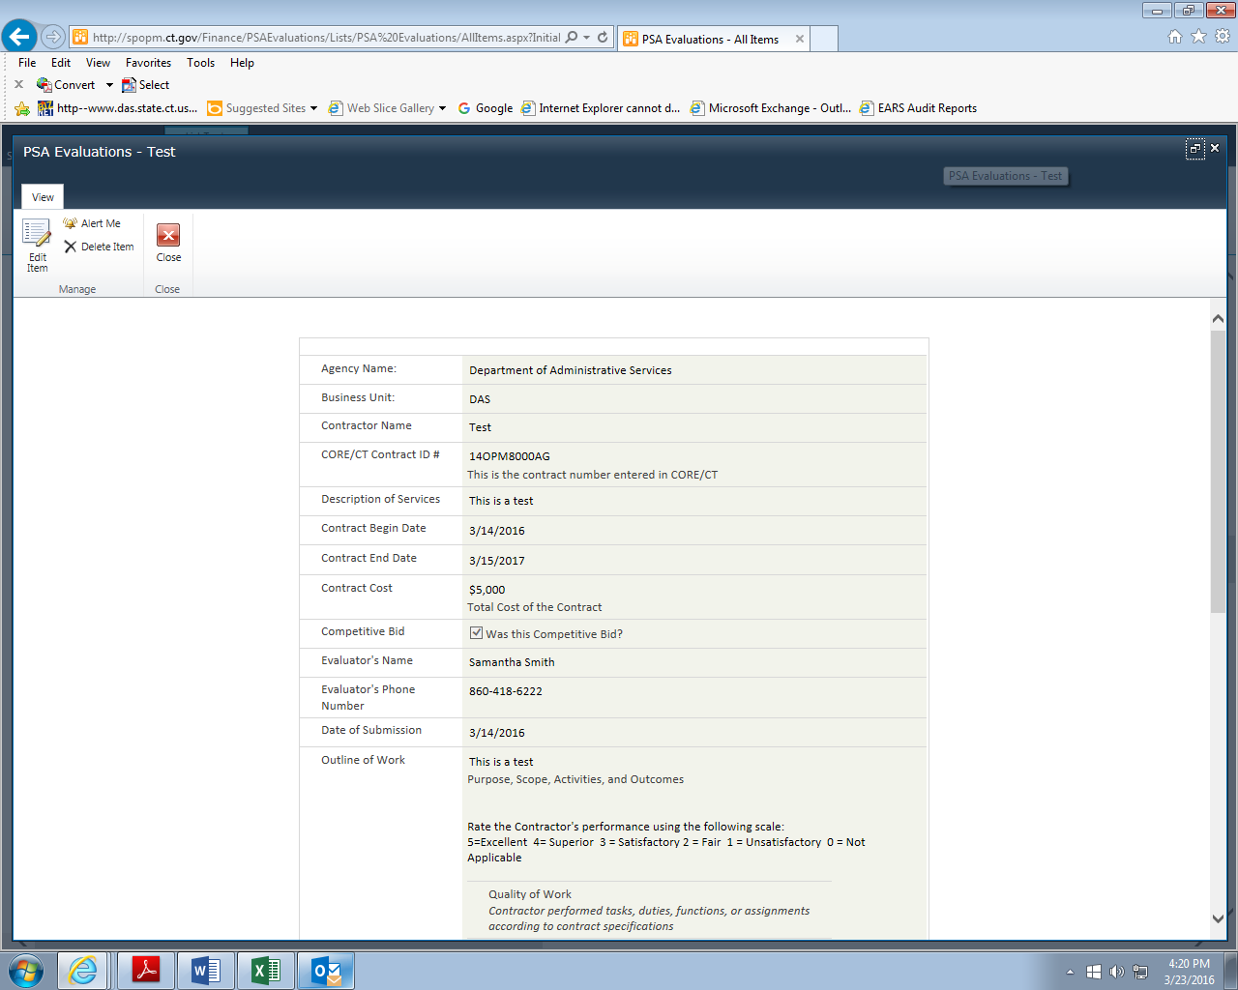

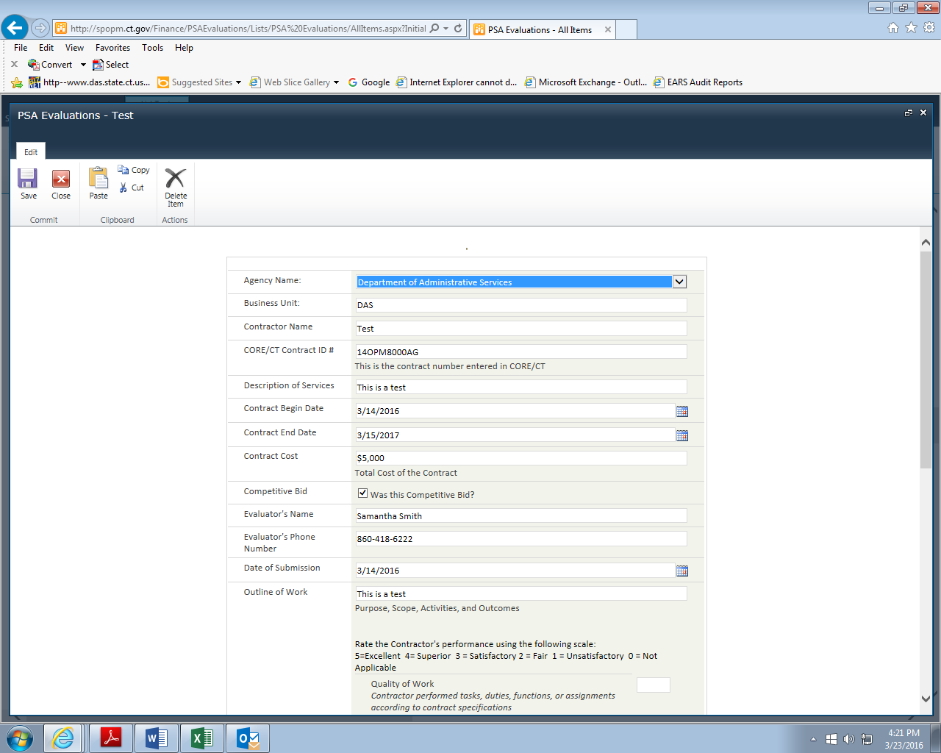

After you’ve entered all of your agency’s data, please review the information for accuracy, grammar, spelling and formatting. Ensure that all completed forms have the “Is this entry ready to be viewed by others?” box checked and are ready to be shared with others. Once complete, close out of the SharePoint site.

Searching:
If you want to search by a contractor, simply list the contractor name in the search field.
Look up Eastconn.

A screen listing the contractors who are entered in this database:

If you have any questions about field definitions, additions or content, please contact Valerie Clark at (860) 418-6313 or Valerie.clark@ct.gov.

Thank you for your assistance with making our government more transparent.

