**Question and Answer Document**

**RE: NGP RFA #OPM_FIN_NGP_071818**

**Responses to Questions Received by August 29, 2018**

***IMPORTANT NOTE!***

**Caution: Do not wait until the last minute to complete your application. You can work on it and save it throughout the process. The deadline will be strictly adhered to.**

**No applications will be accepted via upload, email or paper copies. All applications must be completed online through BizNet. The only uploaded documents that need to be included are the: Signature page,** [**The Nondiscrimination Certification**](http://www.ct.gov/opm/cwp/view.asp?a=2982&q=390928&opmNav_GID=1806)**,** [**The Acknowledgement of Contract Compliance**](http://www.ct.gov/doh/lib/doh/conappdocs/notification_to_bidders.pdf)**,** [**The Contract Compliance Monitoring Report**](http://www.ct.gov/chro/lib/chro/pdf/notificationtobidders.pdf)**, the 501(c)3, and any other supporting documentation you have for your contract. Applications will not be evaluated if there is no signature page uploaded or 501(c)3.**

**Questions & Answers**

1. **Question:** Our question is would the Office of Policy and Management consider a request from xx if the funds we receive from the state are directed by the state agency clients we serve. For example, we do not receive funding from DCF directly, but by written directly into grants by the agencies that solicit funding to pay for our programs.

**Response:** Since your question is a bit unclear, we’ll refer you to our guidelines. Eligible applicants are health and human services organizations that are exempt under Section 501(c)(3) of the Internal Revenue Code of 1986, or any subsequent corresponding internal revenue code of the United States, as amended from time to time and that receive funds from the State to provide direct health and human services to State agency clients.

1. **Question:** I am working with hospital and wish to know if a hospital such as ours is eligible to apply for this grant program

**Response:** Yes. If you receive funds to service State clients, including through receipt of Medicaid funds, you would be eligible.

1. **Question:** We receive funding from the State of Connecticut, Department of Education Child Nutrition Program to supplement the cost of the meals we provide to low income children in our program. Would we be eligible to apply for a grant-in-aid?  
   **Response:** It would appear, in accordance, to guideline provisions included in response to question 1 that you are eligible.
2. **Question:** Can I upload my application?

**Response:** No uploads, emails or paper copies of any kind will be accepted. The online BizNet application will be the only application accepted.

1. **Question:** Is the NGP fillable application available on BizNet or are applicants to fill out the form and then upload on BizNet? I did not see the application link on BizNet.  
   **Response:** Please see question #4.
2. **Question:** Why can’tI access the application in BizNet?

**Response**: You must be signed up as a nonprofit company type and then follow the below instructions: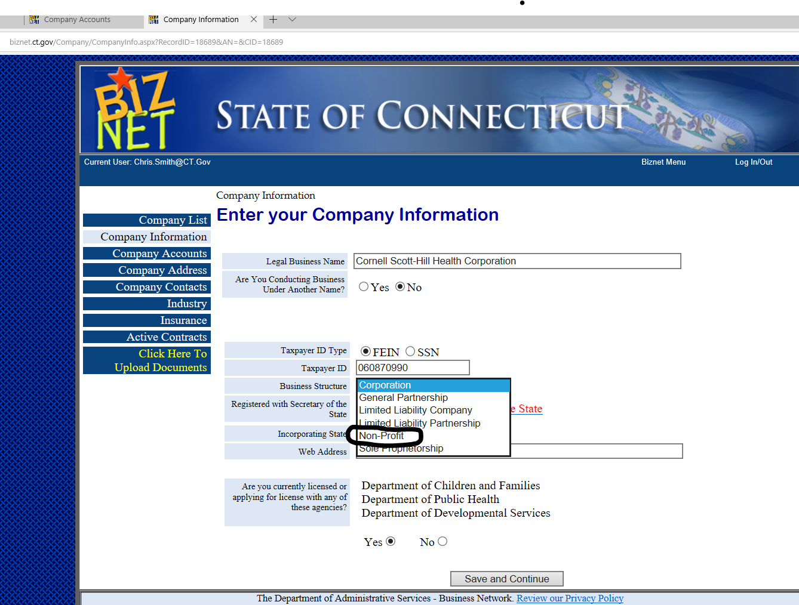

Please note that this is an online application process.  No paper copies, uploads or emailed versions will be accepted.  Please follow the below steps to get to the application online.

1. Log into BizNet.  If you don’t have an account, you are going to need to set one up.
2. BizNet Menu or search for solicitations
3. Doing Business with the State
4. Company Information
5. Click here to upload documents (this is where you will see the button for the NGP Grant Application).
6. **Question:** If the rest of the application site will have actual fillable forms for each of the attachments? The ones available on the “for discussion only” site are not fillable.  
   **Response:** This is an online application, the only documents that should be uploaded is the signature page, nondiscrimination forms (if not already on BizNet) and additional information for your application. You are not to upload the application.
7. **Question:** Due to not exceeding required financial thresholds we not have an independent audit completed, however, we are able to provide unaudited, internally generated financial statements including year-end actuals. Would we be eligible to apply?  
   **Response:** See Section F.2.D.2) on page 7 of the Guidelines.
8. **Question:** Can you clarify if allowable projects, “Capital Equipment” (page 4 of 16), applies only to collaborations between 2 or more eligible nonprofit organizations. Can one applicant apply for capital equipment?  
   **Response:** Yes, if they involve a capital expense.
9. **Question:** Can these dollars be used for Furnishings, permanent fixtures and effects?  
   **Response:** Please see Section C of the Guidelines. These types of costs are typically only eligible if they are part of a larger capital project.
10. **Question:** Is there a guideline pertaining to how frequently a nonprofit agency can be awarded this funding?

**Response:** No

1. **Question:** Is there a way to save the application in progress and not have to do it all at the same time? I’ve gone in 3 times and lost the parts of the org profile I’ve completed each time. We have 4 projects and I hope to heck I don’t have to do them all at once.

**Response:** There is a save feature. The next time you come back into BizNet, go to company list and select your name and the application(s) will be there.

1. **Question:** When the agency has finished with one application/project in BizNet, are there clear instructions as to how to begin the next one, and the next, and the next? Can you provide these instructions now?   
   **Response:** Please see question #12.
2. **Question:** Part J of the application asks that improvements be quantified. How would safety be quantified? For example, could we say “100% of people in the building will be able to exit more safely with a fire escape that conforms to code specifications”? Is that enough quantification?  
   **Response: I**mprovements should be described and quantified, to the extent possible, in Section J.
3. **Question:** Can this software be cloud-based, with us applying for a 10-year license? The budget has an “annual license fee” line item, so would the total be the annual fee times ten?  
   **Response:** License fees are only eligible during the project implementation phase including post implementation stabilization phase of no more than 6 months. Please refer to the guidelines, Section B #2.
4. **Question:** If there is a reason for why this would not be the case, may we consider a group of repairs at one facility (e.g., roof, driveway, sprinkler) to be one project?

**Response:** Please refer to section 3, Part 2 on page 7 of the guidelines. If work is part of an overall renovation project, it could be considered as one project. Using your example, a sprinkler system and a driveway, however, would be separate projects.

1. **Question:** And if the answer is yes, but each individual renovation is less than $50,000 but together they total more than $50,000, which nondiscrimination form do we use?  
   **Response:** Please refer to the chart from [**this link**](http://www.ct.gov/opm/cwp/view.asp?a=2982&q=390928&opmNav_GID=1806) – use either Form B or C depending on the application amount.
2. **Question:** Or do we use just one form for our agency, and consider all the projects/applications we submit as one total contract, in which case we’d use Form B? (Provided we can use the one found online)? If not, where are these nondiscrimination forms in BizNet?  
   **Response:** Please see question #17.
3. **Question:** We submitted three applications in the past and all were scored and we were awarded one of the grants. I am trying to find out if the other two applications are still in the cue or if I need to resubmit these applications. Please see the attached information for reference if needed.

**Response:** This is a brand new application process.

1. **Question:** On the BizNet portal under our company name it shows 3 rows with the following description: Miscellaneous Documents for NGP (OPM Non-Profit Grant Program application). I would like to know if we are to provide a zip file containing all required documents for each grant submission - one per row for a total of 3 projects or if we should request additional rows to attach all the required applications files.  
   **Response:** The only uploaded documents that need to be included are the: Signature page, The Nondiscrimination Certification, The Acknowledgement of Contract Compliance, The Contract Compliance Monitoring Report and any other supporting documentation you have for your contract. Applications will not be evaluated if there is no signature page uploaded.
2. **Question:** Regarding the Miscellaneous Documents for NGP (OPM Non-Profit Grant Program application) row - are we limited to submitting only 3 NGP applications or can we request more rows for additional submissions.  
   **Response:** You do NOT upload any applications using that button. The button is for additional paperwork you might have with your application.
3. **Question:** What is maximum amount that can be requested?  
   **Response:** The maximum amount for any one project is $3.0 million. There is no maximum total when submitting multiple application, however if you apply for the over $1 million category and the under $1 million and receive an award for over $1 million, the under $1 million projects will not be eligible.
4. **Question:** May applicants apply for more than one Component 2 grant? If yes, how do we “add” Part 2 Sections to our electronic application within BizNet?  
   **Response:** Please see question #22. There is a button to add another application.

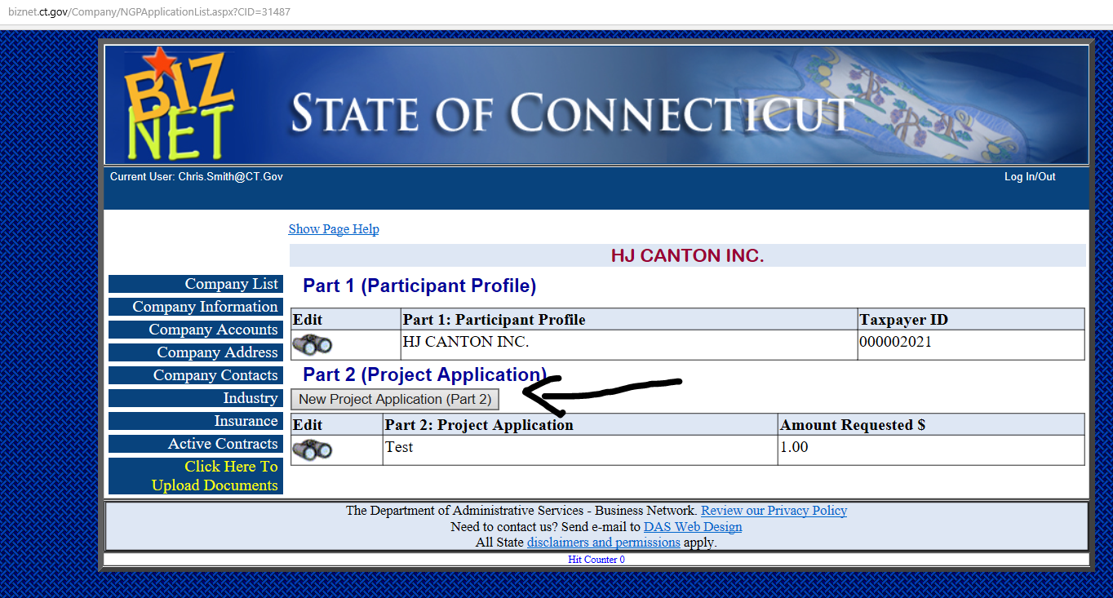

1. **Question:** If we intend to request funds for Component 1 and Component 2, do we need a separate Participant Profile for each component’s application? Or will one Participant Profile suffice for all of our Component 1 and Component 2 applications?  
   **Response:** You would submit one Part 1 application, Please see Section F #1 on page 6 of the Guidelines.
2. **Question:** Is there a deadline for requests of reimbursement by an organization that receives an NGP award? (e.g.; one year? two years from the award announcement date?)

**Response:** There is a contract deadline which is one year from when the Secretary of OPM executes the contract. The reimbursements can be requested anytime during that timeframe.

1. **Question:** Our nonprofit organization serves communities throughout the nation. The organization has different levels of administration, including a regional headquarters in Connecticut, with oversight for operations in Connecticut and Rhode Island. Legally, the corporate office is located in New York. Are you requesting the address of the office with operational oversight for Connecticut or the corporate entity?   
   Since we have a headquarters office in Connecticut would it be acceptable to answer "yes" to the question "is your organization headquartered in Connecticut"?  
   **Response:** You should provide your New York headquarters address and your Connecticut address, however you must select, in Part 1, that you are not headquartered in Connecticut.
2. **Question:** Do proposed projects need to be related to shelter only? Could projects be related to other categories of housing and support for those who are homeless or imminently at risk of becoming homeless, as long as we can demonstrate quantified and improved efficiency, effectiveness, safety, and/or accessibility?

**Response:** No, eligible projects are not just shelters. The purpose of the NGP funds is to improve the efficiency, effectiveness, safety and/or accessibility of health and human services being delivered by eligible nonprofit organizations. The eligible projects include facility alterations, renovations, improvements, and additions; new construction; health, safety and Americans with Disabilities Act (ADA) projects; energy conservation improvements; information technology systems; technology that promotes client independence; purchase of vehicles; and acquisition of property.

1. **Question:** Can NPG funds be used to purchase property which will be use as housing for the homeless?  
   **Response:** That appears to be an eligible project
2. **Question:** Can NPG funds be used acquisition and rehab to develop mix use – housing and commercial space?  
   **Response:** The purpose of the NGP funds is to improve the efficiency, effectiveness, safety and/or accessibility of health and human services being delivered by eligible nonprofit organizations. The eligible projects include facility alterations, renovations, improvements, and additions; new construction; health, safety and Americans with Disabilities Act (ADA) projects; energy conservation improvements; information technology systems; technology that promotes client independence; purchase of vehicles; and acquisition of property.
3. **Question:** Can NPG funds be used to purchase and renovate the same property?   
   **Response:** Yes
4. **Question:** Can NPG funds be combined to purchase, renovate and installed I/T in the same project for the same property?   
   **Response:**  The I/T portion can only be combined if it is to provide I/T infrastructure as part of the overall renovation project.
5. **Question:** Can NPG funds be used for the expansion of program services i.e. renovating an existing build and acquiring a new building?  
   **Response:** The purpose of the NGP funds is to improve the efficiency, effectiveness, safety and/or accessibility of health and human services being delivered by eligible nonprofit organizations. The eligible projects include facility alterations, renovations, improvements, and additions; new construction; health, safety and Americans with Disabilities Act (ADA) projects; energy conservation improvements; information technology systems; technology that promotes client independence; purchase of vehicles; and acquisition of property.
6. **Question:** Can NPG fund be used for a feasibility study?  
   **Response:** No work can be started prior to the grant award being executed. Funding is for capital projects only.
7. **Question:** Can NPG funds used to cover soft cost?  
   **Response:** Please refer to the guidelines regarding eligible and ineligible costs.
8. **Question:** Can you please clarify “for projects involving facility improvements, alterations or renovations, the requested amount shall be less than the current market value”.  
   **Response:** Please refer to Section C in the guidelines (pages 4-5).
9. **Question:** (Section A 3 – Component 2), Is the amount of the grant limited to a certain percentage of the project cost?  
   **Response**: No, although the amount of non-NGP funds for the project is part of the evaluation criteria.
10. **Question:** We are looking to purchase a building to expand and improve our services – If we have a purchase and sales in hand at the time of the application does that disqualify us from receiving funding for the building purchase?  
    **Response:** No, but there can be no NGP reimbursement of purchase costs incurred prior to an executed NGP contract.
11. **Question:** We also need to do interior improvements to the building we are looking to purchase – Can we combine both into one request or would each be a separate request, one for building acquisition and one for building improvements?  
    **Response:** One application would be allowed.
12. **Question:** In addition we are looking to put solar panels on the roof – same questions as above, one project, two or three separate requests?  
    **Response:** Please see question #38. A purchase and renovation could be one application.
13. **Question:** Would a capital project/new construction that includes a furniture warehouse that houses donated furnishings that are given to those exiting shelter/homelessness be something that might be considered?  
    **Response**: The purpose of the NGP funds is to improve the efficiency, effectiveness, safety and/or accessibility of health and human services being delivered by eligible nonprofit organizations. The eligible projects include facility alterations, renovations, improvements, and additions; new construction; health, safety and Americans with Disabilities Act (ADA) projects; energy conservation improvements; information technology systems; technology that promotes client independence; purchase of vehicles; and acquisition of property.
14. **Question:** Under non-eligible costs, it states that leasing equipment is not an eligible cost. Does this include the leasing of computers?  
    **Response:** Yes, this program is for capital projects and leasing is an operating cost.
15. **Question:** What will be the grant award period for the NGP?

**Response:** Contracts are within a year from when they are executed by the Secretary of OPM.

1. **Question:** Once the grant has been awarded and signed, what is the timing the funds have to be used by? 12-24 months?

**Response:** Please see question #42.

1. **Question:** How soon, if awarded, will the funds for acquisition be available?  
   **Response:** Anticipate Summer 2019, but that will depend, in part, on how long the contracting process takes. Also, remember that this a reimbursement grant.
2. **Question:** If awarded, what is the timeframe for renovations?  
   **Response:** Please see question #44.
3. **Question:** What is the State’s expected timeline for making award decisions? When would you expect grantees to be able to begin projects that have satisfied all contract compliance requirements?  
   **Response:** Please see question #44.
4. **Question:** For projects that need an environmental inspection report: is there a date (last 365 days?) that these are accepted? Would a report from 2015 for a previous NGP award be acceptable?  
   **Response:** The most recent report should be submitted for review.
5. **Question:** Are organizations allowed to include the cost of a new appraisal and/or environmental inspection report in their NGP grant budget as a procurement item?

**Response:** Any costs for appraisals and inspections required to be submitted prior to executing an NGP contract would not be eligible.

1. **Question:** Under Section 2.I. Projected Increases and Decrease in Budgetary Expenses and Revenue, can potential cost avoidance be used as a projected expense reduction in future years? For example, year one would be current expenses. Years two –five would show the cost avoidance as decreased expenses (cost that have not occurred but will or could occur if we don’t complete the project).  
   **Response:** Yes, but please be sure to explain in the space provided.
2. **Question:** Component 1 Projects: for property acquisition, can the 25% match be the balance due after the acquisition grant, which would be paid via a new purchase agreement with the seller? Would the balance have to be paid off in a specific number of years?  
   **Response:** No, the 25% match is required (proportionately) each time a reimbursement request is submitted. These grants are for projects to be completed in 1 year long.
3. **Question:** How are the funds disburse for property acquisition?  
   **Response:** This is a reimbursement program for approved eligible expenses.
4. **Question:** If we submit unrelated multiple projects totaling well over the $35,000 minimum, can one of the projects individually be less than $35,000?  
   **Response:** No, project applications under the $35,000 minimum will be evaluated.
5. **Question:** If (for example), all of our homes need roofs (assuming its > $35k) is that all one project?

**Response:** No, a lien analysis would be required for each location, therefore making them separate applications.

1. **Question:** Similarly, if each house needs different work but the total (combined) project is in excess of $35k is each house be a separate project?  
   **Response:** Part 2 Project Application forms for projects involving Facility Improvements, New Construction or Property Acquisition must be submitted separately for each location. If the work is for an overall renovation project, it could be submitted as one application.
2. **Question:** Can we combine multiple facility improvement projects for a multi-building complex into one proposal? For example, Windows replacement, Bathroom repair and remodeling for multiple buildings in the complex AND an expansion of the parking lot for the complex? Can a new generator be part of this proposal as well?

**Response**: These sound like separate projects, but it is difficult to say with certainty based on the question asked.

1. **Question:** If the first three years of licensing fees is paid upfront for upgraded software, would that be a qualifying expense for an OPM grant?  
   **Response:** NGP funds can be used for software licensing for the period of project implementation and a post-implementation stabilization period of not more than 6 months. Any upfront license payments would be prorated to exclude any time beyond this period.
2. **Question:** Of the $30 million allocated for 2018 and 2019 for the Non-Profit Grant Program, is all of it guaranteed to be available for the program?  
   **Response:** The plan is to award projects up to this amount.
3. **Question:** It seems they use “Participant Profile” and “Organizational Profile” interchangeably (end of p.9), is there is a difference between the two or if they are the same thing?

**Response:** Yes, they are the same.

1. **Question:** Will the Bonding Commission need to approve an NGP Project before the State will contract for the project?  
   **Response:** No, they money has been authorized.
2. **Question:** If a nonprofit requests funding for the purchase of an *identified* building for Component 1, what happens if the building is no longer available for purchase at the time the State makes the award? Also, would the nonprofit be allowed to use those funds to select an alternative building that fills the same need?  
   **Response:** Yes, as long as the project plan and scope remain the same; however, all of the provisions regarding purchases that are in the guidelines will apply (e.g. lien analysis, etc) and the requested amount could be reduced, as appropriated.
3. **Question:** Would funding from private foundations count toward the 25% funding matching requirement for component #1?

**Response:** Yes, most likely. Matching funds may **not** include other state funds or the inclusion of provider non-cash in-kind contributions.

1. **Question:** For Section K-It says to list all current liens (existing or proposed), does this apply to any liens on the specific proposed project or does it mean all current liens on all of our projects?

**Response:** The lien analysis applies to the property being renovated or improved.

1. **Question:** We are interested in applying for funds to renovate and equip a leasehold. For the lien analysis, is the landlord expected to fill out the requested information?

**Response:** Whoever has the information to complete the form should fill it out. Owner approval is a post selection requirement.

1. **Question:** If we are awarded funding, will a lien be place on the leasehold? Obviously, since we do not own the property, this could be problematic. If a lien is required, would the state consider a lien on a property that is owned by us but which is not the site of the renovation?

**Response:** No; however, please refer to the guidelines Section J, #7 on page 16 of the Guidelines for the repayment clause.

1. **Question:** Per page 4 & 5 of the RFP, “For projects involving facility improvements, alterations or renovations or property acquisition, the requested funds shall be less than the current market value of the property minus: (1) any liens on the property; (2) amounts received from prior NGP grants for this property; and (3) any outstanding mortgage balance. In the case of new construction, it would need to be demonstrated, to the satisfaction of the State, that the fair market value of the new facility and associated land would exceed the total amount of: (1) any liens on the property; (2) amounts received from prior NGP grants for this property; (3) any outstanding mortgage balance; and (4) any new NGP funds awarded as a result of this RFA.” Must the State be in the first position for a NGP lien?   
   **Response:** Please see question #64.
2. **Question:** Must there be sufficient available equity to cover the NGP lien?  
   **Response:** Yes, although no actual lien will be required.
3. **Question:** For projects involving property acquisition, may the value of the property and the land it is on to be considered when determining if there will sufficient equity to cover the requested NGP funding?  
   **Response:** The application shall contain the lien analysis. If you receive an award, an MAI appraisal will determine the value of the property.
4. **Question:** For projects involving property acquisition, what method(s) does the State require be used to determine the value of the property proposed to be acquired with NGP funding? Realtor? Municipal assessment? Other?

**Response:** For the purpose of applying, the municipal assessment card or existing appraisal can be used. Please see question #67.

1. **Question:** If a nonprofit requests funding for the purchase of a building for Component 1, must the nonprofit have already identified the building?

**Response:** There needs to be a property address to complete the lien analysis form. See response to question # 60.

1. **Question:** Can you receive funds from this within a collaborative if your property is already bonded at 90% of appraised value?  
   **Response:** Please refer to Section C, “Limitations Include:” on bottom of page 4 of the Guidelines. Also see response to question #66.
2. **Question**: I had asked earlier about preparing a request for similar items (for example, roofs and driveways) at different locations. You had said that since each application could only have one lien analysis, we could not have a single project identifying identical upgrades/renovations spread over different locations.

However, p 7 of the Guidelines state that “an EMR system involving multiple locations would be considered to be one project.” The guidelines then go on to use generators and vehicles that go at different locations as examples of things that can all be part of one project. If these distinct items that correspond to different locations can be lumped together in one project, a) how would they have one lien analysis, and b) wouldn’t it be possible to have “roof replacement” at 3 locations be applied for as one project?  
**Response:** EMR, I/T, Vehicles and Generators (that do not require renovations to property) do not require lien analysis. Please refer to section 3, Part 2 on page 8 of the guidelines, first full sentence (starts with “Project Application forms for….).

1. **Question:** If consolidation funds include more than one area (i.e., legal expenses and IT/software upgrades) that benefit two locations, do we submit a lien analysis for the lead applicant only?  
   **Response:** The lien should be for the location of the property being improved. In addition, these funds are only to be used for eligible capital expenses.
2. **Question:** If we are applying for funding for the renovation of 3 bathrooms at 3 different group homes, do we need to complete 3 different applications?  
   **Response:** Please refer to section 3, Part 2 on page 8 of the guidelines, first full sentence (starts with “Project Application forms for….).
3. **Question:** if we are applying for funding for renovations at multiple sites do we have to complete separate applications for each site?

**Response:** Please refer to question #73.

1. **Question:** We are looking at applying for funding for the renovation of 3 bathrooms to make them accessible at 3 different group homes, the renovation of a ramp at our main facility and the renovation of a roof at a group home. Can we group in one application or is each project independent?  
   **Response:** Please see question #73.
2. **Question:** On the application form Part 1 Participant Profile section there is a question…Is this application a collaboration? It is a yes or no answer. It is my understanding that only one Part 1 Profile needs to be submitted and that individual Part 2 sections must be submitted if more than one project. So what do you do if you have one project that is a collaboration, and another that is not? How do you reflect that in Part 1 of the Participant profile if you only need to submit one?

**Response:** All parties in the collaboration complete Part 1 and the provider who will have the contract with the State would indicate they are the lead agency Part 2. You should clearly indicate which of your projects involve a collaboration and which do not. Also, see response to question # 77.

1. **Question:** We are planning to submit an application for two projects

* One in collaboration with another CT non-profit. The other non-profit will be the lead
* One for a project of our own.

Based on this, how do we fill out the application? The first page of Part 1 asks whether “this is part of a collaboration”. In our instance, we have one application that is part of a collaboration and one that is not. Do we fill our Part 1 twice, once saying that it is part of a collaboration and one second application, saying that it is NOT a part of a collaboration?

**Response:** Please see question #76. Your proposed approach would also work.

1. **Question:** If you are submitting a request as a “collaboration” how and where do you do the (@) online profiles? When I looked, BIZNET seemed to be limited to (1)

**Response:** Please see question #76.

1. **Question:** If we are applying for more than one project, and one of them is a collaboration but the others are not, how do we answer this question:

Is this application a collaboration?

|  |  |
| --- | --- |
| Yes | No |

Since we fill this profile form out only once, right?

**Response:** Please see responses to Questions 76 and 77.

1. **Question:** When the collaborating agency is filling out this profile page, where would it indicate with whom it’s collaborating? In the “brief description” section?  
   **Response:** Please refer to the Guidelines, Section F, #2. The brief description box could be used to identify participants.
2. **Question:** Can an applicant submit multiple applications for different sites/projects that when combined exceeds $1 million if each individual project budget is below $1 million and fits into Component 2?   
   **Response:** Yes.
3. **Question:** Can an agency apply once as a partner and once independently?  
   **Response:** Yes
4. **Question:** Does the lead agency of a collaboration have to be the lease holder (or property owner)?  
   **Response:** Yes
5. **Question:** Do all other partners upload Part 1, ‘Participant Profile’ to their own BizNet Account, or as an attachment on the lead agency’s account?
   1. If to their own account; how do we upload two (2) Part 1 forms if also submitting an independent application? Refer to sample BizNet screen below

cid:image004.jpg@01D43EB0.7E0FD500

**Response:** No applications or part of applications get uploaded.

1. **Question:** The RFP says that “architectural fees are limited to no more than 10% of total project costs.” Does this include an engineering diagram for a sprinkler system, which is an integral part of an entire sprinkler system package? Usually the costs, when one gets an estimate for a system, are not broken down.  
   **Response:** Please describe the costs as best you can.
2. **Question:** We recently had an architect put together a critical needs assessment for our existing buildings. There are many updates that are needed to our resident community rooms, office spaces, and public bathrooms since our buildings are over 30 years old. We would like to apply for a grant from OPM. Since this is a larger construction project (under $1M), would we need to do public bidding by putting an advertisement in the newspaper or could we solicit quotes from 3 contractors without having to go through that process?   
   **Response:** For the application, please provide the best estimate possible with the documentation that you have, including the critical needs assessment done by your architect. The bidding process would be required, in accordance with the Guidelines and the contract, after any selection for a grant award.
3. 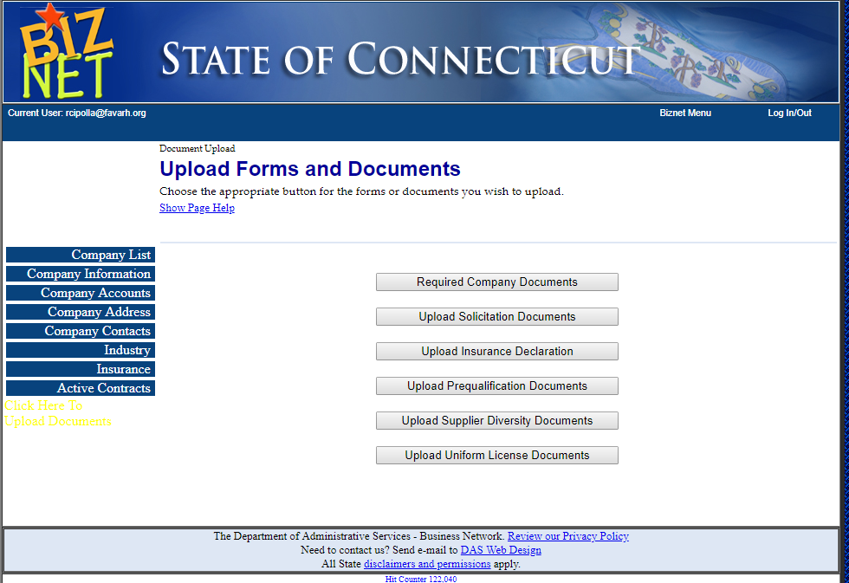**Question:** Page 7 of the guidelines, section D1 (forms) requires 3 forms. I only see Form 3 on the BizNet site (Contract Compliance Monitoring Report), and it’s not called Form 3. Where are the others? Going to “required company documents” after I’ve logged in, and then “click here to upload documents” gives me the ability to “get documents” such as Nondiscrimination certifications, but they are not labeled Forms 1, 2 or 3 and the revision dates are not the same.  
   **Response:** The links in the guidelines are live and you can complete the forms there. You would then upload them in the section labeled upload solicitation documents. If you do not have a current form on file, there will be a link directing you to upload the form. However, if you have a current form on file, you do not need to do anything else.
4. **Question:** Where/how do we upload a copy of the owner’s approval letter for facilities that we lease?  
   **Response:** This is not part of the application. This is a post award requirement.
5. **Question:** On page 7 it lists forms that need to be uploaded into BizNet but Form 1, Nondiscrimination Certification, is the only one that there is a spot to upload. There is no spot in BizNet under “required documents” to upload Form 2, Acknowledgement of Contract Compliance, Notification to Bidders, and Form 3, Contract Compliance Monitoring Report. Where should those 2 forms be uploaded?  
   **Response:** Please see question #87.
6. **Question:** Can we use the nondiscrimination cert. found on line (Form B 1-13-2016-- for contracts valued less than $50000) and Form C (1-13-2016 for contracts valued at $50,000 or more)? Or do we use the ones in this “get forms” place?  
   **Response:** Yes, [**Nondiscrimination Form B**](https://www.ct.gov/opm/lib/opm/secretary/forms/form_b_nondiscriminationcertificationrepentity_lessthan50k.pdf)**,** [**Nondiscrimination Form C**](https://www.ct.gov/opm/lib/opm/secretary/forms/form_c_nondiscriminationcertificationaffentity_50kormore.pdf).
7. **Question:** And if so, is this the place where we upload new forms? Do they automatically supplant the old ones that are there?  
   **Response:** Please see question #87, new forms uploaded supplant old ones.
8. **Question:** Last year there was a “Notification to Bidders/Grantees” form. I’m assuming that this year it’s replaced with Form 2, but I cannot find it. Where is it (Acknowledgment of Contract Compliance)?  
   **Response:** Please refer to the guidelines, Section F, #1-D. [**The Acknowledgement of Contract Compliance**](http://www.ct.gov/doh/lib/doh/conappdocs/notification_to_bidders.pdf)**.**
9. **Question:** Are grantees required to use prevailing wages when subcontracting for renovation projects?  
   **Response:** These are not required by the Guidelines.
10. **Question:** We understand that procurement is not required until after an award is contracted but to accurately budget our request we prefer to secure three bids at time of application. If we are selected to receive an award (Feb 2019) may we engage a contractor and proceed based on those original bids? Or do we have to rebid the project? If bids obtained during application clearly state valid through 3/31/2019.  
    **Response:** We don’t have an objection to that, although the funds may not be available until after 3/31/19.
11. **Question:** We want to apply for funding to improve the security, health and safety of our early childhood program.  The security issues involve improvements to our outdoor spaces for parking and play (fencing, lighting, cameras) and encryption of our client data base.  We also need a capital improvement for our building to prevent water leakage that causes damage.  Can we include these in one application, or would we need separate applications for each item?

**Response:** The I/T should be a separate application. If the facility improvements are part of an overall renovation of the same location, those portions of the work could be in one application.

1. **Question:** Will the parameters used on the scoring sheet be the same as those that were used in the last round?

**Response:** Please refer to the evaluation criteria in the guidelines. There have been some modifications in this regard.

1. **Question:** Our organization has received a score of 2 in prior rounds under the Affirmative Action and Equal Employment Opportunity section of the evaluation criteria. We have submitted our organization’s nondiscrimination certification, acknowledgement of Contract Compliance, Notification to Bidders and Contract Compliance Monitoring Report. What is required for an organization to receive a 5 in this section of the evaluation criteria?  
   **Response:** Applicants are reviewed both for their plans and their demonstrated achievement in regard to providing equal employment opportunities.