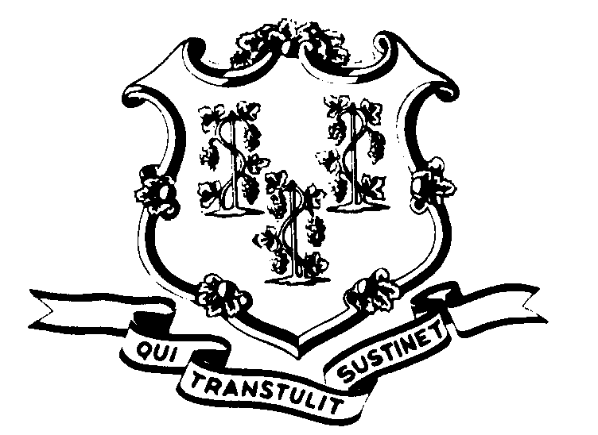
STATE OF CONNECTICUT

OFFICE OF POLICY AND MANAGEMENT

Office of Labor Relations

February 14, 2014

General Notice No. 2014-09

TO: Labor Relations Designees

SUBJECT: February 13th Snow Storm

FEBRUARY 13th
Governor Dannel P. Malloy directed nonessential state employees not to report to work on February 13, 2014 for the first and second shift due to adverse travel conditions related to the snowstorm.
Consistent with past practice, contractual and statutory provisions, you are reminded of the following:
- Nonessential employees scheduled to work first or second shift on that day will record their absence with the code “LWGOV”. Essential employees who did report to work will be paid in accordance with contractual and statutory provisions. Essential employees are not eligible for compensatory time off, unless their contract specifically provides this benefit.
- Employees who were not scheduled to work on February 13 are not covered by the Governor’s direction. Employees absent because of illness or scheduled to take vacation leave, personal leave or other earned time shall have the appropriate leave balance charged and shall not be eligible for “LWGOV” time. Employees on leave of absence without pay (including voluntary leave) or other scheduled day off, such as a pass day or “flex” day, shall not be eligible for “LWGOV” time.
- Governor Malloy’s direction did not cover state employees who work on the midnight shift and therefore the “LWGOV” time does not apply.
DELAYED OPENING – FEBRUARY 14, 2014
Governor Malloy announced that all nonessential first shift employees should report to work on the basis of a one hour delay based on the time each employee would normally report to work. This was due to the travel conditions in order to help stagger the early morning rush hour commute.
Consistent with past practice, contractual and statutory provisions, you are reminded of the following:

- Nonessential employees who reported to work on that day may record the first hour time from the beginning of their scheduled workday as “LWGOV”. Essential employees who did report to work will be paid in accordance with contractual and statutory provisions. Essential employees are not eligible for compensatory time off unless specifically provided in their collective bargaining agreement.
- Employees who were not scheduled to work on February 14th or who did not come in within the first hour of the beginning of their shift (even though they were otherwise scheduled to work) are not covered by the Governor’s action. Employees absent because of illness or scheduled to take vacation leave, personal leave or other earned time shall have the appropriate leave balance charged and shall not be eligible for “LWGOV” time. Employees on leave of absence without pay (including voluntary leave) or other scheduled day off, such as a pass day or “flex” day, shall not be eligible for “LWGOV” time.
- Governor Malloy’s instruction did not impact state employees who work on the second or third shifts as those operations were not delayed.
Labor Relations Designees with questions should be directed to the Office of Labor Relations at 418-6447. All others should contact their Central Personnel Office.

Linda J. Yelmini

Linda J. Yelmini
Director of Labor Relations

