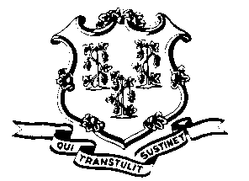
STATE OF CONNECTICUT

OFFICE OF POLICY AND MANAGEMENT

Office of Labor Relations

December 4, 2013
General Notice No. 2013-09
TO: Labor Relations Designees
SUBJECT: Sandy Hook Compensatory Time Stipulated Agreement and Item
The Office of Labor Relations (OLR) on behalf of the Governor has reached an agreement with the American Federation of State, County and Municipal Employees Union, the Administrative and Residual Union, District 1199, the Connecticut State Police Union, the Connecticut State Employees Association and the Connecticut Police and Fire Union which provides a benefit to first responders and other employees who were directly and significantly involved with the direct response to the tragedy at Sandy Hook Elementary School who are employed on December 1, 2013.
By Item, this benefit is being extended to nonrepresented employees who are eligible to earn compensatory time, who were similarly directly and significantly involved.
This benefit is being conferred in recognition of the extraordinary nature of the tragedy and that these individuals may have taken sick and/or vacation time to deal with personal matters related thereto.
- Such employees will be credited with forty (40) hours of compensatory time. The utilization of the compensatory time shall be subject to the normal rules regarding the same. In no event shall there be any payout of this compensatory time.
- Agencies must provide a list of individuals covered by this benefit to DAS no later than December 31, 2013. Each individual approved for this benefit credited as compensatory time by DAS.
- DAS will provide to each Union, the list of their members approved for this benefit.
- The Union may appeal the exclusion of any individual from this benefit to the OLR but any such grievance may not be appealed to arbitration.
- As these agreements require legislative approval, the crediting and use of such compensatory time cannot occur until legislative action is taken or 30 days following submission to the legislature when they are in session. You will be notified when that occurs.
Employees with questions about this General Notice should contact their Agency Human Resources Office. Questions from Agency Human Resources staff may be addressed to the Office of Labor Relations at 418-6447.
Linda J. Yelmini
Linda J. Yelmini
Director of Labor Relations

