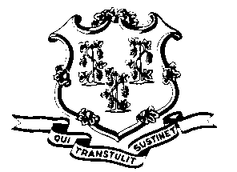
STATE OF CONNECTICUT

OFFICE OF POLICY AND MANAGEMENT

Office of Labor Relations

September 24, 2013
General Notice No. 2013-07
TO: Labor Relations Designees
SUBJECT: CHRO Settlements involving Grievances
There has been some confusion in certain agencies regarding the ability to reach settlements of complaints before the Commission on Human Rights & Opportunities (CHRO) with employees (or their attorneys) that would modify a prior grievance settlement agreement or would withdraw a pending grievance involving the same employee. Agencies cannot negotiate with employees (or their attorneys) about grievances filed by a union or resolved by a union without involving the union, as described below.
A. If an agency wants to modify a grievance settlement agreement between the agency and a union as part of resolving a CHRO complaint from the same employee(s), the agency must notify the union and obtain the union’s written concurrence to any such change or the union’s signature on the CHRO agreement.
B. If an agency wants to have a union-filed grievance resolved or withdrawn as part of resolving a CHRO complaint from the employee(s) covered by the grievance, the agency must contact the union and obtain a signed withdrawal from the union or the union’s signature on the CHRO agreement in order for the grievance to be withdrawn as part of the CHRO settlement.
You are also reminded that, if a grievance settlement agreement was signed by a member of the Office of Labor Relations, then any modification of that agreement must also involve that staff member.
Please share the information in this notice with the staff in your agency who are involved with CHRO complaints from employees. Questions from Agency Human Resources officials may be addressed to the Office of Labor Relations at 860-418-6447.

Linda J. Yelmini
Linda J. Yelmini
Director of Labor Relations

