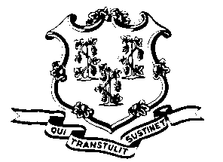
STATE OF CONNECTICUT

OFFICE OF POLICY AND MANAGEMENT

Office of Labor Relations

February 13, 2013

General Notice 2013-02

TO: Labor Relations Designees

SUBJECT: February 8, 2013 and February 11, 2013 absences due to the snowstorm

Governor Dannel P. Malloy directed nonessential state employees not report to work on February 8, 2013 for the first shift because of the expected severe snow- storm and for the first shift on February 11, 2013 due to adverse travel conditions.

Consistent with past practice, contractual and statutory provisions, you are reminded of the following:

- Nonessential employees scheduled to work first shift on that day will record their absence with the code “LWGOV”. Essential employees who did report to work will be paid in accordance with contractual and statutory provisions. Essential employees are not eligible for compensatory time off, unless their contract specifically provides this benefit.
- Employees who were not scheduled to work on February 8 and/or February 11 are not covered by the Governor’s direction. Employees absent because of illness or scheduled to take vacation leave, personal leave or other earned time shall have the appropriate leave balance charged and shall not be eligible for “LWGOV” time. Employees on leave of absence without pay (including voluntary leave) or other scheduled day off, such as a pass day or “flex” day, shall not be eligible for “LWGOV” time.
- Governor Malloy’s direction did not cover state employees who work on the evening or midnight shifts and therefore the “LWGOV” time does not apply.
Labor Relations Designees with questions should be directed to the Office of Labor Relations at 418-6447. All others should contact their Central Personnel Office.

Linda J. Yelmini
Linda J. Yelmini
Director of Labor Relations

