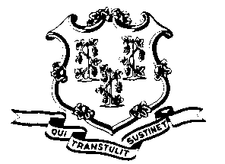
STATE OF CONNECTICUT

OFFICE OF POLICY AND MANAGEMENT

Office of Labor Relations

September 16, 2011

General Notice 2011-26

TO: Labor Relations Designees

SUBJECT: Posting of NP-5 Unit Representation Petition

Enclosed is the petition filed by the United Public Service Employees Union seeking to represent the “POST certified police officers” in the Protective Services (NP-5) bargaining unit. Copies of the petition must be posted “in conspicuous places where the employees in the unit customarily assemble, and leave posted for a period of thirty (30) days.” Since the petition does not encompass the entire NP-5 bargaining unit, the posting requirement would be limited to agencies and locations where there are employees in NP-5 job classifications that require POST certification. We suggest that the copies be posted on the agency bulletin boards used for Human Resources postings or other official notices. The petition should not be posted on bulletin board space designated for the current union. If your agency does not have any NP-5 employees required to have POST certification, there is no need to post this petition. By a separate general notice, we will be asking you to verify the accuracy of our employee list and to provide us with copies of the employees’ signatures.

Agency Labor Relations Designees with questions may contact the Office of Labor Relations at 418-6447.

Linda J. Yelmini
Linda J. Yelmini
Director of Labor Relations

