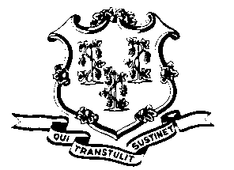
STATE OF CONNECTICUT

OFFICE OF POLICY AND MANAGEMENT

Office of Labor Relations

June 3, 2011

General Notice 2011-12

TO: Labor Relations Designees

SUBJECT: CORE Code for Time off with pay to discuss Tentative SEBAC Agreement

The CORE code that employees should utilize for time spent in the activity outlined in OLR General Notice 2011-11 is LSEBC. The CORE Code will be available no later than June 8, 2011. Secretary of OPM, Ben Barnes has instructed me to inform you that this code is effective for any time spent on this activity from May 13, 2011. Please ask affected bargaining unit members to amend their timesheets to indicate the revised coding. If they utilized vacation or PL, the time should be recredited to their balances.

Agency Labor Relations Designees with questions may contact Secretary Barnes’ office at 860-418-6500. All others should contact their agency Human Resource office.

Linda J. Yelmini
Linda J. Yelmini
Director of Labor Relations

