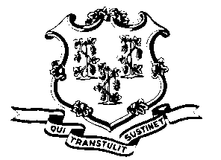
STATE OF CONNECTICUT

OFFICE OF POLICY AND MANAGEMENT

Office of Labor Relations

May 26, 2011

General Notice 2011-10

TO: Labor Relations Designees

SUBJECT: Tentative 2011 SEBAC Agreement

Attached is a copy of the Tentative 2011 SEBAC Agreement. It will now go out for ratification to all employees who are members of unions that are part of SEBAC.

Agency Labor Relations Designees with questions may contact the Office of Labor Relations at 418-6447. All others should contact their agency human resource office.

Linda J. Yelmini
Linda J. Yelmini
Director of Labor Relations

