STATE OF CONNECTICUT
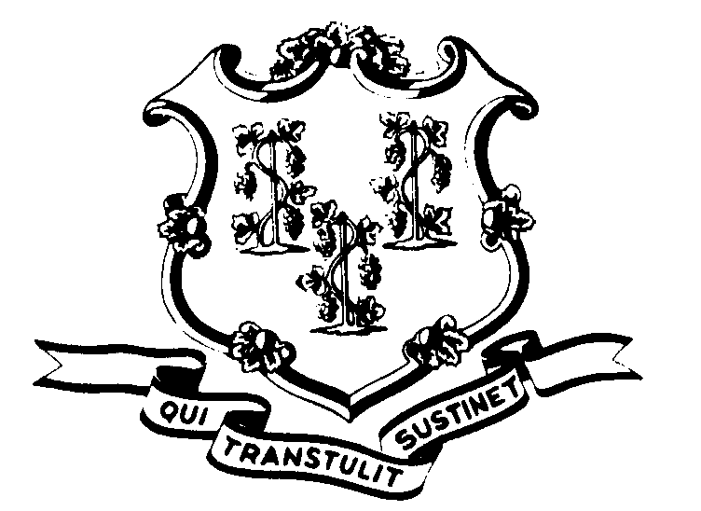

OFFICE OF POLICY AND MANAGEMENT

Office of Labor Relations

January 17, 2007

General Notice No. 2007-01

TO: Labor Relations Designees

SUBJECT: NP-2 Seniority Lists

In October we initiated a statewide project which will enable us to issue an annual seniority list from CORE-CT each January, in compliance with the Maintenance & Service Unit (NP-2) Contract. At this time, we are issuing a reminder to all of you to complete the steps V and VI of that project as outlined in attached Memorandum 2006-01. Please ensure that these steps are completed no later than January 26, 2007, close of business. Failure to complete these final steps may result in inaccurate information on the final report sent to the Union in February.
Thanks to all of you for your cooperation with this initiative. Your efforts will be rewarded as DAS will now be able to issue this list automatically, and on time, each year when it comes due.
Employee questions about this notice should be addressed to the Agency’s Human Resources office. Agency Labor Relations Designees with questions may contact Shari Grzyb or Heather Tweeddale of the DAS Business Rules and Central Audit Unit concerning these procedures. Contractual questions should be directed to Lynn Paton at the Office of Labor Relations.

Robert Curtis

Robert Curtis
Director of Labor Relations

